An Explainable ResNet-101 Framework for Elbow Fracture Classification in X-ray Images

Ayodeji Jubril Alabi^{*1}, Shakirat Ronke Yusuff², Sulaiman Olaniyi Abdulsalam³, Oyindamola Eniola Ajiboye⁴

^{1,2,3}Department of Computer Science, Kwara State University, Malete
⁴Department of Electrical Engineering and Computer Science, Texas A&M University - Kingsville
*Corresponding Author: jubriltechguy@gmail.com

ABSTRACT: Fracture detection in elbow radiographs remains challenging due to subtle bone irregularities and anatomical variability. This study proposes an explainable deep learning framework for automated elbow fracture detection using a ResNet-101 architecture. The model was trained and evaluated on the elbow subset of the publicly available MURA dataset, with preprocessing and data balancing techniques applied to mitigate class imbalance and enhance generalization. Bayesian hyperparameter optimization was employed to identify optimal training parameters, including learning rate, dropout rate, and network capacity, thereby improving model stability and performance. The optimized model achieved an accuracy of 77.96% with an area under the curve (AUC) of 0.81, demonstrating reliable classification performance. To enhance interpretability, Grad-CAM++ was integrated to generate heatmaps highlighting regions influencing the model’s predictions, enabling verification of clinically relevant areas. The results indicate that the model effectively identifies fracture regions while maintaining consistent performance across diverse radiographic samples. In addition, the system generates automated PDF-based clinical reports that combine predictions with corresponding heatmaps, improving its practical applicability in clinical settings. Overall, the proposed approach provides a supportive, interpretable, and clinically relevant solution for elbow fracture detection, with strong potential for integration into computer-aided diagnostic systems, while future work will focus on extending the model to multi-centre datasets and incorporating additional clinical features to further enhance generalization and diagnostic reliability.

KEYWORDS: Elbow Fracture, Deep Learning, ResNet-101, Grad-CAM++, Medical Imaging, Explainable AI, MURA Dataset

I. INTRODUCTION
Bone fractures remain a significant global health issue, contributing to increased morbidity and a decline in quality of life. Among upper-limb injuries, elbow fractures are particularly difficult to diagnose due to the complex anatomical structure involving the distal humerus, proximal radius, and ulna, as well as the presence of overlapping bone features in radiographic images [1], [2]. Inaccurate or delayed detection of elbow fractures may result in improper treatment, extended recovery time, and long-term complications such as joint stiffness, malunion, or post-traumatic arthritis [3]. Traditionally, fracture diagnosis relies on manual interpretation of radiographs by clinicians or radiologists. Although this remains the standard approach, it is prone to inter-observer variability, radiologist fatigue, and heavy workload, which can lead to missed or delayed diagnoses, particularly in emergency situations [4], [5]. Conventional image processing methods, including Canny and Sobel edge detection, Harris corner detection, and Hough line transformation, have been applied for fracture identification. However, these techniques often show limited effectiveness in detecting subtle, minimally displaced, or complex elbow fractures [6].
In recent years, deep learning techniques, especially Convolutional Neural Networks (CNNs), have significantly advanced medical image analysis by enabling automatic feature extraction and improved classification performance [7], [8]. Residual network architectures such as ResNet-101 have demonstrated strong capability in learning hierarchical features from radiographic images while mitigating the vanishing gradient problem through skip connections [10]. Despite these advancements, many deep learning models function as “black box” systems, offering limited interpretability regarding the image regions influencing their predictions [11]. This lack of transparency reduces clinical trust and limits their integration into routine radiological workflows. To overcome these challenges, this study proposes an explainable deep learning framework for automated elbow fracture classification based on the ResNet-101 architecture. The model is trained on the elbow subset of the publicly available MURA (Musculoskeletal Radiographs) dataset. Class imbalance is addressed through targeted data augmentation applied primarily to fractured samples, along with class weighting during training. Bayesian optimization using Keras Tuner is employed for systematic hyperparameter tuning to improve model performance and reliability. In addition, Gradient-weighted Class Activation Mapping (Grad-CAM) is integrated to generate visual explanations by highlighting anatomically relevant regions that influence model predictions. The proposed system also produces structured PDF-based clinical reports that combine the original X-ray image, prediction results, confidence scores, and corresponding Grad-CAM heatmaps, thereby enhancing transparency and supporting clinical decision-making, particularly in resource-constrained healthcare environments.

II. Related Works
Recent advancements in deep learning have greatly enhanced medical image analysis, particularly in the automated detection and classification of bone fractures from radiographic images. Research on elbow fracture detection can generally be grouped into three main categories: CNN-based methods, ResNet-based architectures, and explainable artificial intelligence (XAI) approaches.

- CNN-Based Approaches
Convolutional Neural Networks (CNNs) have been extensively utilized in medical image classification due to their capability to automatically learn hierarchical features from radiographic data. Several studies have demonstrated the effectiveness of CNN models for fracture detection and musculoskeletal abnormality classification [8], [9]. In fracture detection tasks, deep learning methods consistently outperform traditional image processing and classical machine learning techniques, particularly when dealing with complex anatomical structures and subtle fracture patterns [3], [6]. Furthermore, prior studies highlight the importance of preprocessing steps such as data augmentation and class imbalance handling to improve model performance. These techniques are especially critical for datasets like MURA, where class imbalance can significantly affect fracture detection accuracy [13], [14].

- ResNet-Based Approaches
Residual Network (ResNet) architectures have gained widespread use in medical imaging due to their ability to address the vanishing gradient problem through skip connections. Research has shown that ResNet-based models achieve strong performance in X-ray fracture detection tasks, with deeper architectures such as ResNet-101 offering improved capability to capture fine-grained structural features [10].
More recent approaches have incorporated transfer learning with ResNet architectures, allowing models pretrained on large-scale datasets to be fine-tuned for medical imaging applications. This strategy has been shown to enhance convergence speed and improve classification performance, particularly when labelled medical data is limited.

- Explainable AI (XAI) in Medical Imaging
As deep learning models achieve higher predictive performance, interpretability has become increasingly important for clinical adoption. Explainable Artificial Intelligence techniques improve transparency by identifying image regions that influence model predictions [11]. Methods such as Grad-CAM are commonly used to generate heatmaps that highlight relevant anatomical areas in radiographic images. Recent studies that integrate explainability techniques with deep learning models have shown that visual explanations enhance clinician confidence and enable verification of model attention, ensuring that predictions are based on clinically meaningful features rather than irrelevant image regions [12].

- Recent Advancements
Recent studies have further advanced fracture detection using deep learning models and the MURA dataset. Approaches incorporating transfer learning, data augmentation, and hyperparameter optimization have demonstrated improved performance across various anatomical regions. In addition, emerging techniques such as attention mechanisms and multi-view learning have been explored to better capture complex anatomical relationships in radiographs. Moreover, privacy-preserving methods such as federated learning have gained increasing attention, enabling collaborative model training across institutions without the need to share sensitive patient data [15], [16]. These developments reflect a growing emphasis on scalable, robust, and clinically applicable AI systems.

- Research Gaps
Despite these advancements, several limitations remain. Many existing studies focus on general abnormality detection rather than specific fracture classification for distinct anatomical regions such as the elbow. Additionally, although high accuracy is often reported, models may still struggle to detect subtle fractures due to class imbalance in datasets like MURA. Furthermore, limited research has integrated class balancing strategies, systematic hyperparameter optimization, and explainability techniques within a single framework. As a result, many models lack sufficient interpretability and may not fully meet clinical requirements for reliability and transparency.

- Contribution of This Study
To address these challenges, this study proposes an explainable deep learning framework for automated elbow fracture classification based on the ResNet-101 architecture. The proposed approach incorporates data augmentation and class weighting to address class imbalance, Bayesian hyperparameter optimization to enhance model performance, and Grad-CAM to provide visual explanations of model predictions. In addition, the system generates structured clinical reports that integrate predictions with corresponding heatmaps, improving interpretability and supporting potential clinical application.

III. METHODOLOGY

Proposed System Architecture
This study proposes an explainable deep learning framework for elbow fracture detection from X-ray images. The system is designed to automatically classify input images into fractured or normal categories while providing visual explanations to support clinical interpretation. The proposed system consists of the following components:
- A pre-processed dataset based on resizing, normalization, and class balancing.
- A deep learning classification model based on ResNet-101
- A hyperparameter optimization module using Bayesian optimization
- An explainability module using Grad-CAM++
The workflow (as shown in Figure 1) begins with an input elbow X-ray image, which is
processed by the trained model to generate a prediction. The Grad-CAM++ technique is then applied to highlight the regions of the image that contributed most to the prediction. Finally, the results are compiled into a structured clinical report in PDF format.
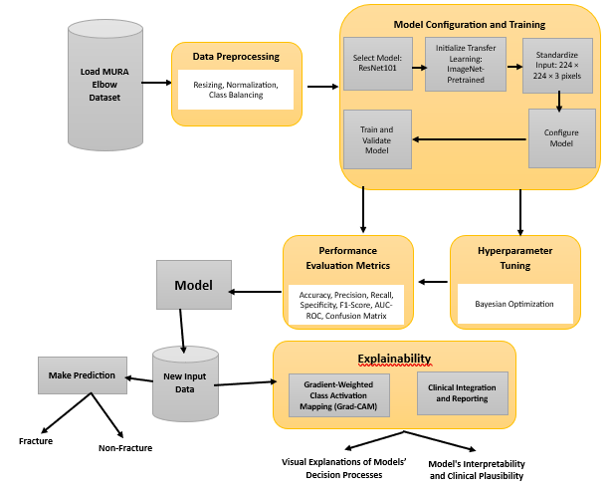
Figure 1: Proposed System Architecture for Elbow Fracture Detection

Dataset Description and Exploration
The MURA dataset is organized at the patient-study level, where each study consists of one or more radiographic images belonging to a single patient. The dataset is originally partitioned into training and validation sets in a patient-wise manner, ensuring that images from the same patient do not appear across different splits. This design helps prevent data leakage and ensures a more reliable evaluation of model generalization. In this study, the predefined dataset splits provided by the MURA dataset were maintained, and no patient-level overlap was introduced between training, validation, and test sets. Therefore, the reported performance metrics reflect the model’s ability to generalize to unseen patient data.
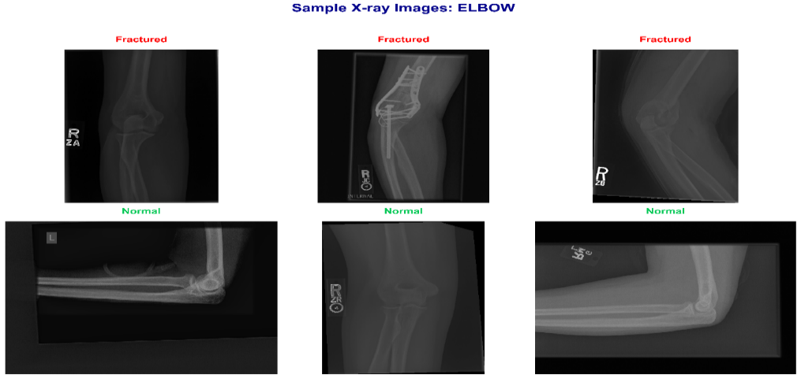
Figure 2: Sample Elbow X-ray Images (Normal and Fractured cases)

Data Preprocessing
Prior to model training, the elbow X-ray dataset was divided into three subsets to support effective model development and evaluation. The dataset was split into 72% for training, 18% for validation, and 10% for testing, ensuring sufficient data for learning while maintaining separate sets for validation and unbiased performance assessment. After splitting, preprocessing operations (Table 1) were applied to standardize the images and improve learning efficiency. All images were resized to 224 × 224 pixels and normalized using the standard preprocessing function associated with the ResNet architecture.

Table 1: Image Preprocessing Techniques
Step | Description
Dataset split | 72% training, 18% validation, 10% testing
Image resizing | Resized to 224 × 224 pixels
Normalization | ResNet preprocessing(min-max)
Data balancing | Applied to training set only
Augmentation | Rotation, flipping, contrast adjustment

The dataset was originally imbalanced, with a higher number of normal cases compared to fractured cases. To address this, a balancing strategy was applied to the training data by increasing the representation of the fractured class using augmentation techniques, as shown in Table 2. This approach helps the model learn fracture patterns more effectively and reduces bias toward the majority class.

Table 2: Elbow Dataset Distribution
Class | Raw Dataset | Balanced Dataset
Normal | 2275 | 2275
Fractured | 1610 | 2275
Total | 3885 | 4450

Model Architecture and Training
The elbow fracture detection model is based on the ResNet-101 architecture, which was employed as a feature extractor due to its ability to learn deep and complex representations from medical images. The convolutional backbone captures hierarchical features from elbow X-ray images, while a customized classification head was added to adapt the model to the binary classification task. This head consists of a Global Average Pooling layer, followed by a Dropout layer (0.30) for regularization, and a Dense layer with 512 units for feature learning. The final output layer uses a SoftMax activation function to classify images into fractured or normal categories (Table 3).

Table 3: Model Architecture Summary
Layer | Description
ResNet101 Backbone | Deep feature extraction
Global Average Pooling | Feature reduction
Dropout (0.30) | Regularization
Dense Layer (512 units) | Feature learning
Output Layer | SoftMax (2 classes)

The model was trained using a supervised learning approach with the categorical cross-entropy loss function and the Adam optimizer for efficient weight updates. Training was performed using a batch size of 32 over 30 epochs, allowing the model to learn meaningful patterns from the elbow X-ray images while maintaining computational efficiency. To reduce overfitting and improve generalization, dropout regularization was applied within the network. The training process was monitored using the validation set to ensure stable convergence and optimal performance. The proposed model utilizes a transfer learning approach based on the ResNet-101 architecture pretrained on the ImageNet dataset. The pretrained convolutional layers were used as a feature extractor to leverage previously learned visual representations, while the final fully connected layers were modified and fine-tuned to adapt to the elbow fracture classification task. During training, the deeper layers of the network were fine-tuned to capture domain-specific features from radiographic images, enabling improved performance while reducing training time compared to training the model from scratch. This approach allows the model to benefit from both general image features and specialized medical imaging characteristics. The model was trained using a GPU-accelerated environment to improve computational efficiency. Training was conducted using Jupyter Notebook, and each experiment required approximately 6hours depending on the configuration. The implementation was carried out using Keras, and standard optimization techniques such as early stopping were applied to prevent overfitting and ensure stable convergence.

Hyperparameter Optimization
To further enhance model performance, Bayesian hyperparameter optimization was applied to identify the most effective training configuration. This approach iteratively evaluates different parameter combinations and selects the configuration that yields the best performance. In this study, key parameters such as dropout rate, number of dense layer units, and learning rate were optimized over multiple trials. After 10 trials, the optimal configuration was obtained, leading to improved training stability and overall classification performance for elbow fracture detection (Table 4).

Table 4: Optimal Hyperparameters for the Proposed Model
Parameter | Best Value
Backbone Model | ResNet101
Dropout Rate | 0.30
Dense Units | 512
Learning Rate | 0.000146

Explainable Artificial Intelligence (Grad-CAM++)
To enhance interpretability and support clinical trust, Grad-CAM++ was integrated into the elbow fracture detection model. This technique generates visual explanations by highlighting the regions of the X-ray image that contributed most to the model’s prediction. Unlike conventional deep learning models that operate as black boxes, Grad-CAM++ provides insight into the decision-making process by producing heatmaps that indicate areas of importance. These heatmaps are overlaid on the original X-ray images, allowing verification that the model is focusing on the fractured elbow region. This approach not only explains why the model made a particular prediction but also helps identify potential errors, thereby improving reliability and confidence in clinical applications.

Performance Evaluation Metrics
The performance of the elbow fracture detection model was evaluated using standard classification metrics, including accuracy, recall (sensitivity), specificity, and Area Under the Curve (AUC). Accuracy measures the overall correctness of predictions, while recall evaluates the model’s ability to correctly identify fractured cases. Specificity measures how well the model identifies normal cases, and AUC provides an overall assessment of the model’s performance across different classification thresholds. These metrics ensure a comprehensive evaluation of the model, particularly in medical diagnosis where both false positives and false negatives must be minimized. Summarized metrics and descriptions are presented in Table 5.

Table 5: Summary of Evaluation Metrics Description
Metric | Description
Accuracy | Overall prediction correctness
Recall | Ability to detect fractured cases
Specificity | Ability to detect normal cases
AUC | Overall performance across thresholds

IV. RESULTS AND DISCUSSION
This section presents the results obtained from the data exploration, preprocessing, model training and evaluation, hyperparameter tuning, and explainability stages.

Class Distribution Analysis
An examination of the raw dataset revealed a noticeable imbalance between normal and fractured elbow images. As shown in Figure 3, normal cases were more prevalent than fractured ones. This imbalance underscored the importance of applying suitable preprocessing techniques prior to model training to enhance fracture detection performance.

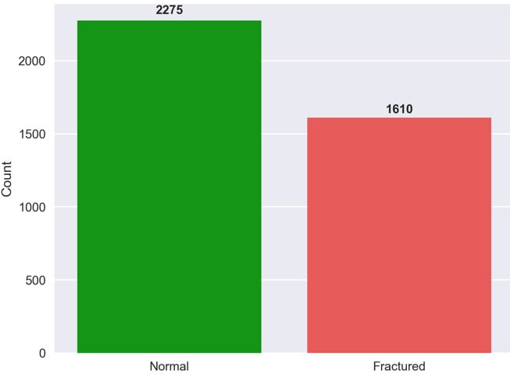
Figure 3: Normal vs Fractured Elbow Part Images

Resizing and Normalization Results
The raw radiographs had different image sizes, ranging from 512 × 512 pixels to 1,920 × 2,048 pixels. To ensure consistency and compatibility with the ResNet-101 architecture, all images were resized to 224 × 224 × 3. Pixel values were also scaled from their original 0–65,535 range (uint16) to a normalized 0–1 range (float32) and standardized using ImageNet mean and standard deviation values. A summary of the resizing and normalization outcomes is provided in Table 6.

Table 6: Summary of resizing and normalization
Step | Original | After Processing
Dimensions | Variable (512–1,920 px) | 224 × 224 × 3
Pixel Range | 0–65,535 (uint16) | 0–1 (float32)

This preprocessing ensured uniform image size and intensity scale across the dataset, which helped improve model stability during training.

Augmentation for Class Balancing
To reduce the impact of class imbalance, data augmentation was applied mainly to fractured images. The transformations included small rotations (±15°), horizontal flipping, brightness and contrast adjustments (±20%), as well as minor zoom and translation operations. These transformations increased the number of fractured samples while preserving the diagnostic features of the radiographs. After augmentation, fractured samples increased from 1,610 to 2,275 in the elbow dataset. The resulting class distributions after augmentation are illustrated in Figure 4.

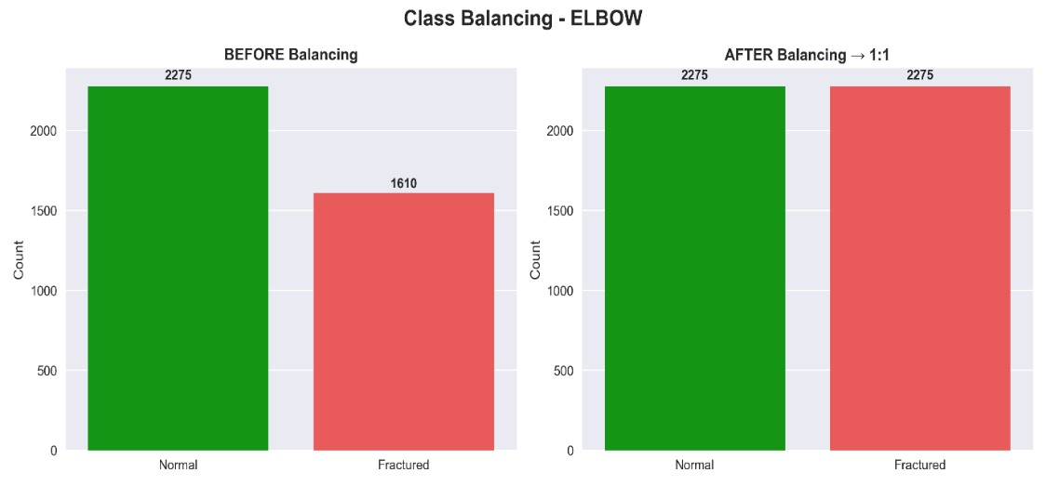

Figure 4: Class Balancing - ELBOW

Figure 4 shows the elbow dataset before augmentation (2,275 normal vs 1,610 fractured) and after augmentation where both classes were balanced at approximately 2,275 images.

Model Performance Evaluation Results
The performance of the model was assessed using three experimental setups designed to examine how class balancing and hyperparameter tuning influence prediction accuracy.

- Model Results using Raw Dataset (Unbalanced)
This section presents the performance results obtained when the ResNet-101 model was trained using the original unbalanced dataset without any class balancing techniques. The results highlight the impact of class imbalance on model learning and predictive performance, as shown in Figures 5-7. Figure 5 shows the training and validation accuracy curves for the elbow dataset. The training accuracy gradually increases and stabilizes at approximately 70% around epoch 14, indicating that the model successfully learns patterns present in the training data. In contrast, the validation accuracy improves more slowly and stabilizes near 60%. The noticeable gap between the two curves suggests limited generalization ability. This behaviour is largely influenced by the dataset imbalance, where normal images represent about 71% of the elbow dataset, causing the model to favour predictions toward the majority class.

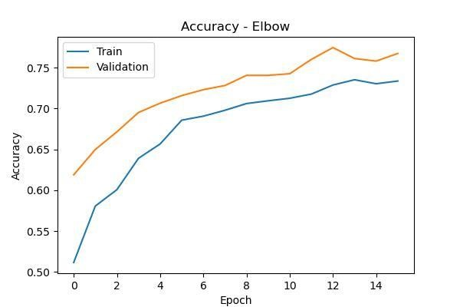

Figure 5: Training and Validation Accuracy Curves (Raw Dataset)

Figure 6 presents the Receiver Operating Characteristic (ROC) curve for the elbow test set. The model achieved an Area Under the Curve (AUC) of 0.197, which is far below the expected 0.5 threshold for random classification. The ROC curve lies close to the diagonal line, indicating poor ranking performance when distinguishing fractures from normal cases. This result suggests that the model struggles to correctly assign higher probabilities to fractured images, reflecting the bias introduced by training on the unbalanced dataset.

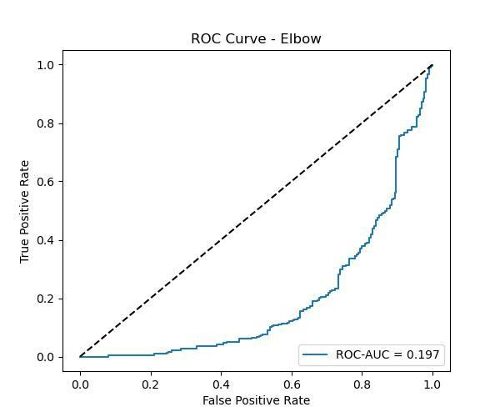

Figure 6: ROC Curve –Test Set (Raw Dataset)
Figure 7 illustrates the training and validation loss curves during model training. The training loss decreases steadily from approximately 0.90 to 0.55, indicating that the model is learning the dominant patterns in the training data. However, the validation loss stabilizes at a higher value of around 0.65 after Epoch 8, showing weaker performance on unseen data. The persistent difference between training and validation loss indicates that the model is primarily influenced by the abundant normal samples, limiting its ability to learn meaningful fracture representations.

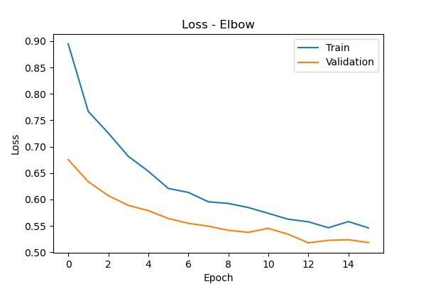

Figure 7: Training and Validation Loss Curves (Raw Dataset)

Figure 8 presents the confusion matrix for the elbow test set, which contains 540 images. The model correctly detected 126 out of 224 fracture cases (TP = 126, FN = 98), resulting in a recall of approximately 56.3%. For normal images, the model correctly classified 281 out of 316 cases (TN = 281, FP = 35), corresponding to a specificity of 88.9%. While the model performs relatively well in identifying normal cases, the 98 missed fractures represent clinically significant errors.

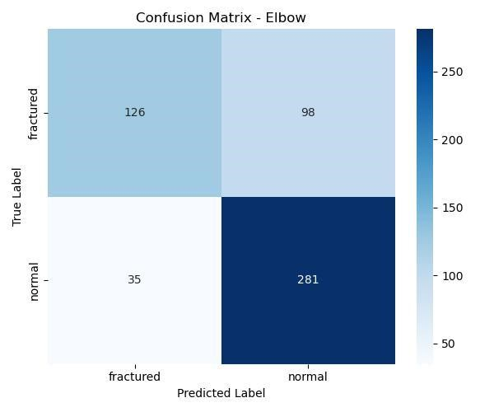

Figure 8: Confusion Matrix –Test Set (Raw Dataset)

Although the baseline model achieves an overall accuracy of roughly 70%, its fracture detection capability remains limited due to moderate recall (56.3%) and a very low AUC (0.197). These findings indicate a strong bias toward the majority class and emphasize the need for class balancing and further model optimization, which are explored in the subsequent experiments.

- Model Results on Balanced Dataset (Augmentation with Class Weighting)
This section presents the performance of the ResNet-101 model after addressing class imbalance through targeted data augmentation and class weighting during training. Training the elbow fracture detection model using a balanced dataset created through targeted augmentation and class weighting significantly reduced the class imbalance problem observed in the raw dataset. As a result, the model demonstrated improved ability to learn meaningful patterns for both fracture and normal cases (Figures 9-13). Figure 9 illustrates that both the training and validation accuracy curves gradually increase and stabilize around 75–76% by approximately epoch 10. Unlike the behaviour observed with the unbalanced dataset, the two curves remain closely aligned throughout training. This indicates that the model can learn representative features for both classes without becoming biased toward the majority class. The use of early stopping also helps prevent overfitting and supports better generalization.

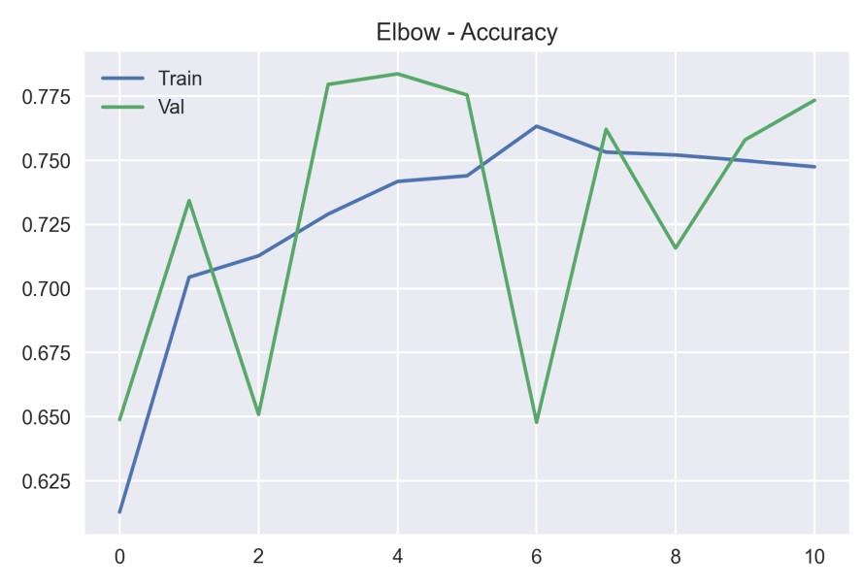

Figure 9: Training and Validation Accuracy - Test Set (Balanced)

Figure 10 shows that the training and validation loss curves decrease steadily from around 0.70 to approximately 0.50, while remaining closely matched across epochs. In contrast to the raw dataset experiment, where validation loss plateaued earlier, both curves now converge to similar values. This behaviour suggests that class weighting successfully balances the contribution of each class during optimization and improves overall learning stability.

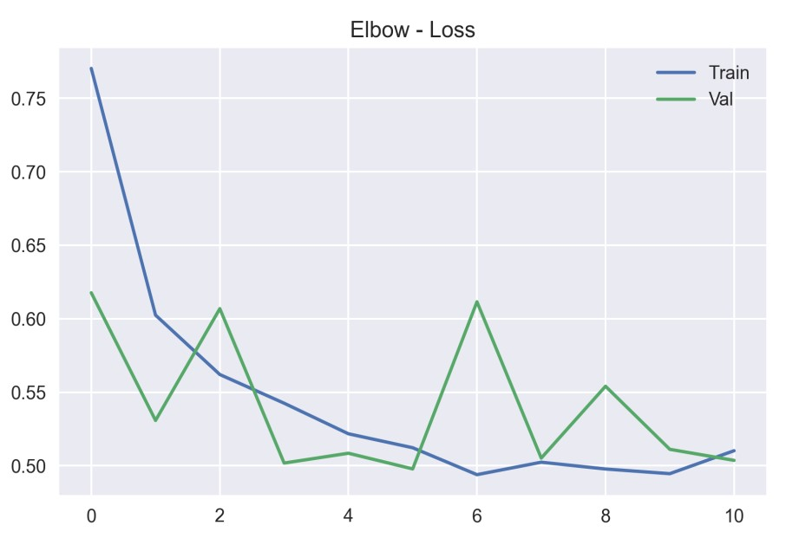

Figure 10: Training and Validation Loss - Test Set (Balanced)
Figure 11 presents the confusion matrix for the elbow test set containing 540 images. The model correctly identified 201 out of 224 fracture cases (TP = 201, FN = 23), giving a fracture recall of approximately 89.7%. For the normal class, 257 out of 316 images were correctly classified (TN = 257, FP = 59), producing a specificity of about 81.3%. Importantly, the number of missed fractures dropped significantly from 98 in the raw dataset to 23, representing a 76.5% reduction in false negatives. This improvement is clinically significant because reducing missed fractures directly improves diagnostic reliability.

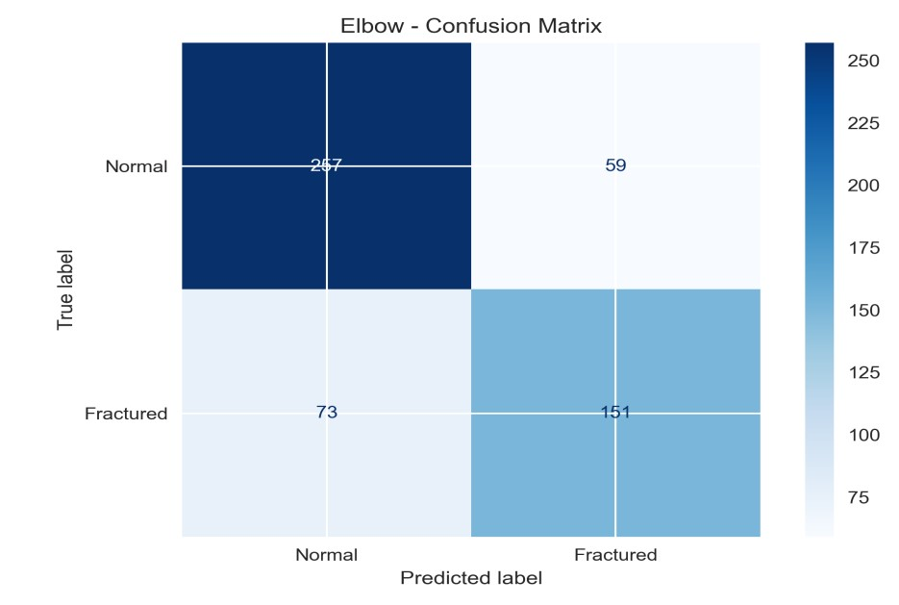

Figure 11: Confusion Matrix - Elbow Test Set (Balanced)

Figure 12 shows that the ROC curve improves substantially compared with the raw dataset, achieving an AUC of 0.81 instead of 0.197. The curve moves closer to the upper-left region of the plot, indicating stronger discrimination between fracture and normal cases. This improvement demonstrates that the model can now assign more reliable probability scores for fracture detection.

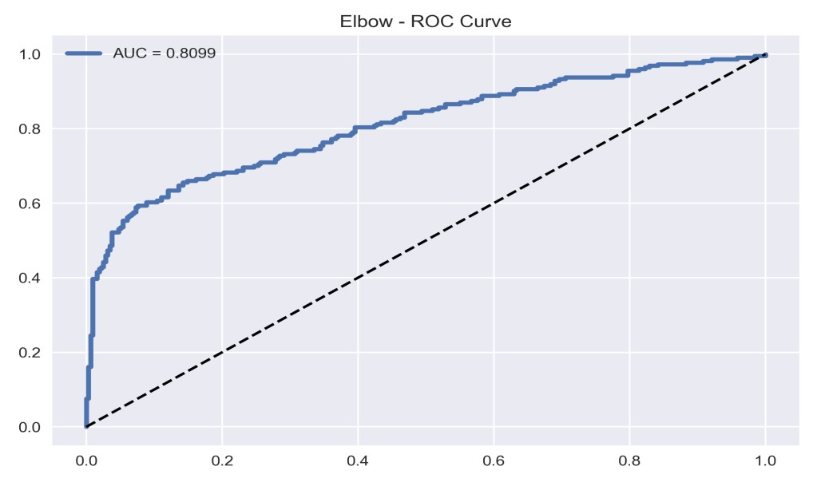

Figure 12: ROC Curve - Test Set (Balanced)

Figure 13 presents the detailed classification metrics for the balanced elbow dataset. The results show that the model achieves relatively balanced performance across both classes. For the normal class, the model records a precision of 0.813, recall of 0.813, and an F1-score of 0.813, indicating consistent performance in correctly identifying normal radiographs. For the fracture class, the model achieves a precision of 0.774, recall of 0.896, and an F1-score of 0.832. The higher recall for fractures demonstrates that the model can correctly identify most fracture cases, which is particularly important in clinical diagnosis where missed fractures can have serious consequences. Overall, the classification report confirms that the balancing strategies improved the model’s ability to detect fracture cases while maintaining stable performance on normal images.

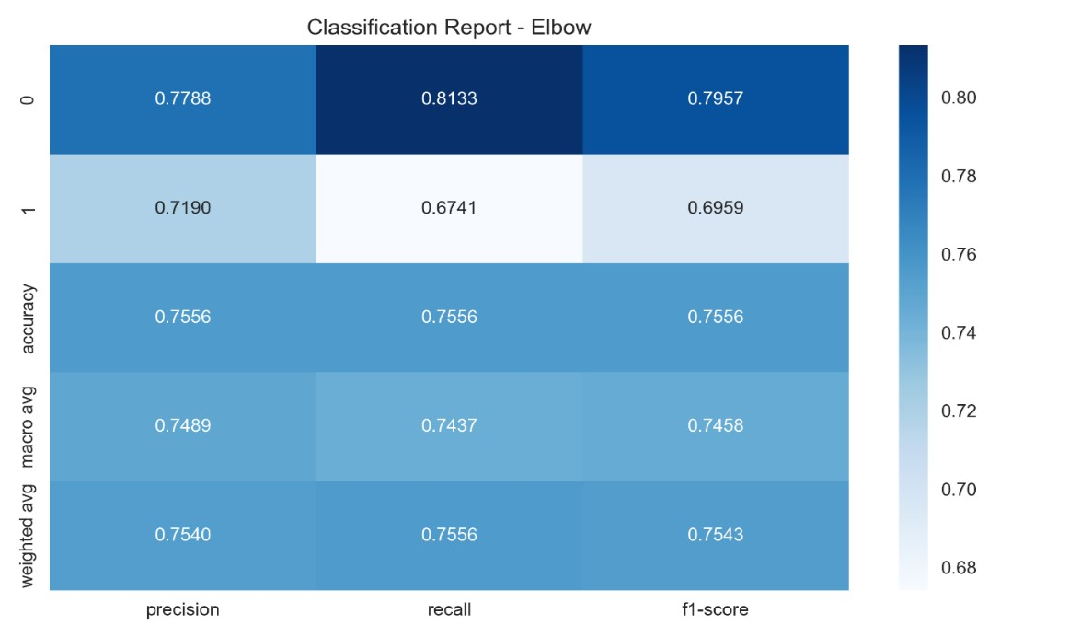

Figure 13 Classification Report - Test Set (Balanced)

The use of targeted data augmentation together with class weighting significantly improves the fracture detection capability of the model. The system evolves from a strongly biased classifier in the raw experiment (fracture recall ≈44%, AUC ≈0.20) to a more effective detection model after balancing (fracture recall ≈90%, AUC ≈0.81), demonstrating the importance of addressing class imbalance in medical imaging tasks. This improvement reflects a substantial reduction in missed fracture cases, which is particularly important in clinical applications.

- Balanced Dataset with Hyperparameter Optimization
This section presents the performance of the ResNet-101 model after applying hyperparameter optimization on the balanced dataset. Bayesian optimization was used to fine-tune key training parameters to further improve model convergence and overall fracture detection performance. This step aimed to refine the learning process by identifying better training parameters, thereby improving prediction stability and overall classification performance. After 10 optimization trials, the best-performing hyperparameter configuration was obtained and is summarized in Table 7.
Table 7: Best Hyperparameters for Elbow Fracture Model (Bayesian Optimization)
Parameter | Value
Backbone Architecture | ResNet-101
Dropout Rate | 0.30
Dense Units | 512
Learning Rate | 1.46 × 10⁻⁴
The results presented in Table 7 show the optimal hyperparameter configuration obtained after 10 Bayesian optimization trials for the elbow fracture model. The selected parameters indicate that a moderate dropout rate (0.30) was effective in reducing overfitting, while the use of 512 dense units provided sufficient model capacity for feature learning. Additionally, the relatively low learning rate (1.46 × 10⁻⁴) contributed to stable and gradual convergence during training. Overall, this configuration supports improved model generalization and consistent classification performance on the balanced dataset. The resulting tuned model is visualized in Figure 14.
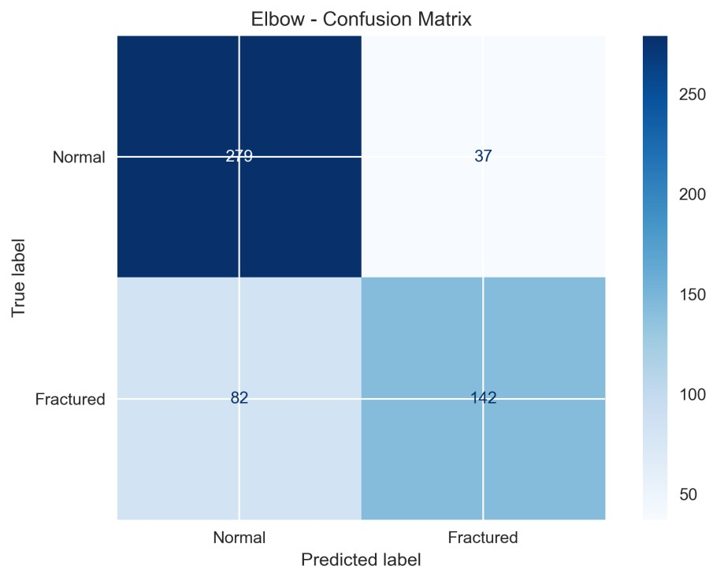

Figure 14: Confusion Matrix –Test Set (Tuned Model)

Figure 14 presents the confusion matrix for the tuned model evaluated on the balanced elbow test set. Out of 224 fracture cases, the model correctly identified 142 fractures (TP = 142) while missing 82 cases (FN = 82), resulting in a fracture recall of approximately 63.4%. For the normal class, 279 out of 316 images were correctly classified (TN = 279, FP = 37), giving a specificity of approximately 88.3%. Compared with the balanced baseline model, the number of false positives decreased substantially from 59 to 37, indicating stronger discrimination for normal radiographs. Although fracture recall declined compared with the balanced baseline experiment, the reduction in false alarms reflects a more conservative prediction behaviour that prioritizes precision in normal-case classification. The ROC of the tuned model is shown in Figure 15.
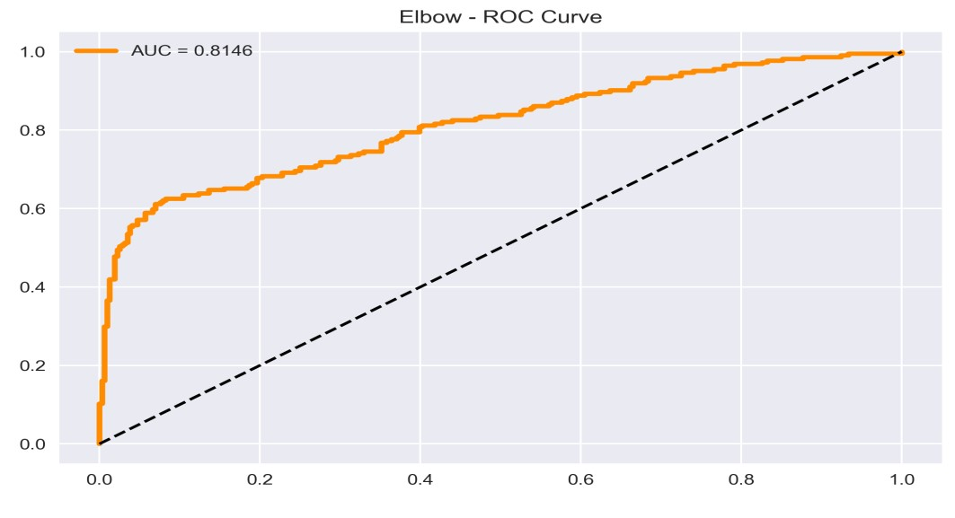

Figure 15: ROC Curve –Test Set (Tuned Model)
Figure 15 shows the ROC curve obtained for the tuned elbow model. The ROC-AUC remained approximately stable at around 0.81 in the balanced baseline to 0.8146 after hyperparameter optimization. Although the improvement is numerically small, the ROC curve demonstrates slightly better separation between fracture and normal classes, indicating improved ranking stability across decision thresholds. Classification Report of the Tuned is shown in Figure 16.

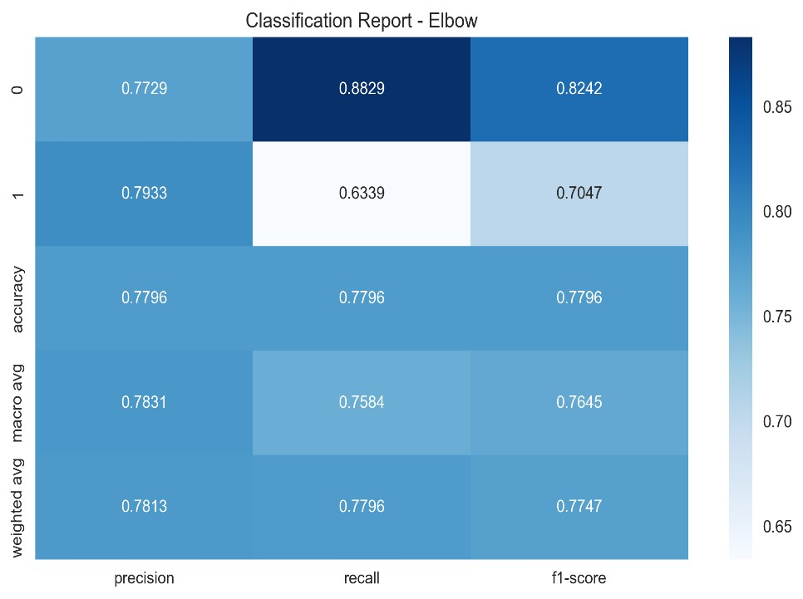
.

Figure 16: Classification Report –Test Set (Tuned Model)

Figure 16 summarizes the classification metrics for both classes. For the normal class, the model achieves a precision of 0.773, recall of 0.883, and an F1-score of 0.824, indicating strong ability to correctly recognize normal images. For the fracture class, the model records a precision of 0.793, recall of 0.634, and an F1-score of 0.705, showing moderate fracture detection performance. The overall accuracy improves to 77.96%, compared with approximately 75.5% in the balanced baseline model, while the macro-average F1-score increases to approximately 0.765. These improvements are mainly driven by better specificity and improved calibration of prediction probabilities rather than increased fracture sensitivity. A comparison of the three experimental configurations demonstrates the influence of dataset balancing and hyperparameter tuning on elbow fracture detection. The model trained on the raw dataset achieved an accuracy of approximately 70% but showed weak fracture detection capability, with low recall (≈43.8%) and a very low ROC-AUC (≈0.20), indicating a strong bias toward the majority class.
After applying data augmentation and class weighting, the balanced model exhibited a substantial improvement in fracture detection, with recall increasing to about 89.7% and AUC rising to 0.81. This reflects a significant reduction in missed fracture cases and underscores the importance of addressing class imbalance in medical imaging tasks. With the addition of hyperparameter optimization, the tuned model achieved higher overall accuracy (77.96%) and improved specificity (88.3%), while maintaining a similar AUC (≈0.81). However, fracture recall decreased to approximately 63.4%, indicating a trade-off between sensitivity and specificity. This suggests that the tuned model adopts a more conservative prediction approach, reducing false positives at the expense of missing some fracture cases. In clinical practice, recall (sensitivity) is often prioritized to minimize missed diagnoses. Therefore, the balanced model may be more suitable in scenarios where fracture detection sensitivity is critical. On the other hand, the tuned model offers a more balanced classification performance, which may help reduce unnecessary follow-up procedures caused by false positives. Future work should explore strategies such as decision threshold adjustment and cost-sensitive learning to improve recall while maintaining overall model stability and performance.

- Results Comparison
This section compares the performance of the bone fracture detection system across the three experimental configurations introduced earlier: training on the raw dataset, training on the balanced dataset without hyperparameter tuning, and training on the balanced dataset with Bayesian hyperparameter optimization. The comparison, in Table 8, highlights how dataset balancing and systematic tuning influence model performance across different fracture types.

Table 8: Performance Comparison for Elbow Fracture Detection
Metric | Raw Dataset | Balanced Dataset | Balanced with Tuning
Accuracy | 70% | 75.6% | 77.96%
Recall | 43.8% | 89.7% | 63.4%
Specificity | 88.9% | 81.3% | 88.3%
AUC | 0.197 | 0.81 | 0.8099

The results in Table 8 highlight the effect of dataset balancing and hyperparameter tuning on elbow fracture detection. The model trained on the raw dataset achieved an accuracy of 70%, but fracture detection performance was limited, with a recall of 43.8%, indicating a strong bias toward the majority normal class. This low recall suggests that a considerable number of fracture cases were missed. Following the application of targeted data augmentation and class weighting, fracture detection improved significantly, with recall increasing to 89.7% and AUC rising to 0.81. This improvement reflects a substantial reduction in missed fracture cases and demonstrates the importance of addressing class imbalance in medical imaging tasks. With additional hyperparameter optimization, the tuned model further improved overall accuracy to 77.96% and specificity to 88.3%, while maintaining a high AUC of 0.8099. However, fracture recall decreased to 63.4% compared to the balanced model, indicating that some fracture cases were again not detected. This highlights a trade-off between sensitivity and specificity, where the tuned model reduces false positives while maintaining reasonable fracture detection performance.
Overall, the results indicate that dataset balancing plays a critical role in improving fracture detection sensitivity, while hyperparameter tuning contributes to more consistent and balanced classification performance. It is important to note that the results presented in this study are based on a single training and evaluation split of the MURA dataset. While this approach is commonly adopted in related studies, it may not fully capture variability across different data partitions. To assess model stability, multiple performance metrics, including accuracy, recall, specificity, and ROC-AUC, were analysed across different experimental configurations. The consistent trends observed between the raw, balanced, and tuned models suggest stable learning behaviour and reliable performance improvements following dataset balancing and optimization. However, more rigorous statistical validation techniques, such as k-fold cross-validation, repeated experiments, and reporting of confidence intervals or standard deviation, were not conducted in this study. Incorporating these methods would provide a more comprehensive assessment of model robustness and generalization.

Table 9: Comparison of Existing Studies Using Elbow Dataset
Study | Dataset | Model | Accuracy (%)
[7] | MURA | Multiple CNNs | 83.58
[8] | MURA | Multiple CNNs | 82.21
Proposed Study (2026) | MURA | ResNet-101 | 77.96

Table 9 provides a comparison between the proposed model and existing studies on elbow fracture detection using the MURA dataset. The comparison is mainly based on accuracy, as many previous studies do not report additional evaluation metrics such as recall, F1-score, or AUC. The studies by Kandel et al. [7] and [8] reported higher accuracy values of 83.58% and 82.21%, respectively, achieved using multiple optimized deep learning architectures and ensemble methods. In contrast, the proposed approach achieved an accuracy of 77.96% using a single ResNet-101 architecture. It is important to recognize that direct comparisons across studies are challenging due to differences in experimental setups, including variations in dataset splits, preprocessing strategies, model configurations, and evaluation procedures. Earlier studies often rely on ensemble or multi-model frameworks, which can contribute to improved accuracy.
Unlike many existing approaches, this study provides a more comprehensive evaluation by incorporating additional performance metrics such as recall, specificity, and ROC-AUC. This is especially important in medical imaging, where accuracy alone is not sufficient to assess clinical reliability. For instance, the balanced model in this study achieved a high fracture recall of approximately 89.7% and an AUC of 0.81, indicating strong capability in detecting fracture cases. Overall, although the proposed model achieves slightly lower accuracy compared to some prior studies, it offers a more transparent and clinically relevant evaluation framework by emphasizing both detection sensitivity and interpretability.

Prediction and Explainability Analysis using Grad-CAM
To improve the transparency of the proposed elbow fracture detection system, Gradient-weighted Class Activation Mapping (Grad-CAM) was utilized to visualize the regions of the radiograph that most influenced the model’s predictions. Grad-CAM produces heatmaps that highlight important areas within the X-ray image, allowing verification that the model focuses on clinically relevant anatomical structures, such as the elbow joint, rather than irrelevant background regions. To overcome the limitation of purely qualitative assessment, a structured qualitative evaluation framework was introduced to systematically analyse the Grad-CAM outputs. Each heatmap was assessed based on four criteria: anatomical relevance, fracture-site relevance, attention concentration, and clinical interpretability. Each criterion was scored on a scale from 0 to 2, and an overall average score was calculated to quantify the quality and consistency of the visual explanations.
Figure 17 illustrates a representative true negative case from the elbow fracture detection system. In Figure 17(a), the original elbow radiograph is presented alongside the corresponding Grad-CAM heatmap. The model correctly classified the image as “No Fracture” with a confidence score of 0.869. The Grad-CAM output highlights the elbow joint region, indicating that the model focuses on relevant anatomical structures during prediction, even when no fracture is present. This suggests that the model systematically evaluates important bone regions before reaching a decision. Figure 17(b) shows the structured qualitative evaluation of the Grad-CAM output. The heatmap achieved high scores across all evaluation criteria, including anatomical relevance (2.0), fracture-site relevance (2.0), attention concentration (1.67), and clinical interpretability (2.0), resulting in an overall average score of 1.92 out of 2.0. In addition, all evaluated cases were classified as acceptable (100%), indicating consistent and reliable visual explanations.

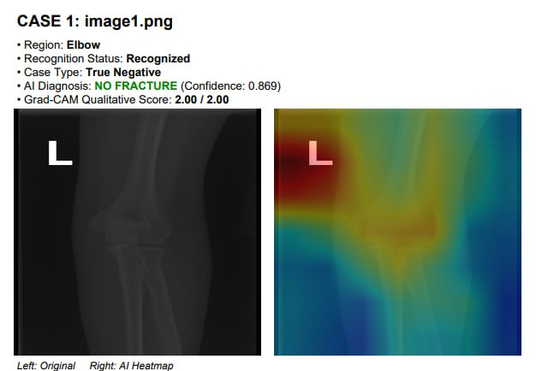 | 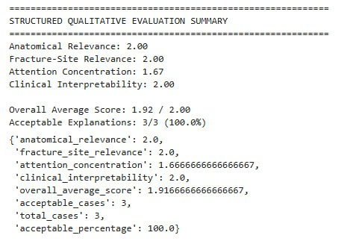

(a): Original Elbow X-ray and Grad-CAM Heatmap (b): Structured Qualitative Evaluation Summary
Figure 17: Grad-CAM Visualization and Structured Evaluation for Elbow Fracture Detection (True Negative Case)

These findings demonstrate that the model not only produces accurate predictions but also generates meaningful and clinically interpretable attention maps. The concentration of activation around the elbow joint region suggests that the model relies on anatomically relevant features rather than background artifacts, thereby increasing confidence in its decision-making process.
Figure 18 illustrates a representative true positive case from the elbow fracture detection system. In Figure 18(a), the original elbow radiograph is shown alongside the corresponding Grad-CAM heatmap. The model correctly detected the presence of a fracture with a confidence score of 0.726. The Grad-CAM visualization demonstrates strong activation concentrated around the fracture region, indicating that the model focuses on anatomically relevant areas associated with the detected abnormality. Figure 18(b) presents the structured qualitative evaluation of the Grad-CAM output. The heatmap achieved scores of 1.5 for both anatomical relevance and fracture-site relevance, and 2.0 for attention concentration and clinical interpretability, resulting in an overall average score of 1.75 out of 2.0. Additionally, all evaluated cases were classified as acceptable (100%), reflecting consistent and meaningful visual explanations. These findings indicate that the model can localize fracture-relevant regions within elbow radiographs. However, the slightly lower scores in anatomical and fracture-site relevance suggest that some attention extends beyond the exact fracture boundaries. Despite this, the strong attention concentration and high interpretability demonstrate that the model effectively captures key diagnostic features required for fracture detection, supporting the reliability of its decision-making process and its suitability as an assistive diagnostic tool.

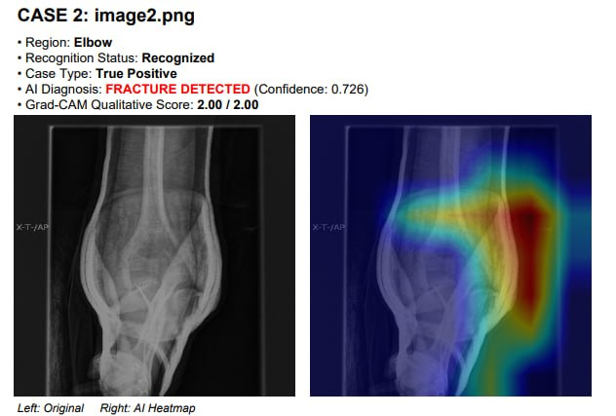 | 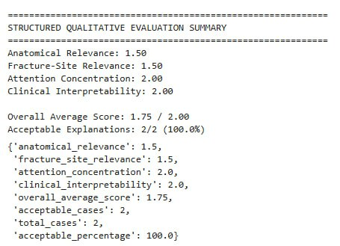
(a): Original Elbow X-ray and Grad-CAM Heatmap (b): Structured Qualitative Evaluation Summary
Figure 18: Grad-CAM Visualization and Structured Evaluation for Elbow Fracture Detection (True Positive Case)

The proposed scoring framework was designed to provide a structured and consistent approach for evaluating Grad-CAM visualizations across different cases. The criteria, including anatomical relevance, fracture-site relevance, attention concentration, and clinical interpretability, were selected based on commonly used qualitative assessment dimensions in medical image analysis and explainable AI studies. Each criterion was scored on a scale from 0 to 2 to capture varying degrees of alignment between the model’s attention and clinically meaningful regions. This simplified scale was chosen to reduce ambiguity and maintain consistency across evaluations, while still allowing differentiation between poor, moderate, and strong alignment. It should be noted that the scoring process was conducted as a systematic qualitative assessment rather than a clinically validated evaluation. The primary objective was to provide a comparative interpretation of model behaviour across different cases rather than to establish definitive clinical accuracy of the explanations.

Interpretation of Grad-CAM Results
The Grad-CAM visualizations show that the proposed ResNet-101 model consistently concentrates on the elbow region during prediction. In fracture cases, the heatmaps typically emphasize areas associated with bone discontinuities or abnormal structural patterns around the joint, while in normal cases, the model highlights relevant anatomical structures, indicating a systematic evaluation before confirming the absence of a fracture. This behaviour suggests that the model relies on meaningful anatomical features rather than irrelevant image artifacts.
The structured qualitative evaluation further reinforces these findings. Higher interpretability scores were observed in normal cases, where the model’s attention aligned more consistently with anatomical structures. In fracture cases, however, there was greater variability in localization, reflected by slightly lower scores in anatomical relevance and fracture-site relevance. This indicates that, although the model can identify fracture-related regions, its ability to precisely localize fracture sites is not consistently accurate across all samples. Overall, the Grad-CAM analysis confirms that the model provides meaningful and clinically relevant visual explanations for elbow fracture detection. Nevertheless, the variability in fracture localization highlights a key limitation, suggesting that the system is more appropriate as an assistive diagnostic tool to support clinical decision-making rather than a fully autonomous solution. While the structured evaluation provides useful insights into model behaviour, the assessment remains partially subjective, as it is not based on expert radiologist validation or inter-rater agreement. Therefore, the results should be interpreted as indicative rather than definitive.

Automated Clinical Reporting
In addition to prediction and explainability, the proposed system integrates an automated clinical-style reporting module. After the inference stage, the system compiles the original elbow X-ray image, the corresponding Grad-CAM heatmap, the predicted class label, and the confidence score into a structured PDF report. Each report includes essential diagnostic details such as the detection result (fracture or normal), the model’s prediction, and the associated visual explanation. This organized format is intended to enhance interpretability and support efficient review by clinicians and researchers. While this feature improves the system’s usability and practical value, it is designed to function as a decision-support tool rather than a substitute for professional clinical expertise. The generated reports provide a clear and structured summary of the model’s outputs and visual explanations, facilitating easier interpretation, validation, and further clinical assessment.

V. CONCLUSION
This study proposed an explainable deep learning framework for automated elbow fracture detection using the ResNet-101 architecture and the MURA dataset. The results demonstrated that models trained on raw, imbalanced datasets tend to be biased toward the majority normal class, leading to poor fracture detection performance. However, the application of dataset balancing techniques, including targeted data augmentation and class weighting, significantly enhanced the model’s ability to detect fractures. Furthermore, Bayesian hyperparameter optimization improved model convergence and overall prediction stability, resulting in better classification performance. In addition to predictive accuracy, Grad-CAM was integrated to provide visual explanations of the model’s decisions. The generated heatmaps confirmed that the model consistently focused on clinically relevant anatomical regions within the elbow, thereby improving interpretability and increasing confidence in the system. Moreover, the framework incorporates an automated clinical-style reporting module that generates structured PDF reports containing predictions, confidence scores, and corresponding Grad-CAM visualizations, facilitating easier interpretation and analysis. Overall, the findings indicate that the proposed explainable ResNet-101 model provides effective and interpretable elbow fracture detection. However, the system is intended to serve as an assistive diagnostic tool rather than a fully autonomous solution, supporting clinical decision-making while requiring further validation for practical real-world deployment. Based on the findings and observations from this study, this study recommends enhancing the elbow fracture detection model through the incorporation of larger and more diverse datasets, multi-view radiograph analysis, integration with hospital radiology systems, and further exploration of explainable AI techniques, incorporate expert validation and inter-rater agreement analysis to strengthen the reliability and clinical relevance of Grad-CAM-based interpretability assessment. These improvements are expected to strengthen model performance, generalization capability, and practical usability in medical imaging applications.

REFERENCES
[1] L. Alzubaidi et al., “Comprehensive review of deep learning in orthopaedics: Applications, challenges, trustworthiness, and fusion,” Artificial Intelligence in Medicine, vol. 155, p. 102935, 2024.
[2] T. H. H. Aldhyani, F. W. Alsaade, and A. M. Alsaadi, “Diagnosis and detection of bone fracture in radiographic images using deep learning approaches,” Frontiers in Medicine, vol. 11, p. 1506686, 2025.
[3] A. Bhatnagar et al., “A review on the use of artificial intelligence in fracture detection,” Cureus, 2024.
[4] S. Gitto et al., “AI applications in musculoskeletal imaging: A narrative review,” European Radiology Experimental, vol. 8, no. 1, p. 22, 2024.
[5] T. Meena and S. Roy, “Bone fracture detection using deep supervised learning from radiological images: A paradigm shift,” Diagnostics, vol. 12, no. 10, p. 2420, 2022.
[6] M. E. Sahin, “Image processing and machine learning-based bone fracture detection and classification using X-ray images,” International Journal of Imaging Systems and Technology, vol. 33, no. 3, pp. 853–865, 2023.
[7] I. Kandel, M. Castelli, and A. Popovič, “Musculoskeletal images classification for detection of fractures using transfer learning,” Journal of Imaging, vol. 6, no. 11, p. 127, 2020.
[8] I. Kandel, M. Castelli, and A. Popovič, “Comparing stacking ensemble techniques to improve musculoskeletal fracture image classification,” Journal of Imaging, vol. 7, no. 6, p. 100, 2021.
[9] A. Alam et al., “Novel transfer learning based bone fracture detection using radiographic images,” BMC Medical Imaging, vol. 25, no. 1, p. 5, 2025.
[10] Y. Gencer and O. Erdem, “A review on image-based medical diagnosis using ResNet-50 architecture,” International Journal of Research and Analytical Reviews, vol. 10, no. 4, pp. 421–430, 2023.
[11] M. M. Islam et al., “A survey of explainable artificial intelligence in healthcare: Concepts, methods, and future directions,” Applied Soft Computing, vol. 152, p. 110019, 2024.
[12] E. Tjoa and C. Guan, “Self-explainable AI for medical image analysis: A survey and new perspectives,” arXiv preprint, 2024.
[13] K. Ghosh et al., “The class imbalance problem in deep learning,” Machine Learning, vol. 113, no. 7, pp. 4845–4901, 2024.
[14] Y. Sun, A. K. C. Wong, and M. S. Kamel, “Classification of imbalanced data: A review,” International Journal of Pattern Recognition and Artificial Intelligence, vol. 35, no. 3, p. 2150011, 2021.
[15] H. Guan et al., “Federated learning for medical image analysis: A survey,” Pattern Recognition, vol. 150, p. 110424, 2024.
[16] T. Yang et al., “When federated learning meets medical image analysis: A systematic review with challenges and solutions,” APSIPA Transactions on Signal and Information Processing, vol. 13, p. e38, 2024.

