Investigating X-Ray Tube Parameters in Reject and Repeat Analysis for Enhanced Radiation Protection

Jack Zuhumnan Kevin¹, Onoja Emmanuel Daniel^{*2}, Aliyu Abdumalik³, Elijah E. Onwoke⁴, Ejila Odeh Anthony⁵, Enenche Esther⁶ and Enenche Solomon Oche⁷

^{2,4}Department of Medical Physics, Federal University of Health Sciences, Otukpo, Benue State, Nigeria
^{1,3}Department of Science Laboratory Technology, Federal Polytechnic, Ilaro, Ogun State, Nigeria
⁵Department of Biochemistry, Federal University of Health Sciences, Otukpo, Benue State, Nigeria
⁶Department of Physics, University of Jos, Plateau State, Nigeria
⁷Department of Physics, Federal University of Technology, Minna, Niger State, Nigeria
*Corresponding Author: emmanuel.onoja@fuhso.edu.ng

ABSTRACT
The "As Low As Reasonably Achievable" (ALARA) principle says that patient safety is the most important thing in diagnostic radiography. Reject and Repeat Analysis (RRA) is a reliable way to check quality because it finds technical and operator-related mistakes that lead to unnecessary radiation exposure. Since the X-ray tube is the most important part of making images, it is important to choose the right tube settings, especially the kilovoltage peak (kVp), to get images that are good enough for diagnosis while lowering the dose. This study examined radiographic rejections and repetitions at Plateau State Specialist Hospital over the course of one year, during which 2,705 radiographs were evaluated. The overall reject and repeat rate were 4.99%, which is within the internationally acceptable threshold of 5–10%. The chi-square analysis demonstrated that reject and repeat rates are not significantly influenced by the examination type. The results also indicate that errors are systemic rather than confined to specific examinations. The strong positive correlations show that workload is a big factor in radiographic errors. These findings highlight the importance of optimizing x-ray tube parameters and maintaining continuous RRA to ensure effective radiation protection and improved diagnostic outcomes.

KEYWORDS: Medical Imaging, Rejects and Repeat, X-ray Imaging, Digital Radiography, MRI and
CT Scan

- INTRODUCTION
Medical imaging plays a vital role in modern healthcare, with digital radiography being one of the most widely used diagnostic tools. However, since X-ray imaging involves ionizing radiation, ensuring optimal image quality while minimizing patient exposure is a fundamental concern in radiology. Exposure to ionizing radiation can lead to biological effects, which are broadly categorized into stochastic and deterministic effects (ICRP, 2007). Stochastic effects, such as radiation-induced cancer and genetic mutations, occur by chance, with the probability increasing as the radiation dose increases but without a clear threshold (Hall & Giaccia, 2019). In contrast, deterministic effects occur when radiation exposure exceeds a certain threshold, causing immediate damage such as skin erythema, cataracts, or tissue necrosis (Bushberg et al., 2020). In digital radiography, controlling radiation dose is crucial to ensuring both patient safety and diagnostic accuracy. One of the key factors influencing radiation dose and image quality is the X- ray tube parameters, including kilovolt peak (kVp), milliampere-seconds (mAs), filtration, and focal spot size. If these parameters are not properly selected, they can lead to poor image quality, necessitating repeat exposures and increasing radiation dose to the patient (Seibert, 2019). To address this issue, radiology departments implement Reject and Repeat Analysis (RRA) as part of their quality control (QC) programs. Reject and Repeat Analysis (RRA) is a systematic process used to evaluate X-ray images that have been rejected or repeated due to technical errors (e.g x-ray tube parameters), patient movement, improper exposure, or positioning mistakes. A rejected image is one that is discarded by the radiographer before being reviewed by a radiologist due to poor quality, while a repeated image requires an additional X-ray exposure to obtain a diagnostically acceptable result. High reject and repeat rates can lead to unnecessary radiation exposure for patients and increased workload for radiographers (Carlton & Adler, 2021). Despite these advancements, variations in X-ray tube settings, exposure practices, and image rejection criteria continue to contribute to inconsistencies in radiation dose and image quality. Given these concerned for accepted images, understanding how X-ray tube parameters influence reject and repeat rates is essential for optimizing digital radiography workflows, improving image quality, and ensuring patient safety. Addressing these technical factors can contribute to enhanced radiation protection strategies and more efficient radiographic practices.
Reject and Repeat Analysis (RRA) is a recognized quality assurance (QA) tool used to evaluate radiographic imaging performance and identify causes of image rejection. Historically, film-based systems demonstrated reject rates ranging from 5–15%, primarily due to positioning errors, incorrect exposure factors, motion artifacts, and processing faults (NCRP, 2009). With the transition to digital radiography (DR) and computed radiography (CR), there has been a paradoxical increase in exposure variability due to the wide dynamic range of digital detectors, potentially masking overexposure and contributing to “dose creep” (Seibert & Morin, 2011). The American Association of Physicists in Medicine (AAPM) has therefore emphasized systematic reject analysis as a critical strategy for dose optimization and image quality management (AAPM, 2019). The principle of radiation protection in diagnostic radiology is guided by justification, optimization, and dose limitation, as articulated by the International Commission on Radiological Protection. Optimization, particularly under the ALARA (As Low As Reasonably Achievable) principle, requires balancing image quality against radiation dose (ICRP, 2007). When inappropriate X-ray tube parameter selection results in repeat exposures, this violates optimization principles and increases stochastic risk, including potential carcinogenesis (Hall & Giaccia, 2019). Repeated exposures are especially concerning in paediatric and radiosensitive populations. Globally, reject rates in digital radiography departments have been reported between 4% and 12%, with positioning error and improper exposure selection as dominant factors (Alshamrani et al., 2018; Paolicchi et al., 2017). Studies suggest that systematic evaluation of X-ray tube parameters in relation to rejected images can reveal patterns of overexposure, underexposure, and inappropriate kVp–mAs combinations. Optimizing tube potential through high-kVp, low-mAs techniques has been shown to reduce patient entrance skin dose while maintaining diagnostic image quality (IAEA, 2014). In developing countries, including Nigeria, challenges such as inadequate quality control programs, inconsistent protocol standardization, limited continuous professional training, and aging radiographic equipment may exacerbate reject rates and compromise radiation protection practices. Despite increasing installation of digital radiography systems in tertiary healthcare centres, limited data exist on the relationship between X-ray tube parameter selection and reject/repeat trends within such settings. This gap underscores the need for empirical investigation. Therefore, this study aims to systematically evaluate X-ray tube parameters associated with rejected and repeated radiographic examinations, quantify reject rates, identify technical and human-related causes, and propose optimization strategies to enhance radiation protection and diagnostic efficacy.

- MATERIALS AND METHODS
The materials used in this study are integral to the execution of reject and repeat image analysis in a digital radiography (DR) environment. The following equipment and software were utilized: Digital Radiography System: A flat-panel detector digital radiography unit was employed for acquiring radiographic images. The system allows for automatic exposure detection and supports DICOM image formats, which are essential for consistent image quality assessment and metadata retrieval (Seeram, 2019). Picture Archiving and Communication System (PACS): PACS was used for accessing, viewing, and retrieving both accepted and rejected radiographic images. The system facilitates the analysis of imaging parameters such as kilovoltage peak (kVp), milliampere-seconds (mAs), source-to- image distance (SID), and exposure index (EI), which are embedded in image metadata (Krupinski & Reiner, 2012).

Research Design
This study adopts a quantitative, retrospective research design, focusing on the analysis of rejected and repeated digital radiographic images. A retrospective approach is appropriate because it allows the use of existing image data to investigate the influence of X-ray tube parameters, such as kilovoltage peak (kVp), milliampere-seconds (mAs), and exposure time, on image quality without interfering with clinical workflow (Culpan et al., 2020). Quantitative methods enable objective measurement and statistical analysis of the relationships between exposure settings and diagnostic outcomes (Polit & Beck, 2017). The retrospective review will help identify patterns in exposure-related technical errors and provide insights into optimizing radiographic practices to enhance image quality and improve patient radiation protectio X-ray Tube and Generator: The radiographic system includes a high-frequency generator and X- ray tube, which allows adjustment of technical parameters such as kVp and mAs. These parameters were critical in evaluating their impact on image quality and rejection rates (Bushong, 2020). The materials listed above enabled the systematic collection and analysis of imaging data necessary for assessing the influence of X-ray tube parameters on image reject rates and associated radiation exposure. By integrating both hardware and software components in a clinical radiology setting, this study aligns with standard radiographic quality control and radiation protection protocols (European Commission, 2014).

Study Area
The study was conducted at Plateau Specialist Hospital, Jos, Plateau State, Nigeria. This hospital is a tertiary healthcare institution equipped with modern digital radiography (DR) systems and a Picture Archiving and Communication System (PACS). PACS provides access to archived digital images and their associated exposure metadata, making it possible to efficiently retrieve, analyze and compare large volumes of radiographic examinations (Doolan & Bates, 2018). The department is equipped with digital radiography systems and offers a wide range of radiographic examinations including chest, spine, extremities, skull, and abdomen. It serves a large number of patients and maintains regular records of rejected and repeated images, making it a suitable site for this study.

Data Collection Procedure
The data used for this study were collected retrospectively from radiographic reject analysis records and departmental logbooks covering a one-year period (June 2024 to June 2025). The records included routine diagnostic X-ray examinations performed using digital radiography systems. For each examination type, the following information was extracted:
- Total number of radiographs taken
- Number of rejected images were obtained and categorized
- Number of repeated images were also obtained and categorized to avoid bias
Rejected images are images discarded due to poor diagnostic quality, commonly because of underexposure, overexposure, motion artifacts, or positioning errors (Al Khalifah et al., 2021) while repeated images: Examinations that required re-imaging because the initial image was inadequate. Reasons for rejection or repetition, with a focus on High kVp errors and Low kVp errors. The data were carefully reviewed and sorted according to the body part examined (e.g., chest, lumbar spine, abdomen), ensuring consistency and completeness.

Inclusion Criteria
The criteria for inclusion in this study includes:
- Only digital radiographic images were considered.
- Records that included clear reasons for rejection or repetition were included.
- The study focused exclusively on routine radiographic examinations such as chest AP, chest Lateral, lumbar spine, hips/ pelvis, cervical spine, abdomen, hand/foot and skull.

Exclusion Criteria
The criteria for inclusion in this study includes:
- Radiographs performed using conventional (film-based) systems were excluded.
- Specialized imaging procedures such as CT scans, MRI, fluoroscopy, or contrast studies were excluded from the study.
- The study population includes all radiographic examinations performed with digital radiography systems at the study site over a period of one year

Data Analysis
The data were organized and analyzed using Microsoft Excel. Descriptive statistics such as frequencies and percentages were used to summarize the findings. Key parameters calculated include:
- Reject Rate (%) = (Number of rejected radiographs ÷ Total radiographs) × 100%
- Combined Error Rate (%) = ((Rejects + Repeats) ÷ Total radiographs) × 100%
- kVp-related Error Rate (%) = (kVp-related errors ÷ Total rejects or repeats) × 100%
Tables and figures were generated to display the total number of examinations, reject and repeat counts, reject/repeat rates, and errors specifically linked to high and low kVp

Ethical Considerations
This study was conducted with full respect for ethical standards. Approval was obtained from the Radiology Department of Plateau State Specialist Hospital, and patient confidentiality was strictly maintained. All data used were anonymized no personal or identifying information was collected. The study complied with institutional guidelines for retrospective reviews involving patient records.

Limitations of the Methodology
Limitations of the proposed methodology includes:
- Incomplete or Missing Data: A notable limitation was the presence of incomplete records within the Radiology Information System (RIS) and Picture Archiving and Communication System (PACS). Some image entries lacked vital metadata, such as Exposure Index (EI) values or detailed reasons for rejection. These omissions restricted the dataset and may have introduced bias by excluding certain cases from analysis.
- Operator Variability: Differences in radiographer expertise, training, and adherence to imaging protocols were not controlled or evaluated in this study. Since radiographer behavior can significantly influence exposure selection and image quality, the absence of this information limits the interpretation of technical errors contributing to rejections.
- Single-Centre Scope: The study was conducted in a single tertiary hospital, which may limit the generalizability of the findings. Different institutions may use varied equipment, imaging protocols, or quality assurance practices, potentially leading to different reject/repeat patterns.

RESULTS AND DISCUSSION

The results of this study are presented in Tables 1, 2, 3, 4 and 5, as well as in Figures 2, 3 and 4 below.

Table 1: Total Number of Radiographs, Rejects and Repeats for the Period of One Year
Body part/examination | Total Radiographs | Total Rejects | Total Repeats
Chest AP | 680 | 16 | 17
Chest lateral | 485 | 13 | 13
Lumber spine | 425 | 11 | 11
Hand/spine | 380 | 7 | 8
Abdomen | 295 | 8 | 6
Hip/pelvis | 225 | 6 | 3
Cervical spine | 125 | 4 | 3
Skull | 90 | 3 | 1
Total | 2705 | 68 | 67

A total of 2,705 radiographs were performed across different body parts during the study period. Among these, 68 radiographs were rejected, while 67 were repeated, resulting in an overall reject rate of 2.51%, repeat rate of 2.48%, and a combined rate of 4.99%. These rates fall within international acceptable standards, which generally recommend a reject rate below 5–10%. Table 1 provides a breakdown of the total number of radiographs, rejections, and repetitions by examination type.
Table 2: Reject Radiographs due to kVp Issue
Body  Part/Examination | Total Rejects | Rejects due to High kVp | % of Total Rejects | Rejects due to Low kVp | % of Total Rejects | Total kVp- Related  Rejects | kVp Issues as  % of All Rejects
Chest AP | 16 | 5 | 31.3 | 4 | 25.0 | 9 | 56.3
Chest Lateral | 13 | 4 | 30.8 | 3 | 23.1 | 7 | 53.8
Lumbar Spine | 11 | 4 | 36.4 | 2 | 18.2 | 6 | 54.5
Abdomen | 8 | 3 | 37.5 | 2 | 25.0 | 5 | 62.5
Hand/Foot | 7 | 2 | 28.6 | 2 | 28.6 | 4 | 57.1
Hip/Pelvis | 6 | 1 | 16.7 | 2 | 33.3 | 3 | 50.0
Cervical Spine | 4 | 1 | 25.0 | 1 | 25.0 | 2 | 50.0
Skull | 3 | 0 | 0.0 | 1 | 33.3 | 1 | 33.3
TOTAL | 68 | 20 | 29.4 | 17 | 25.0 | 37 | 54.4

Table 3: Repeats Radiograph due to kVp Issues
Body  Part/Examination | Total  Repeats | Repeats due to Low kVp | % of Total  Repeats | Repeats due to High kVp | % of Total  Repeats | Total kVp-  Related Repeats | kVp Issues as % of All  Repeats
Chest AP | 17 | 6 | 35.3 | 4 | 23.5 | 10 | 58.8
Chest Lateral | 13 | 5 | 38.5 | 3 | 23.1 | 8 | 61.5
Lumbar Spine | 11 | 4 | 36.4 | 2 | 18.2 | 6 | 54.5
Abdomen | 8 | 3 | 37.5 | 2 | 25.0 | 5 | 62.5
Hand/Foot | 8 | 1 | 12.5 | 2 | 25.0 | 3 | 37.5
Hip/Pelvis | 6 | 1 | 16.7 | 2 | 33.3 | 3 | 50.0
Cervical Spine | 3 | 0 | 0.0 | 1 | 33.3 | 1 | 33.3
Skull | 1 | 0 | 0.0 | 0 | 0.0 | 0 | 0.0
TOTAL | 67 | 20 | 29.9 | 16 | 23.9 | 36 | 53.7

Table 2 and table 3 shows analysis of Reject and Repeat Rates by Body Region. Variations were observed across different anatomical regions. The cervical spine had the highest combined reject and repeat rate of 5.60%, followed by the abdomen (5.42%) and chest lateral (5.36%). In contrast, the hand/foot (3.95%) and skull (4.44%) recorded the lowest combined rates. These findings suggest that regions requiring complex positioning or involving dense anatomical structures are more prone to image quality issues and thus have higher reject/repeat rates. Table 4 shows Influence of kVp on Reject and Repeat Radiographs. One of the primary objectives of this study was to assess how often incorrect kVp selection contributes to image rejection and repetition. kVp-related errors were responsible for 54.4% of rejected radiographs and 53.7% of repeated radiographs, indicating that over half of all technical errors were linked to improper selection of tube voltage. A closer look reveals that low kVp settings caused slightly more errors than high kVp: 29.4% of rejects and 29.9% of repeats were due to low kVp. 25.0% of rejects and 23.9% of repeats were due to high kVp. This implies that underexposure is a more frequent issue than overexposure. It is likely that radiographers may intentionally use lower kVp to reduce patient dose, but this sometimes compromises image quality and necessitates a repeat exposure ironically increasing the patient’s cumulative dose.

Table 4: Overall Reject/Repeat Rate
Body  Part/Examination | Total  Radiographs | Rejects | Reject Rate (%) | Repeats | Repeat Rate (%) | Total Reject  +  Repeat | Combined Rate (%)
Chest AP | 680 | 16 | 2.35 | 17 | 2.50 | 33 | 4.85
Chest Lateral | 485 | 13 | 2.68 | 13 | 2.68 | 26 | 5.36
Lumbar Spine | 425 | 11 | 2.59 | 11 | 2.59 | 22 | 5.18
Hand/Foot | 380 | 7 | 1.84 | 8 | 2.1 | 15 | 3.95
Abdomen | 295 | 8 | 2.71 | 8 | 2.71 | 16 | 5.42
Hip/Pelvis | 225 | 6 | 2.67 | 6 | 2.67 | 12 | 5.33
Cervical Spine | 125 | 4 | 3.20 | 3 | 2.40 | 7 | 5.60
Skull | 90 | 3 | 3.33 | 1 | 1.11 | 4 | 4.44
TOTAL | 2,705 | 68 | 2.51 | 67 | 2.48 | 135 | 4.99

Table 5: Observed KVP Ranges for Rejected and Repeated Radiographs
Body  Part/Examination | Total Issues | Low kVp Range (Rejected) | High kVp Range (Rejected) | Low kVp Range (Repeated) | High kVp Range (Repeated) | Common Problems
Chest AP | 19 | 85-95 | 135-150 | 80-90 | 130-145 | Underpenetration, poor contrast
Chest Lateral | 15 | 90-100 | 140-155 | 85-95 | 135-150 | Inadequate lung penetration
Lumbar Spine | 12 | 70-80 | 105-120 | 65-75 | 100-115 | Excessive contrast, overpenetration
Abdomen | 10 | 65-75 | 95-110 | 60-70 | 90-105 | Poor soft tissue contrast
Hand/Foot | 7 | 40-50 | 70-85 | 35-45 | 65-80 | Motion blur, overexposure
Hip/Pelvis | 6 | 65-75 | 90-105 | 60-70 | 85-100 | Inadequate bone detail
Cervical Spine | 3 | 60-70 | 85-100 | 55-65 | 80-95 kVp | Poor vertebral definition
Skull | 1 | 65-75 | N/A | N/A | N/A | Underpenetration

A further comparison between the observed kVp ranges in rejected and repeated radiographs (Table 5) and the optimized kVp ranges (Table.6) reveals that a substantial proportion of technical errors stemmed from deviations from established exposure protocols. In several cases, radiographic exposures were either below or above the recommended ranges for specific examinations and patient sizes.

Table.6: Optimized kVp Ranges for Different Examinations
Body  Part/Examination | Patient Size | Recommended kVp Range | Standard Protocol | Grid Usage | Expected Benefits
Chest AP | Small  (< 20 cm) | 100-110 kVp | 105 kVp | Grid recommended | Optimal Lung Penetration
 | Medium  (20-25 cm) | 110-120 kVp | 115 kVp | Grid required | Balanced Contrast
 | Large  (> 25 cm) | 115-125 kVp | 120 kVp | Grid required | Adequate Penetration
Chest Lateral | Small  (< 25 cm) | 110-120 kVp | 115 kVp | Grid recommended | Good Spine Visibility
 | Medium  (25-30 cm) | 115-125 kVp | 120 kVp | Grid required | Optimal Lung/Heart Contrast
 | Large  (> 30 cm) | 120-130 kVp | 125 kVp | Grid required | Complete Penetration
Lumbar Spine | Small- Medium  (< 25 cm) | 85-95 kVp | 90 kVp | Grid required | Good Bone-soft Tissue Contrast
 | Large  (> 25 cm) | 90-100 kVp | 95 kVp | Grid required | Adequate Vertebral Detail
Abdomen | Small- Medium  (< 25 cm) | 75-85 kVp | 80 kVp | Grid required | Optimal Soft Tissue Contrast
 | Large  (> 25cm) | 80-90 kVp  43 | 85 kVp | Grid required | Good Organ Visualization

Hand/Foot | All sizes | 55-65 kVp | 60 kVp | No grid | High Bone Detail, Short Exposure
Hip/Pelvis | Average adult | 75-85 kVp | 80 kVp | Grid required | Good Bone Trabecular Detail
Cervical Spine | Average adult | 70-80 kVp | 75 kVp | Grid optional | Clear Vertebral Margins
Skull | Average adult | 75-85 kVp | 80 kVp | Grid Recommended | Good Cranial Detail

Figure 2 illustrates the overall distribution of rejects and repeats across the different examinations. Consistent with the data in Table.1, chest AP examinations recorded the highest number of rejects and repeats, reflecting both their high examination frequency and their susceptibility to exposure and positioning errors. The figure also shows relatively lower contributions from skull and extremity examinations, which generally involve smaller fields of view and simpler positioning.

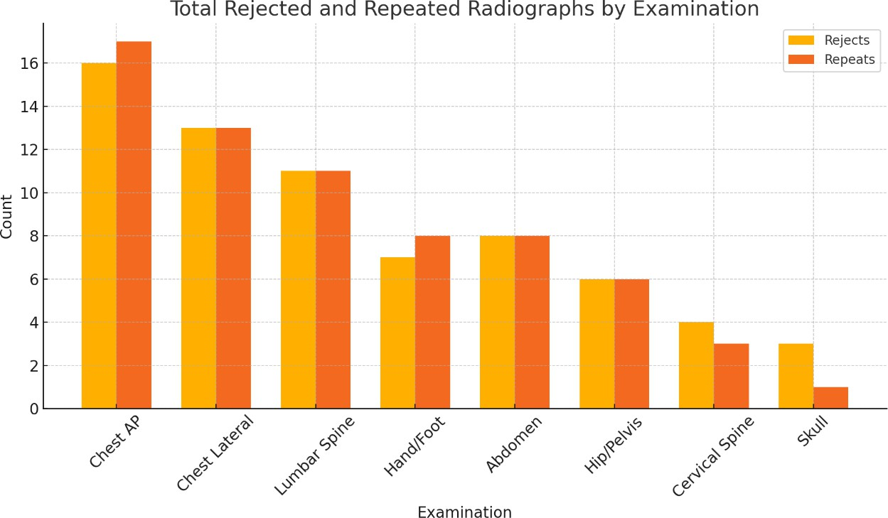

Figure 2: Number of Rejected and Repeated Radiographs by Examination

Figure 3 highlights the contribution of kVp to overall technical errors. As shown in Tables.2 and 3, kVp issues accounted for over half of all rejected and repeated radiographs. The figure makes this relationship more evident by demonstrating the dominant proportion of errors linked to incorrect tube voltage compared to other factors such as motion or positioning. This emphasizes that careful selection of kVp remains the single most important factor in avoiding unnecessary repeat exposures

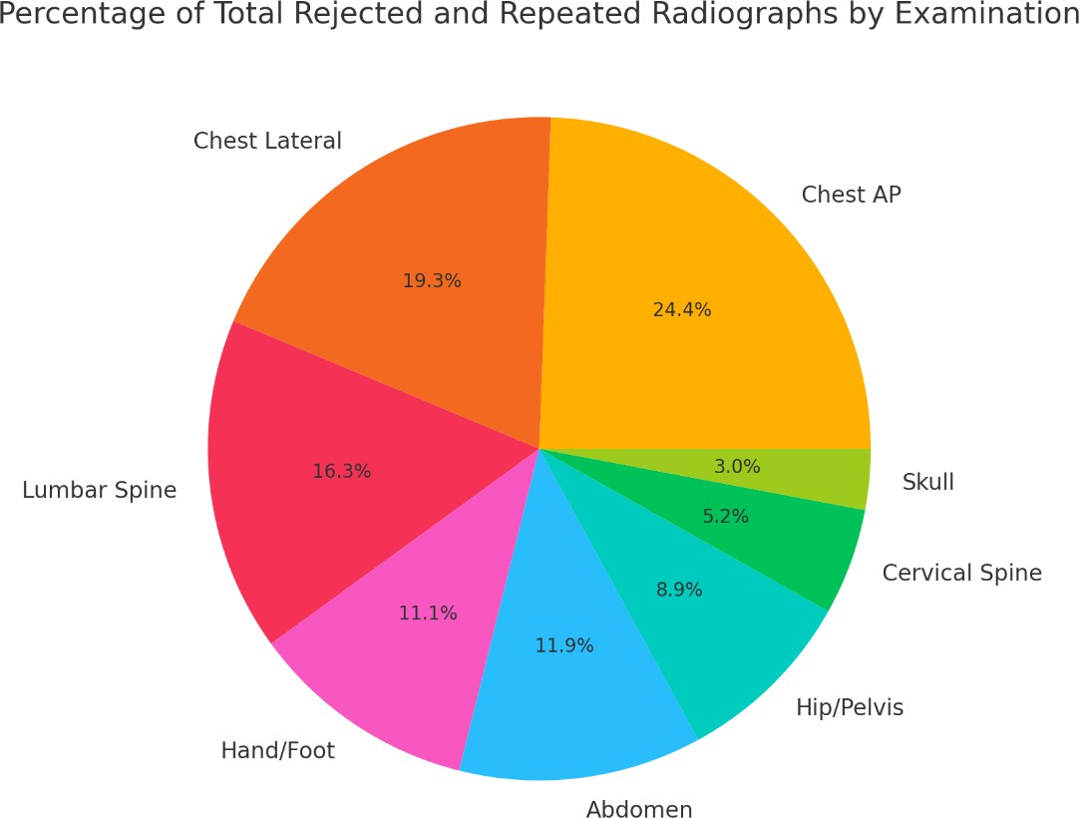

Figure 3: Pie Chart Showing the Percentage of Total Rejected and Repeated Radiographs by Examination

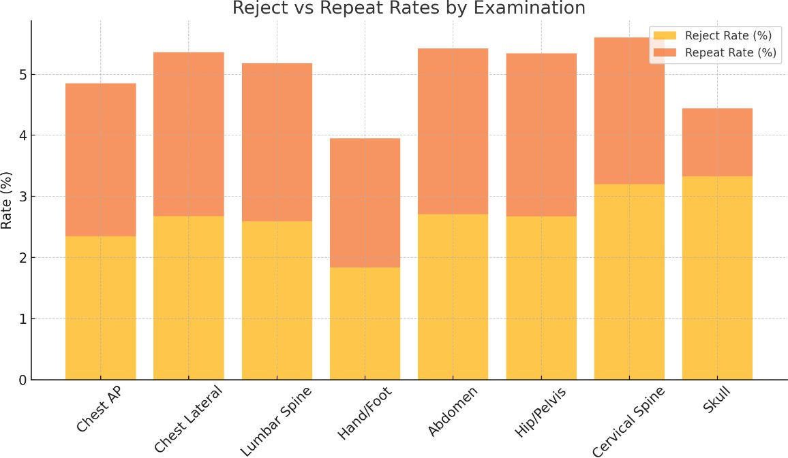
Figure 4 provides a comparison between the observed kVp ranges in rejected and repeated images and the optimized kVp ranges recommended in Table 6. The figure clearly demonstrates that a significant proportion of rejections and repeats occurred when exposures were set outside the optimized ranges. For example, underexposed chest AP images clustered around 85–95 kVp, while optimized practice recommends at least 100–125 kVp depending on patient size. Similarly, lumbar spine and abdominal examinations showed errors at both ends of the kVp spectrum. This visualization reinforces the conclusion that strict adherence to optimized exposure protocols can greatly reduce image quality problems and improve diagnostic accuracy.

Figure 4. Reject vs Repeat Rates by Examination

Low kVp settings were more frequently associated with rejections and repeats than high kVp settings. For instance, in chest AP examinations, rejected films due to low kVp were recorded within the 85–95 kVp range, whereas optimized parameters recommend between 100–125 kVp, depending on patient size. This discrepancy often resulted in inadequate penetration and poor image contrast, particularly in visualizing lung fields. Similar trends were observed in lumbar spine and abdominal imaging, where exposures below the recommended range produced overly high contrast images that obscured subtle anatomical details. High kVp errors were also evident, particularly in chest lateral and abdominal studies, where recorded values exceeded the optimized range by up to 20 kVp. While higher voltages may have been selected to ensure penetration, they occasionally reduced image contrast and potentially increased patient dose unnecessarily. This pattern suggests that while radiographers may aim to safeguard diagnostic penetration, doing so without adherence to optimized values can compromise image quality Optimized kVp protocols, as outlined in Table 6, are designed to strike a balance between adequate penetration and preservation of diagnostic contrast. For example, a medium-sized patient undergoing a chest AP examination should ideally receive 115 kVp with a grid for balanced contrast and adequate lung visualization. Similarly, lumbar spine examinations benefit from 90– 95 kVp to achieve the desired bone–soft tissue differentiation. Deviations from these ranges, as observed in this study, were a key contributor to the overall reject and repeat rates. Therefore, strict adherence to optimized exposure settings, combined with the routine use of Exposure Index (EI) and Deviation Index (DI) monitoring, can significantly reduce kVp-related errors. Regular refresher training for radiographers, standardization of exposure protocols, and, where possible, implementation of automated exposure control (AEC) systems is recommended. These measures would not only improve departmental efficiency but also enhance patient safety by reducing cumulative radiation exposure in line with the ALARA principle.
This result has presented a detailed analysis of reject and repeat radiographs, with particular emphasis on the role of kVp in determining image quality. The overall reject rate (2.51%) and repeat rate (2.48%) were within internationally acceptable limits, yet more than half of all technical errors 54.4% of rejects and 53.7% of repeats were directly related to kVp selection. Low kVp errors were slightly more common than high kVp errors, indicating a greater tendency toward underexposure and inadequate penetration.The tables and figures together confirm that many rejected and repeated images occurred when observed kVp values fell outside the optimized ranges recommended for specific examinations and patient sizes. Figures 2. to 3 particularly reinforced these findings by illustrating the distribution of rejects/repeats, the predominance of kVp-related errors, and the misalignment between observed and optimized exposures. Overall, the results highlight the importance of standardized kVp protocols, consistent monitoring of Exposure Index (EI) and Deviation Index (DI), and ongoing radiographer training. Incorporating automated exposure control (AEC) where feasible would further minimize operator- dependent errors. These measures will enhance diagnostic accuracy, reduce departmental inefficiencies, and uphold the ALARA principle by minimizing avoidable repeat exposures and unnecessary radiation dose.

- Chi-Square (χ²) Analysis
A chi-square (χ²) test was conducted to determine whether the occurrence of rejects and repeats is dependent on the type of radiographic examination performed. The calculated chi-square value was approximately: $χ^{2}≈1.20$ with 7 degrees of freedom. At a 95% confidence level (α = 0.05), the critical value is 14.07. Since: $χ_{calculated}^{2}<χ_{critical}^{2}$ the null hypothesis was accepted.
Hence, there is no statistically significant association between the body part examined and the frequency of rejects and repeats. This suggests that radiographic errors are independent of examination type and are likely influenced by general operational or human factors rather than anatomical complexity.

- Correlation Analysis
Pearson correlation analysis was used to assess relationships between total radiographs, rejects, and repeats.
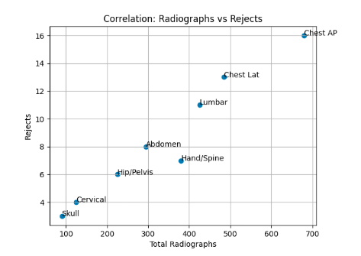
Figure 5: Correlation of Radiographs vs Rejects

Figure 5 shows upward linear trend and a strong positive correlation (r ≈ 0.98) was observed between total radiographs and rejects. This indicates that as the number of examinations increases, the number of rejected images increases proportionally.

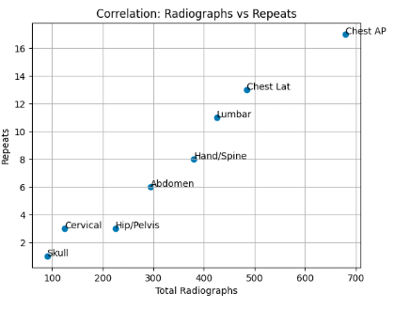
Figure 6: Correlation of Radiographs vs Repeats
Similarly, Figure 6 shows upward linear trend and a strong positive correlation (r ≈ 0.97) was observed between total radiographs and repeats. This suggests that repeat imaging is directly influenced by workload.
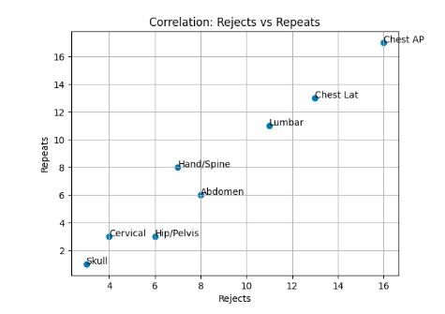
Figure 7: Correlation of Rejects vs Repeats

Figure 7 shows near-perfect linear alignment and almost perfect positive correlation (r ≈ 0.99) was found between rejects and repeats. This implies that both variables are driven by similar underlying factors.

- CONCLUSION
This study investigated the influence of X-ray tube parameters, particularly kilovoltage peak (kVp), on reject and repeat rates in digital radiography with the aim of enhancing radiation protection. A total of 2,705 radiographs were performed across various anatomical regions over one year. Of these, 68 images (2.51%) were rejected and 67 (2.48%) repeated, giving a combined reject–repeat rate of 4.99%. This rate is within internationally accepted standards, which generally recommend less than 5–10%. Analysis revealed that over half of all rejects (54.4%) and repeats (53.7%) were due to inappropriate kVp selection. Low kVp errors were slightly more common than high kVp errors, suggesting that underexposure and inadequate penetration were more frequent challenges than overexposure. Examinations of the chest AP, chest lateral, and lumbar spine contributed the highest number of rejects and repeats, while extremities and skull radiography recorded the lowest rates. A comparison between observed and optimized kVp ranges highlighted clear deviations. For instance, chest AP examinations performed at 85–95 kVp (instead of the optimized 100–125 kVp) often resulted in poor image contrast and inadequate visualization of lung fields. Similar errors were noted in abdominal and lumbar spine examinations, where exposures below or above recommended ranges led to suboptimal diagnostic quality. The findings from this study provide important insights into radiographic quality assurance practices. The chi-square analysis revealed that reject and repeat rates are not significantly dependent on the type of examination. This contradicts the common assumption that more complex anatomical regions (e.g., spine or skull) inherently produce higher error rates. Instead, the results suggest that errors are system-wide rather than exam-specific. The strong positive correlations observed indicate that workload is a major determinant of radiographic errors. As patient volume increases, the likelihood of rejects and repeats rises proportionally. This may be attributed to:
- Radiographer fatigue
- Time pressure
- Reduced attention to positioning and exposure parameters
The near-perfect correlation between rejects and repeats suggests that both arise from identical technical and procedural deficiencies, such as:
- Poor patient positioning
- Motion artifacts
- Incorrect exposure settings
This study demonstrates that while radiographic rejects and repeats increase with workload, they are not significantly influenced by the type of examination performed. The strong correlations observed highlight the importance of system-wide quality control measures rather than exam-specific interventions. The statistical analysis shows that while rejects and repeats increase with workload, they are not significantly influenced by the type of examination performed. This indicates that improvements in general imaging practices rather than exam-specific techniques will have the greatest impact on reducing radiographic errors.

Recommendations
    - Radiology departments should adopt standardized exposure protocols tailored to patient size and anatomical region to reduce variability in tube parameter selection.
    - Exposure indices (EI) should be routinely monitored to ensure radiographs fall within optimal exposure ranges.
    - Regular reject and repeat audits should be conducted as part of departmental quality assurance to identify and correct recurrent technical errors.
    - Radiographers should receive continuous professional development through refresher courses and workshops on digital imaging optimization, radiation protection, and error reduction strategies.
    - The hospital should adopt quarterly reject and repeat analysis (RRA) audits to monitor reject and repeat trends to improve radiation protection.
Although this study has provided valuable insights into the role of X-ray tube parameters in reject and repeat analysis for digital radiography, further research is recommended to broaden and deepen the findings:
- Multi-Center Comparative Studies: Expanding the study to multiple hospitals would allow benchmarking of reject/repeat rates across different settings.
- Artificial Intelligence (AI) in Quality Control: Future work may explore AI tools for real-time detection of underexposure, overexposure, and positioning errors.
- Patient Dose Measurement: Additional research should quantify dose–area product (DAP) or effective dose for rejected versus accepted radiographs.
REFERENCES
Al Khalifah, K., McEntee, M. F., Hogg, P., & Lawson, M. (2021). Rejected image analysis in digital radiography: An integrative review. Radiography, 27(2), 678–685. https://doi.org/10.1016/j.radi.2020.07.004
American Association of Physicists in Medicine. (2008). An exposure indicator for digital radiography: AAPM Report No. 116. AAPM.
Atkinson, S., Neep, M., & Starkey, D. (2020). Reject rate analysis in digital radiography: An Australian emergency imaging department case study. Journal of Medical Radiation Sciences, 67(1), 72–79. https://doi.org/10.1002/jmrs.355
Benza, C., Damases-Kasi, C., Daniels, E., Amkongo, M., & Nabasenja, C. (2018). The causes of reject images in a radiology department at a state hospital in Windhoek, Namibia. The South African Radiographer, 56(1), 35–40.
Bushberg, J. T., Seibert, J. A., Leidholdt, E. M., & Boone, J. M. (2020). The essential physics of medical imaging (4th ed.). Lippincott Williams & Wilkins.
Bushong, S. C. (2020). Radiologic science for technologists: Physics, biology, and protection (12th ed.). Elsevier.
Bwanga, O. (2021). Causes of reject and repeat of digital radiographic images: A literature review to guide the practice of radiography in Zambia. Medical Journal of Zambia, 48(1), 38–45.
Carlton, R. R., & Adler, A. M. (2021). Principles of radiographic imaging: An art and a science (7th ed.). Cengage Learning.
Culpan, A. M., Culpan, J. P., Docherty, P. D., & Denton, E. R. E. (2020). Retrospective research studies: Advantages and pitfalls. The British Journal of Radiology, 93(1107), 20190572. https://doi.org/10.1259/bjr.20190572
Daniel, W. W. (2012). Biostatistics: A foundation for analysis in the health sciences (10th ed.). Wiley.
Dewji, S. A., & Hertel, N. E. (2019). Patient dose optimization in diagnostic imaging: Current knowledge and future challenges. Health Physics, 116(1), 124–131. https://doi.org/10.1097/HP.0000000000000990
Dobbins, J. T., & McAdams, H. P. (2009). Chest radiography: Digital image acquisition and display techniques. Journal of Thoracic Imaging, 24(3), 161–170. https://doi.org/10.1097/RTI.0b013e3181ac046a
Doolan, D. F., & Bates, D. W. (2002). Computerized physician order entry systems in hospitals: Mandates and incentives. Health Affairs, 21(4), 180–188. https://doi.org/10.1377/hlthaff.21.4.180
European Commission. (2014). Radiation protection No. 181: European guidelines on diagnostic reference levels for paediatric imaging. Publications Office of the European Union. 51
European Federation of Radiographer Societies. (2018). Exposure index: A guide to the optimal exposure of digital radiographs.
European Federation of Radiographer Societies. (2021). European guidelines on diagnostic reference levels for paediatric imaging.
European Society of Radiology. (2015). Summary of the European Directive 2013/59/Euratom: Essentials for health professionals in radiology. Insights into Imaging, 6(4), 411–417. https://doi.org/10.1007/s13244-015-0409-x
Fauber, T. L. (2020). Radiographic imaging and exposure (6th ed.). Elsevier.
Fazel, R., Krumholz, H. M., Wang, Y., Ross, J. S., Chen, J., Ting, H. H., … Einstein, A. J. (2009). Exposure to low-dose ionizing radiation from medical imaging procedures. The New England Journal of Medicine, 361(9), 849–857. https://doi.org/10.1056/NEJMoa0901249
Fernandez, J., Kotecha, A., & Richardson, M. S. (2021). Radiation dose and risk in diagnostic imaging: Balancing the benefits and risks. Radiologic Technology, 92(4), 349–357.
Field, A. (2013). Discovering statistics using IBM SPSS statistics (4th ed.). SAGE Publications.
Gijbels, F., Jacobs, R., & Bogaerts, R. (2020). Image quality and radiation dose in digital radiography: An update for dental applications. Radiation Protection Dosimetry, 189(1), 54–59. https://doi.org/10.1093/rpd/ncaa033
Haddad, L., Saleme, H., Howarth, N., & Tack, D. (2023). Reject analysis in digital radiography and CT: A Belgian imaging department case study. Journal of the Belgian Society of Radiology, 107(1), 100. https://doi.org/10.5334/jbsr.3233
Hall, E. J., & Giaccia, A. J. (2019). Radiobiology for the radiologist (8th ed.). Lippincott Williams & Wilkins.
International Commission on Radiological Protection. (2007). The 2007 recommendations of the International Commission on Radiological Protection. Annals of the ICRP, 37(2–4). https://doi.org/10.1016/j.icrp.2007.10.003
International Commission on Radiological Protection. (2018). Radiological protection in digital imaging. Annals of the ICRP, 47(6), 1–78. https://doi.org/10.1177/0146645318759804
International Atomic Energy Agency. (2014). Radiation protection and safety of radiation sources: International basic safety standards (General Safety Requirements Part 3, No. GSR Part 3). IAEA.
International Atomic Energy Agency. (2018). Radiation protection and safety in medical uses of ionizing radiation (Safety Standards Series No. SSG-46). IAEA.
Kang, K. W. (2016). History and organizations for radiological protection. Journal of Korean Medical Science, 31(Suppl. 1), S4–S5. https://doi.org/10.3346/jkms.2016.31.S1.S4
Krupinski, E. A., & Reiner, B. I. (2012). PACS and imaging informatics: Basic principles and applications (2nd ed.). Wiley-Blackwell. 52
Lança, L., & Silva, A. (2013). Digital radiography detectors A review. Radiography, 19(4), 298–306. https://doi.org/10.1016/j.radi.2013.09.003
Lee, C. I., & Elmore, J. G. (2021). Radiation exposure from medical imaging: Time to act, not just react. JAMA, 325(7), 607–608. https://doi.org/10.1001/jama.2020.26823
Martin, C. J., Sutton, D. G., West, D., et al. (2010). Patient doses in radiographic examinations. The British Journal of Radiology, 83(986), 565–578. https://doi.org/10.1259/bjr/15054760
Nemi, J., Mohammed, S., & Isaac, U. (2022). Reject–repeat analysis of radiographs in digital computed radiography at University of Abuja Teaching Hospital, Nigeria. Journal of Radiography and Radiation Sciences.
Seeram, E. (2019). Digital radiography: An introduction for technologists (2nd ed.). Delmar Cengage Learning.
Seeram, E. (2019). Digital radiography: Physical principles and quality control (2nd ed.). Springer.
Seeram, E., & Davidson, R. (2022). Radiologic science for technologists: Physics, biology, and protection (12th ed.). Elsevier.
Seibert, J. A. (2006). Radiation dose and image quality in digital radiography. Applied Radiology, 35(7), 8–12.
Seibert, J. A. (2019). Digital radiography: Physical principles and quality control. In E. Samei & E. E. Krupinski (Eds.), The handbook of medical image perception and techniques (pp. 57–78). Cambridge University Press. https://doi.org/10.1017/9781108551380.007
Willis, C. E., Slovis, T., Enzmann, D., & Kruskal, J. (2020). Managing exposure creep in digital radiography. Radiologic Technology, 91(4), 377–386.
Wusu-Banahene, J., Darko, E. O., Hasford, F., Addison, E. K., & Asirifi, J. O. (2014). Film rejects analysis and image quality in diagnostic radiology department of a teaching hospital in Ghana. Journal of Radiation Research and Applied Sciences, 7(4), 589–594. https://doi.org/10.1016/j.jrras.2014.07.002
Geijer, M., Inci, F., Solidakis, N., Szaro, P., & Al-Amiry, B. (2021). The development of musculoskeletal radiology for 100 years as presented in the pages of Acta Radiologica. Acta Radiologica, 62(11), 1460–1472.
Morigi, M. P., & Albertin, F. (2022). X-ray digital radiography and computed tomography. Journal of Imaging, 8(5), 119.
Tay, Y. X., & McNulty, J. P. (2023). Radiography education in 2022 and beyond: Writing the history of the present – A narrative review. Radiography (London), 29(2), 391–397.

