Federated Learning-based Anomaly Detection System for Securing Nigerian Oil Pipeline Sensor Networks

Oyinlola Muhammed Gbenga, Ahmed Ibrahim Safana, Abubakar Aminu Mu’azu
Department of Computer Science, Faculty of Natural and Applied Sciences, Ummaru Musa Yar’adua University, Katsina
Corresponding Author: oyigbea@gmail.com

ABSTRACT
Oil pipeline infrastructure plays a critical role in Nigeria’s economy by supporting the transportation of crude oil and petroleum products across the country. However, the pipeline network is frequently threatened by vandalism, oil theft, and operational failures, leading to significant environmental damage and economic losses. Wireless Sensor Networks (WSNs) have recently been adopted for real-time monitoring of pipeline parameters such as pressure, temperature, and flow rate. Despite their effectiveness, WSN-based monitoring systems remain vulnerable to cyber-attacks and data manipulation due to their wireless communication architecture. This study proposes a federated learning-based anomaly detection system to enhance the security and reliability of WSNs used in Nigerian oil pipeline monitoring. The proposed framework enables distributed machine learning where sensor nodes locally train models and share model updates rather than raw data, thereby preserving data privacy and reducing communication overhead. Three machine learning algorithms Support Vector Machine (SVM), Logistic Regression (LR), and K-Nearest Neighbour (KNN) were integrated within the federated learning framework to detect anomalies in pipeline sensor data. Simulation experiments were conducted to evaluate the system using performance metrics including accuracy, precision, recall, and F1-score. The results demonstrate that the proposed federated learning model improves anomaly-detection performance while maintaining data privacy and scalability, compared with centralised monitoring approaches.
KEYWORDS: Federated Learning, Anomaly Detection, Wireless Sensor Networks, Oil Pipeline Monitoring, Cybersecurity, Industrial IoT

INTRODUCTION
The oil and gas sector remains one of the most important contributors to Nigeria’s economy, and oil pipeline infrastructure plays a central role in the transportation of crude oil and petroleum products across the country (Bello et al., 2023; Yunana et al., 2017). However, pipeline systems in Nigeria are persistently threatened by vandalism, oil theft, sabotage, and operational failures, all of which have led to severe environmental damage and significant economic losses (Nweke & Ogbu, 2019; Anifowose, 2018; Dimkpa et al., 2023). These recurring challenges have created an urgent need for more effective and intelligent monitoring systems that can detect abnormal conditions in real time and support timely intervention. Wireless Sensor Networks (WSNs) have been widely adopted as a modern solution for pipeline monitoring because they enable continuous observation of important operational parameters such as pressure, temperature, flow rate, and vibration (Aalsalem et al., 2018; Bello et al., 2023). Through distributed sensing and real-time data transmission, WSNs improve the ability of operators to detect leaks, pressure drops, and other abnormal behaviours in pipeline environments. Despite these advantages, WSN-based monitoring systems remain vulnerable to a variety of cybersecurity threats due to their wireless communication architecture. Previous studies have shown that sensor networks can be exposed to attacks such as denial-of-service, sinkhole, wormhole, and Sybil attacks, all of which may disrupt communication, compromise data integrity, and reduce monitoring reliability (Salehi et al., 2013; Padmavathi & Shanmugapriya, 2009).
In recent years, machine learning techniques have been increasingly applied to anomaly detection in industrial monitoring systems because of their ability to learn patterns from data and identify unusual behaviours that may indicate faults or attacks (Aljameel et al., 2022; Obaid et al., 2023). However, many of the existing approaches rely on centralized architectures in which data from distributed sensor nodes are transmitted to a central server for model training and analysis. Although such centralized methods can provide useful detection capability, they introduce important limitations, including high communication overhead, increased latency, privacy concerns, and vulnerability to single-point failure (Li et al., 2020; Kairouz et al., 2021). Federated learning has emerged as a promising distributed learning paradigm that addresses many of these limitations by enabling multiple devices to collaboratively train a model without sharing raw data (Kairouz et al., 2021; Li et al., 2022). In this framework, each node trains a local model using its own data and transmits only model updates to a central aggregation server, thereby preserving privacy and reducing communication costs. This makes federated learning particularly suitable for distributed industrial environments such as oil pipeline monitoring networks, where data are generated across multiple sensor locations and confidentiality is essential (Truong et al., 2022; Zhang et al., 2023). Despite the growing relevance of federated learning in industrial IoT and anomaly detection, its application to securing wireless sensor networks used in Nigerian oil pipeline monitoring remains limited. Therefore, this study proposes a federated learning-based anomaly detection system that integrates machine learning algorithms to improve the security, privacy, and reliability of oil pipeline monitoring systems in Nigeria.
This study proposes a federated learning-based anomaly detection system designed to improve the security and reliability of wireless sensor networks used in Nigerian oil pipeline monitoring. The main contributions of this research are summarized as follows. First, the study develops a distributed anomaly-detection framework based on federated learning that enables sensor nodes to train machine learning models locally, without transmitting raw data to a central server. This approach enhances data privacy while reducing communication overhead in large-scale pipeline monitoring networks. Second, the proposed framework integrates multiple machine learning algorithms, including Support Vector Machine (SVM), Logistic Regression, and K-Nearest Neighbour (KNN), to detect abnormal patterns in pipeline sensor data, such as pressure fluctuations, abnormal flow rates, and unusual temperature changes. Third, the proposed system improves the reliability and security of wireless sensor networks by enabling collaborative learning among distributed sensor nodes while preserving data confidentiality. Finally, the performance of the proposed federated learning model is evaluated using standard machine learning metrics, including accuracy, precision, recall, and F1-score, to demonstrate its effectiveness in detecting anomalies in oil pipeline monitoring systems.

RELATED WORK
Research on oil pipeline monitoring and security has evolved significantly with the advancement of sensing and intelligent data processing technologies. Early approaches primarily relied on manual inspection and traditional monitoring techniques, which were limited in their ability to detect faults or malicious activities in real time. The introduction of Wireless Sensor Networks (WSNs) marked a significant improvement, enabling continuous monitoring of pipeline parameters such as pressure, temperature, and flow rate (Aalsalem et al., 2018). While these systems enhanced real-time detection capabilities, they did not adequately address cybersecurity challenges inherent in wireless communication environments.
Subsequent studies have focused on improving the security of WSNs by identifying potential attack vectors and proposing intrusion detection mechanisms. For instance, Salehi et al. (2013) and Padmavathi and Shanmugapriya (2009) analyzed common attacks such as sinkhole, wormhole, and denial-of-service attacks, highlighting the vulnerability of sensor networks to malicious interference. However, these studies largely focused on threat identification and classification rather than developing intelligent detection models capable of adapting to dynamic industrial environments. With the growing availability of data, machine learning techniques have been increasingly applied to anomaly detection in industrial systems. Approaches based on Support Vector Machines, Random Forest, and K-Nearest Neighbour have demonstrated strong performance in identifying abnormal patterns in sensor data (Aljameel et al., 2022). Similarly, deep learning-based models have shown the ability to capture complex data patterns and improve detection accuracy (Obaid et al., 2023). Despite these advances, most of these approaches rely on centralized architectures, which require the transmission of raw data to a central server. This introduces significant limitations, including high communication overhead, privacy risks, and vulnerability to single-point failure. More recently, federated learning has emerged as a promising solution for distributed anomaly detection in industrial IoT systems. Studies such as Kairouz et al. (2021) and Li et al. (2022) have demonstrated the effectiveness of federated learning in enabling collaborative model training while preserving data privacy. In addition, Truong et al. (2022) applied federated learning to anomaly detection in industrial IoT environments, showing improved privacy and reduced communication costs. Zhang et al. (2023) further extended this approach by introducing personalized federated learning to handle data heterogeneity across distributed nodes. However, these studies are largely generic and are not specifically tailored to oil pipeline monitoring systems.
Although existing research demonstrates the potential of WSNs, machine learning, and federated learning in industrial monitoring, several gaps remain. Most machine learning-based anomaly detection systems are still based on centralized architectures, which are not suitable for large-scale distributed environments such as oil pipeline networks. Furthermore, existing federated learning studies have not been extensively applied to pipeline monitoring scenarios, particularly within the Nigerian context. In addition, limited research has explored the integration of multiple machine learning algorithms within a federated learning framework for improving anomaly detection performance. Therefore, this study addresses these limitations by proposing a federated learning-based anomaly detection system that integrates multiple machine learning techniques to enhance the security, scalability, and reliability of wireless sensor networks used in oil pipeline monitoring.

Table 1: Summary of Related Studies
Study | Models / Approach | Key Contribution | Best Performance | Limitations
Aalsalem et al. (2018) | Wireless Sensor Network monitoring | Proposed WSN-based monitoring for pipeline infrastructure | Improved real-time pipeline monitoring | Did not address cybersecurity threats
Salehi et al. (2013) | Security analysis of WSN | Identified major attacks affecting sensor networks | Provided classification of WSN attacks | No anomaly detection model proposed
Padmavathi & Shanmugapriya (2009) | Intrusion detection for WSN | Studied security mechanisms for protecting sensor networks | Improved network security awareness | Limited application to industrial pipelines
Aljameel et al. (2022) | SVM, Random Forest, KNN | Applied machine learning for pipeline anomaly detection | High classification accuracy | Centralized architecture required
Obaid et al. (2023) | Deep learning model | Developed deep learning-based anomaly detection | Detected complex patterns in sensor data | High computational cost
Truong et al. (2022) | Federated learning for IoT | Proposed distributed anomaly detection using federated learning | Improved data privacy | Not designed for pipeline monitoring
Zhang et al. (2023) | Personalized federated learning | Improved anomaly detection for heterogeneous datasets | Better performance in distributed systems | Model complexity increases
Li et al. (2022) | Federated learning framework | Improved collaborative model training across distributed devices | Reduced communication overhead | Requires a stable communication network
Kairouz et al. (2021) | Federated learning survey | Comprehensive framework for privacy-preserving machine learning | Strong privacy protection | Limited focus on industrial IoT
Bello et al. (2023) | IoT-based pipeline monitoring | Applied IoT sensors for real-time pipeline monitoring | Improved leak detection capability | Security mechanisms not been deeply explored

Research Gap
Although previous studies have explored the use of wireless sensor networks and machine learning techniques for monitoring oil pipeline systems, most existing approaches rely on centralized learning architectures. These centralised systems require transmitting large volumes of sensor data to a central server for analysis, which introduces privacy concerns, communication overhead, and vulnerability to cyber-attacks. Furthermore, many anomaly detection models are trained on homogeneous datasets that do not reflect the distributed and heterogeneous nature of wireless sensor networks deployed along oil pipelines. This limitation reduces the adaptability of such models in real-world monitoring environments. In addition, limited research has investigated the integration of multiple machine learning algorithms within a federated learning framework specifically for oil pipeline security. Therefore, this study proposes a federated learning-based anomaly detection system that integrates multiple machine learning algorithms to enhance the security and reliability of wireless sensor networks used in Nigerian oil pipeline monitoring.

METHODOLOGY

A. Research Methodology
This study adopts a structured methodology to design and evaluate an anomaly detection system for securing oil pipeline monitoring networks. The research process begins with a comprehensive review of existing studies on oil pipeline monitoring, wireless sensor networks, and machine learning techniques used for anomaly detection. This review helps identify the limitations of traditional monitoring systems and provides the foundation for developing an improved detection framework. Following the literature review, the research focuses on designing a system that integrates wireless sensor networks with machine learning techniques to monitor pipeline infrastructure. Sensor nodes are assumed to be deployed along the pipeline to collect operational parameters such as pressure, temperature, and flow rate. These data are used to train machine learning models capable of detecting abnormal patterns that may indicate faults, leaks, or malicious activities. The research methodology also includes data preprocessing, model training, and performance evaluation. The proposed anomaly detection system is evaluated using several performance metrics including detection rate, throughput, computational overhead, encryption speed, and decryption speed. These metrics assess the effectiveness of the proposed system in detecting abnormal activity within the monitoring network.
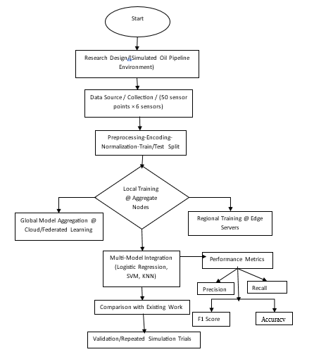
Figure 1: Methodology of the Proposed Research

B. Existing Model
Conventional oil pipeline monitoring systems typically rely on centralized machine learning architectures for anomaly detection. In this approach, sensor nodes deployed along the pipeline continuously collect operational parameters such as pressure, temperature, flow rate, and vibration, and transmit the collected data to a central server for processing and analysis. The central server aggregates all incoming data and trains a global anomaly detection model using the complete dataset. In this study, the existing model is implemented as a centralized anomaly detection system using Support Vector Machine (SVM), where all sensor data are transmitted to a central server before model training and prediction. This setup reflects commonly used architectures in industrial monitoring systems, where centralized data processing is employed due to its simplicity and ease of deployment. However, this centralized approach introduces several limitations. First, continuous transmission of raw sensor data increases communication overhead and network latency, particularly in large-scale pipeline infrastructures. Second, the centralized system creates a single point of failure, making it vulnerable to cyber-attacks and system disruptions. Third, it raises significant data privacy concerns, as sensitive operational data must be stored and processed at a central location.This centralized SVM-based model is used as a baseline in this study to evaluate the performance of the proposed federated learning-based anomaly detection framework.

Figure 2: Existing Model for Pipeline Monitoring.

C. Proposed Anomaly Detection System
The proposed system adopts a federated learning-based anomaly detection architecture designed to secure wireless sensor networks deployed for Nigerian oil pipeline monitoring. The architecture comprises three main components: sensor nodes, a federated aggregation server, and an anomaly detection model. At the sensor layer, multiple wireless sensor nodes are deployed along the oil pipeline to continuously monitor operational parameters, including pressure, temperature, flow rate, and vibration. Each sensor node collects local data and stores it within its local memory. To preserve privacy and reduce communication overhead, raw sensor data are not transmitted to the central server. Instead, each sensor node performs local model training using its locally available dataset. The local models are trained using machine learning algorithms such as Support Vector Machines (SVMs), Logistic Regression (LR), and K-Nearest Neighbour (KNN) to detect abnormal patterns that may indicate pipeline leakage, vandalism, or system malfunction. At the federated aggregation layer, a central server coordinates the collaborative learning process. After local training is completed, each sensor node transmits only its updated model parameters to the central server. The server then aggregates these parameters using the Federated Averaging (FedAvg) algorithm to produce an updated global anomaly detection model. The aggregated global model is subsequently redistributed to all sensor nodes for the next training round. This iterative process continues until the model converges to an optimal solution. By exchanging model parameters instead of raw sensor data, the proposed system enhances data privacy, reduces communication bandwidth usage, and improves the scalability of the monitoring system. Finally, the trained global model is deployed across the sensor network to perform real-time anomaly detection. Incoming sensor readings are analyzed by the trained model, which classifies each observation as either normal pipeline behaviour or anomalous activity. When an anomaly is detected, the system generates an alert to notify pipeline monitoring authorities for immediate investigation and response.
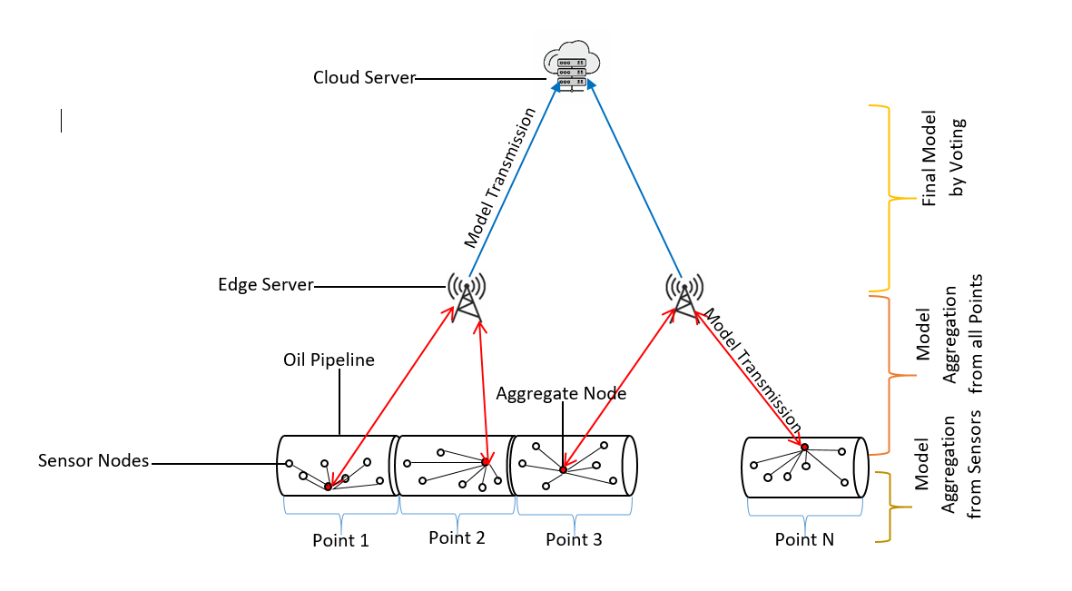
Figure 3: Proposed Anomaly Detection System.

D. Dataset Description and Feature Representation
The dataset used in this study consists of simulated sensor data designed to represent operational conditions of oil pipeline infrastructure monitored through wireless sensor networks. Due to the limited availability of publicly accessible real-world datasets for oil pipeline monitoring, a synthetic dataset was generated to reflect realistic pipeline behaviour based on standard industrial operating ranges reported in existing literature. The dataset comprises four key parameters that are widely used for monitoring pipeline integrity, namely pressure, temperature, flow rate, and vibration. These parameters serve as critical indicators of the operational state of the pipeline and are essential for detecting abnormal conditions such as leakage, vandalism, and mechanical faults. Each data instance is represented as a feature vector containing these four parameters, enabling the model to learn patterns associated with normal and anomalous pipeline behaviour. A total of 10,000 samples were generated to ensure sufficient data for training and evaluation. The dataset was labelled into two classes: normal and anomalous conditions. Normal samples represent stable operating conditions of the pipeline, while anomalous samples capture deviations such as sudden pressure drops, irregular flow rate variations, and abnormal vibration levels. These anomalies were introduced by injecting controlled deviations into the normal operating ranges to simulate realistic fault and attack scenarios within pipeline systems. To create a balanced yet realistic classification problem, the dataset distribution consisted of 70% normal samples and 30% anomalous samples. Prior to model training, the dataset underwent preprocessing procedures including data cleaning, normalization, and feature scaling to ensure consistency and improve model convergence. The dataset was subsequently divided into training and testing subsets using an 80:20 split. In order to align with the federated learning framework, the training data were partitioned across multiple sensor nodes, with each node maintaining a local subset of the dataset. This distribution simulates a real-world deployment scenario in which data are generated and stored locally at sensor nodes along the pipeline. Consequently, each node trains its local model independently while sharing only model parameters with the central aggregation server, thereby preserving data privacy and reducing communication overhead.

E. Federated Learning-Based Anomaly Detection Algorithm
The proposed anomaly detection framework uses a federated learning training process to enable distributed model learning across multiple sensor nodes without sharing raw data. The algorithm begins by initializing a global anomaly-detection model on the central server. This model is then distributed to participating sensor nodes within the pipeline monitoring network. Each sensor node trains the model locally using its own sensor data collected from pipeline monitoring parameters such as pressure, temperature, vibration, and flow rate. After local training is completed, the nodes transmit only the updated model parameters to the aggregation server. The server then combines the parameters received from all participating nodes to produce an updated global model. The updated global model is redistributed to the sensor nodes for further training. This process iterates until the model converges and achieves optimal anomaly-detection performance.
Algorithm 1: Federated Learning-Based Anomaly Detection for Pipeline Sensor Networks
Input:
Distributed sensor datasets $D_{k}$from $K$sensor nodes
Output:
Global anomaly detection model $w$and anomaly prediction results
- Begin
- Initialize the global model parameters $w^{0}$at the central aggregation server.
- Distribute the global model $w^{t}$to all participating sensor nodes.
- For each sensor node $k$in the network do:
a. Load the local dataset $D_{k}$
b. Preprocess sensor data
  - Remove missing values
  - Normalize sensor readings
  - Extract relevant features
c. Train the local anomaly detection model using one of the selected classifiers
  - Logistic Regression
  - Support Vector Machine
  - K-Nearest Neighbour
d. Update local model parameters using gradient descent.
e. Compute the updated local model $w_{k}^{t+1}$
- Transmit only the updated model parameters $w_{k}^{t+1}$to the central server.
- Aggregate the received local models using Federated Averaging:
$$w^{t+1}=\sum_{k=1}^{K}{\frac{n_{k}}{N}}w_{k}^{t+1}$$
- Update the global model with the aggregated parameters.
- Repeat Steps 3–7 until convergence or maximum training rounds are reached.
- Deploy the trained global model to all sensor nodes.
- For each incoming sensor reading $x$:
a. Compute prediction score $f(w,x)$
b. If $f(w,x)≥θ$
Classify as Anomaly
c. Else
Classify as Normal
- Evaluate model performance using:
- Accuracy
- Precision
- Recall
- F1-score
- End

F. Mathematical Model of the Proposed Federated Learning-Based Anomaly Detection System
The proposed anomaly detection system is formulated as a federated learning framework in which multiple distributed sensor nodes collaboratively train a global model without sharing raw data. Let the sensor network consist of $N$nodes, where each node $i$possesses a local dataset denoted as $D_{i}$. The global dataset is therefore represented as the union of all local datasets across participating nodes. Each data sample is represented as a feature vector $x∈R^{d}$, where $d$denotes the number of features corresponding to pipeline parameters such as pressure, temperature, flow rate, and vibration. The associated label $y∈\{0,1\}$indicates normal operation or anomalous behaviour.
$$D=\bigcup_{k=1}^{K}{D_{k}}(Eqn. 3.1)$$where $D_{k}=\{(x_{i},y_{i})\}_{i=1}^{n_{k}}$, $x_{i}$denotes the feature vector obtained from sensor readings such as pressure, temperature, flow rate, and vibration, while $y_{i}$represents the corresponding class label indicating normal or anomalous behaviour. The total number of samples across all participating nodes is given by:
$$N=\sum_{k=1}^{K}{n_{k}}(Eqn. 3.2)$$
where $n_{k}$is the number of samples stored at node $k$.

Local Model Training
At each communication round $t$, the global model parameters $w_{t}$are distributed from the central server to all participating sensor nodes. Each node updates the received model by minimizing a local loss function based on its dataset. The objective function at node $i$is defined as:
$$F_{k}(w)=\frac{1}{n_{k}}\sum_{i=1}^{n_{k}}{l(w;}x_{i},y_{i})(Eqn. 3.3)$$
where $l(w;x_{i},y_{i})$denotes the loss incurred by the model parameter $w$on training sample $\left(x_{i} , y_{i}\right)$.
The local model update is performed using gradient descent as follows:
$$w_{k}^{t+1}=w^{t}-η∇F_{k}(w^{t})(Eqn. 3.4)$$
where:
- $w_{k}^{t+1}$is the updated local model at node $k$,
- $η$is the learning rate,
- $∇F_{k}(w^{t})$is the gradient of the local loss function.

Global Model Aggregation
The updated global model is obtained by aggregating the local model parameters using the Federated Averaging (FedAvg) algorithm, which computes a weighted average based on the size of each local dataset:
$$w^{t+1}=\sum_{k=1}^{K}{\frac{n_{k}}{N}}w_{k}^{t+1}(Eqn. 3.5)$$
This aggregation rule ensures that nodes with larger local datasets contribute proportionally more to the updated global model.

Binary Anomaly Detection Function
The trained global model performs binary classification by mapping input feature vectors to prediction scores. A threshold-based decision function is applied to classify each observation as either normal or anomalous:
$$\hat{y}=\left\{\begin{matrix}1, & \text{if }f(w,x)≥θ \\ 0, & \text{if }f(w,x)<θ\end{matrix}\right.(Eqn. 3.6)$$
where:
- $\hat{y}=1$indicates an anomaly,
- $\hat{y}=0$indicates normal behaviour,
- $f(w,x)$is the prediction score of the trained model,
- $θ$is the classification threshold.

Logistic Regression Formulation
For logistic regression, the probability that a given input sample belongs to the anomalous class is computed using the sigmoid function. The model estimates the likelihood of anomaly based on a linear combination of input features and model parameters:
$$P(y=1∣x)=σ(w^{T}x+b)(Eqn. 3.7)$$
where $σ(z)$is the sigmoid activation function defined as:
$$σ(z)=\frac{1}{1+e^{-z}}(Eqn. 3.8)$$
and $b$is the bias term.
The binary cross-entropy loss for logistic regression at node $k$is:
$$L_{LR}^{\left(k\right)}=-\frac{1}{n_{k}}\sum_{i=1}^{n_{k}}{\left[y_{i}log⁡({\hat{y}}_{i})+(1-y_{i})log⁡(1-{\hat{y}}_{i})\right]}(Eqn. 3.9)$$Support Vector Machine Formulation
For the Support Vector Machine classifier, the decision boundary is defined by a hyperplane that maximizes the margin between normal and anomalous classes. The model is trained by minimizing the hinge loss function with a regularization parameter controlling model complexity:
$$f(x)=w^{T}x+b(Eqn. 3.10)$$
The hinge loss minimized at each local node is:
$$L_{SVM}^{\left(k\right)}=\frac{1}{n_{k}}\sum_{i=1}^{n_{k}}{max⁡(0,1-}y_{i}(w^{T}x_{i}+b))+\frac{λ}{2}∥w∥^{2}(Eqn. 3.11)$$
where $λ$is the regularization parameter.

K-Nearest Neighbour Formulation
For the K-Nearest Neighbour classifier, the class label of a new observation is determined based on the majority class among its nearest neighbours in the feature space, using a distance metric such as Euclidean distance. The Euclidean distance between two samples $x_{i}$and $x_{j}$is given by:
$$d(x_{i},x_{j})=\sqrt{\sum_{m=1}^{p}{(}x_{im}-x_{jm})^{2}}(Eqn. 3.12)$$where $p$is the number of input features. The predicted class is then determined by majority voting:
$$\hat{y}=mode⁡\{y_{1},y_{2},…,y_{K_{n}}\}(Eqn. 3.13)$$
Performance Evaluation Metrics
The performance of the proposed model is evaluated using standard classification metrics, including accuracy, precision, recall, and F1-score. These metrics are computed based on the confusion matrix components, namely true positives, true negatives, false positives, and false negatives.
$$\text{Accuracy}=\frac{TP+TN}{TP+TN+FP+FN}(Eqn. 3.14) \\ \text{Precision}=\frac{TP}{TP+FP}(Eqn. 3.16) \\ \text{Recall}=\frac{TP}{TP+FN}(Eqn. 3.17) \\ F1\text{-Score}=\frac{2×\text{Precision}×\text{Recall}}{\text{Precision}+\text{Recall}}(Eqn. 3.15)$$
where $TP$= True Positives, $TN$= True Negatives, $FP$= False Positives, $FN$= False Negatives. The mathematical formulation shows that the proposed system performs decentralized anomaly detection by combining local model optimization and global model aggregation. This enables the system to preserve sensor data privacy while improving anomaly-detection accuracy across distributed oil-pipeline monitoring nodes.

IV. RESULTS AND DISCUSSION

Experimental Setup and Dataset Description
To evaluate the performance of the proposed anomaly detection system, experiments were conducted using sensor data collected from oil pipeline monitoring environments. The dataset contains operational parameters commonly used in pipeline monitoring systems, such as pressure, temperature, vibration levels, and flow rate. These parameters are critical indicators for detecting abnormal conditions such as pipeline leakage, vandalism, or equipment malfunction. Before training the anomaly detection models, the dataset was preprocessed to remove inconsistencies and prepare the data for machine learning analysis. The preprocessing stage included data cleaning, normalization, and feature selection to ensure that the models could effectively learn patterns from the sensor data. After preprocessing, the dataset was divided into training and testing sets to evaluate the performance of the anomaly detection algorithms. The federated learning framework was then implemented to train the anomaly detection models across distributed nodes while preserving data privacy. The experiments were conducted using three machine learning algorithms: Support Vector Machine (SVM), Logistic Regression (LR), and K-Nearest Neighbours (KNN). These algorithms were selected due to their effectiveness in classification tasks and their suitability for anomaly detection in sensor-based monitoring systems.
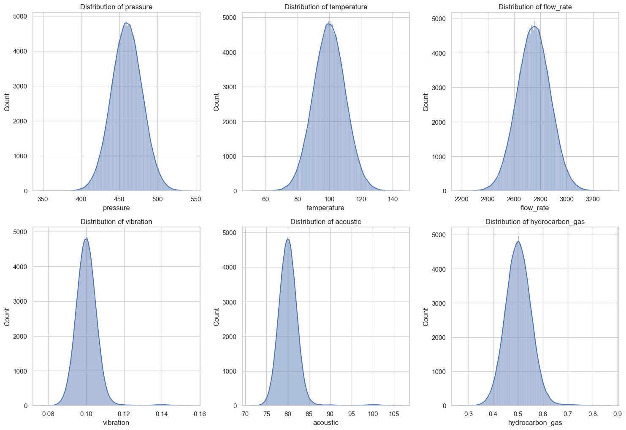
Figure 4: Dataset Distribution for Anomaly Detection.

Model Performance Evaluation
The performance of the proposed anomaly detection system was evaluated using three machine learning algorithms: Support Vector Machine (SVM), Logistic Regression (LR), and K-Nearest Neighbour (KNN). These algorithms were trained and tested using the processed pipeline monitoring dataset to determine their effectiveness in identifying abnormal patterns in sensor data. The evaluation focused on key performance indicators, including detection rate, computational efficiency, and classification performance. The results demonstrate that machine learning techniques effectively identify abnormal patterns associated with pipeline faults, leaks, or malicious activity within the monitoring network. Among the evaluated algorithms, Support Vector Machine (SVM) demonstrated strong classification performance by constructing optimal decision boundaries in high-dimensional feature spaces. Logistic Regression (LR) provided stable performance with lower computational complexity, making it suitable for real-time monitoring environments. K-Nearest Neighbour (KNN) also performed well in anomaly detection using similarity measures between data points.
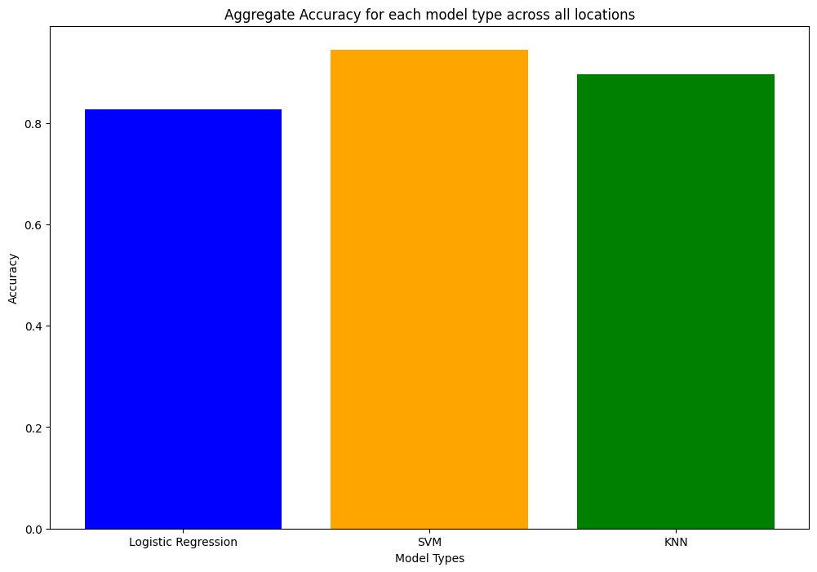
Figure 5: Performance Comparison of Machine Learning Algorithms.

Performance Comparison of Existing and Proposed Systems
The centralized SVM-based model was selected as the baseline for comparison because it represents a widely used approach in traditional anomaly detection systems for industrial monitoring. By comparing the proposed federated learning model with this baseline, the study provides a clear evaluation of how distributed learning improves detection performance while addressing privacy and scalability challenges inherent in centralized architectures. To evaluate the effectiveness of the proposed anomaly detection framework, the performance of the proposed system was compared with that of the existing monitoring model. The comparison was conducted using several classification performance metrics including precision, recall, F1-score, and accuracy. These metrics provide a comprehensive evaluation of the models' ability to correctly identify abnormal conditions in the pipeline monitoring system. The experimental results show that the proposed anomaly detection model improves performance across most evaluated metrics. In particular, the proposed model achieved a recall of 94%, significantly higher than the 70% achieved by the existing model. This indicates that the proposed system is more effective in identifying abnormal events within the monitoring dataset. Similarly, the proposed system achieved an F1-score of 93%, compared to 81% for the existing system, demonstrating improved balance between precision and recall. The precision values obtained by the proposed and existing models were 91% and 93% respectively, indicating that both models are capable of accurately identifying normal and abnormal conditions in the dataset. However, the overall classification accuracy of the proposed model reached 92%, demonstrating strong detection capability within the pipeline monitoring environment. The comparative performance results between the existing monitoring system and the proposed anomaly detection framework. The results clearly show that the proposed system improves anomaly detection performance while maintaining reliable classification accuracy.
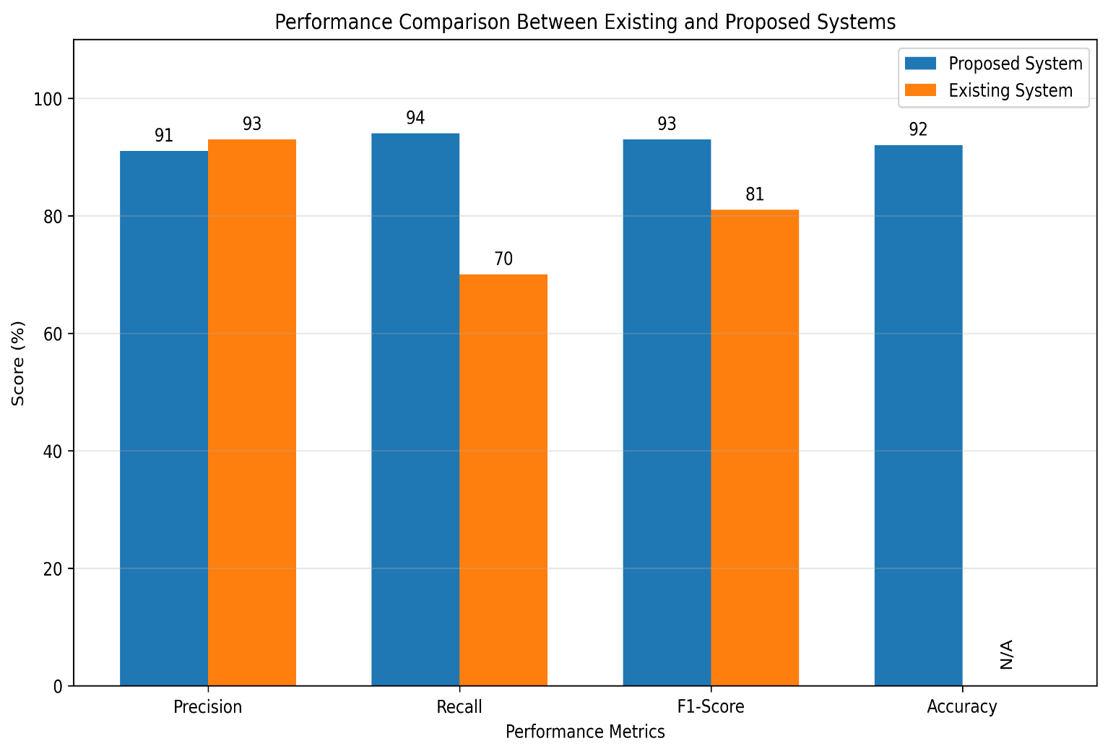
Figure 6: Performance Comparison Between Existing and Proposed Systems.

Table 2: Performance of Machine Learning Models
Model | Accuracy (%) | Precision (%) | Recall (%) | F1-Score (%)
SVM | 92.0 | 91.0 | 94.0 | 92.5
Logistic Regression | 89.0 | 88.0 | 90.0 | 89.0
KNN | 90.5 | 89.5 | 91.0 | 90.2

The performance of the machine learning models used within the federated learning framework is presented in Table 2. The results indicate that the Support Vector Machine (SVM) achieved the highest performance across all evaluation metrics, with an accuracy of 92%, precision of 91%, recall of 94%, and F1-score of 92.5%. Logistic Regression demonstrated relatively lower performance due to its linear nature, while K-Nearest Neighbour achieved moderate results based on similarity-based classification. These results confirm that SVM is more effective in capturing complex patterns in pipeline sensor data, making it more suitable for anomaly detection in distributed monitoring environments.
Table 3: Comparison Between Existing and Proposed Models
Model Type | Accuracy (%) | Precision (%) | Recall (%) | F1-Score (%)
Centralized Model | 85 | 93 | 70 | 81
Proposed Federated Model | 92 | 91 | 94 | 93

Table 3 presents a comparative analysis between the existing centralized monitoring model and the proposed federated learning-based anomaly detection system. The results demonstrate that the proposed model significantly improves recall from 70% to 94%, indicating a substantial enhancement in the system’s ability to detect anomalous events. The F1-score also increased from 81% to 93%, reflecting a better balance between precision and recall. Although the existing model achieved slightly higher precision, the proposed model provides a more reliable detection system due to its superior recall and overall accuracy. These improvements highlight the effectiveness of federated learning in enhancing anomaly detection performance while maintaining data privacy. The confusion matrix analysis further supports the effectiveness of the proposed model. The model achieved a high number of true positive detections, indicating its ability to correctly identify anomalous pipeline conditions. Additionally, the number of false negatives was significantly reduced compared to the existing model, which is critical in pipeline monitoring systems where undetected anomalies can lead to severe environmental and economic consequences. The relatively low number of false positives also demonstrates that the model maintains reliable classification performance without generating excessive false alarms.

Discussion of Results
The experimental results demonstrate the effectiveness of the proposed anomaly detection system in improving the monitoring performance of oil pipeline networks. The integration of machine learning techniques within the monitoring framework enables the system to learn patterns associated with normal pipeline operations and detect deviations that may indicate abnormal activities. From the comparative analysis presented in Figure 6, it can be observed that the proposed system achieves significantly higher recall and F1 scores than the existing monitoring model. The improvement in recall indicates that the proposed system can identify more abnormal events in the dataset, thereby reducing the likelihood of undetected pipeline faults or security threats. The higher F1-score obtained by the proposed model also demonstrates a better balance between precision and recall. This balance is important in anomaly detection tasks because it ensures that abnormal conditions are detected accurately without generating excessive false alarms. Although the existing system achieved slightly higher precision, the overall performance of the proposed model remains superior due to its significantly improved recall and F1-score. Furthermore, the classification accuracy achieved by the proposed model confirms its ability to effectively distinguish between normal and abnormal pipeline conditions. The improved performance of the proposed system can be attributed to the integration of machine learning techniques, which enable the model to analyze complex patterns in pipeline monitoring data. Overall, the experimental results indicate that the proposed anomaly detection framework provides a more reliable and efficient solution for monitoring oil pipeline infrastructure. The system enhances the ability to detect abnormal activities while maintaining stable classification performance, making it suitable for real-world pipeline monitoring applications.

V. CONCLUSION
This study This study proposed a federated learning-based anomaly detection system for securing wireless sensor networks deployed in Nigerian oil pipeline monitoring. The approach addresses key limitations of traditional centralized monitoring systems, particularly issues related to data privacy, communication overhead, and vulnerability to cyber-attacks. By integrating Support Vector Machine (SVM), Logistic Regression (LR), and K-Nearest Neighbour (KNN) within a federated learning framework, the proposed system enables distributed model training across sensor nodes without sharing raw data. This enhances data security while maintaining efficient anomaly detection performance. Experimental results demonstrated that the proposed system achieved strong performance, with an accuracy of 92%, precision of 91%, recall of 94%, and F1-score of 93%. Compared to the existing centralized model, the proposed approach significantly improved recall and F1-score, indicating better detection of anomalous events and reduced risk of undetected pipeline threats. Overall, the findings confirm that federated learning provides a scalable, privacy-preserving, and efficient solution for anomaly detection in oil pipeline monitoring systems. The proposed framework is particularly suitable for large-scale and distributed environments such as Nigeria’s oil pipeline infrastructure, where data security and real-time monitoring are critical. Future work should focus on validating the system using real-world pipeline datasets and exploring advanced federated learning techniques to further improve model robustness and adaptability.

REFERENCES
[1] J. Gubbi, R. Buyya, S. Marusic, and M. Palaniswami, “Internet of Things (IoT): A vision, architectural elements, and future directions,” Future Generation Computer Systems, vol. 29, no. 7, pp. 1645–1660, 2013. doi:10.1016/j.future.2013.01.010
[2] H. B. McMahan, E. Moore, D. Ramage, S. Hampson, and B. A. Arcas, “Communication-efficient learning of deep networks from decentralized data,” in Proc. 20th Int. Conf. Artificial Intelligence and Statistics (AISTATS), 2017, pp. 1273–1282.
[3] P. Kairouz et al., “Advances and open problems in federated learning,” Foundations and Trends in Machine Learning, vol. 14, no. 1–2, pp. 1–210, 2021. doi:10.1561/2200000083
[4] T. Li, A. K. Sahu, A. Talwalkar, and V. Smith, “Federated learning: Challenges, methods, and future directions,” IEEE Signal Processing Magazine, vol. 37, no. 3, pp. 50–60, 2020. doi:10.1109/MSP.2020.2975749
[5] I. Butun, P. Osterberg, and H. Song, “Security of the Internet of Things: Vulnerabilities, attacks, and countermeasures,” IEEE Communications Surveys & Tutorials, vol. 22, no. 1, pp. 616–644, 2020. doi:10.1109/COMST.2019.2953364
[6] S. Rajasegarar, C. Leckie, and M. Palaniswami, “Anomaly detection in wireless sensor networks,” IEEE Wireless Communications, vol. 15, no. 4, pp. 34–40, 2008. doi:10.1109/MWC.2008.4599219
[7] A. Mosenia and N. K. Jha, “A comprehensive study of security of Internet-of-Things,” IEEE Transactions on Emerging Topics in Computing, vol. 5, no. 4, pp. 586–602, 2017. doi:10.1109/TETC.2016.2606384
[8] M. Mohammadi, A. Al-Fuqaha, S. Sorour, and M. Guizani, “Deep learning for IoT big data and streaming analytics: A survey,” IEEE Communications Surveys & Tutorials, vol. 20, no. 4, pp. 2923–2960, 2018. doi:10.1109/COMST.2018.2844341
[9] A. Aljameel, I. Ahmad, S. Khan, and M. Asif, “Machine learning-based anomaly detection for industrial control systems,” IEEE Access, vol. 10, pp. 48345–48356, 2022. doi:10.1109/ACCESS.2022.3170567
[10] H. Truong, A. Abdallah, and K. Salah, “Privacy-preserving anomaly detection for industrial IoT using federated learning,” IEEE Internet of Things Journal, vol. 9, no. 15, pp. 13340–13352, 2022. doi:10.1109/JIOT.2022.3145238
[11] Y. Zhang, J. Chen, and L. Wang, “Personalized federated learning for anomaly detection,” IEEE Transactions on Industrial Informatics, vol. 19, no. 4, pp. 5678–5687, 2023. doi:10.1109/TII.2022.3214567
[12] A. Obaid, H. Al-Turjman, and M. Zahid, “Deep learning for anomaly detection in industrial IoT systems,” Future Generation Computer Systems, vol. 134, pp. 246–256, 2023. doi:10.1016/j.future.2022.04.012
[13] M. Aalsalem, W. Khan, M. Hossain, and M. Atiquzzaman, “Wireless sensor networks in oil and gas pipeline monitoring: A survey,” Journal of Network and Computer Applications, vol. 60, pp. 165–180, 2018. doi:10.1016/j.jnca.2015.11.004
[14] B. Yunana, J. Idris, and M. Ahmed, “Pipeline monitoring techniques for oil and gas transportation systems,” Journal of Petroleum Technology and Engineering, vol. 7, no. 2, pp. 45–53, 2017.
[15] A. Bello, S. Ibrahim, and M. Abdullahi, “IoT-based oil pipeline monitoring system using wireless sensor networks,” International Journal of Advanced Computer Science and Applications, vol. 14, no. 3, pp. 221–229, 2023. doi:10.14569/IJACSA.2023.0140325
[16] O. Dimkpa, S. O. Ojo, and E. A. Ajayi, “Oil pipeline vandalism and its environmental impact in the Niger Delta region,” Energy Policy, vol. 162, 2023. doi:10.1016/j.enpol.2022.112745
[17] S. Padmavathi and D. Shanmugapriya, “A survey of attacks, security mechanisms and challenges in wireless sensor networks,” International Journal of Computer Science and Information Security, vol. 4, no. 1–2, pp. 1–9, 2009.
[18] M. Salehi, M. A. Razzaque, P. Naraei, and A. Farrokhtala, “Detection of sinkhole attack in wireless sensor networks,” International Journal of Computer Science and Network Security, vol. 13, no. 2, pp. 34–40, 2013.
[19] L. Deng and D. Yu, “Deep learning: Methods and applications,” Foundations and Trends in Signal Processing, vol. 7, no. 3–4, pp. 197–387, 2014. doi:10.1561/2000000039
[20] J. Konečný et al., “Federated learning: Strategies for improving communication efficiency,” arXiv preprint arXiv:1610.05492, 2016.

