EFFECT OF ANNUAL TEMPERATURE AND RAINFALL VARIABILITY ON CEREALS YIELD IN NIGER STATE, NIGERIA

Muhammed, Jibril Bala, A. S. Abubakar
Department of Geography, Federal University of Technology Minna, Niger State

ABSTRACT
Globally, temperature and rainfall variability are part of the greatest socioeconomic and biophysical challenges confronting the world in the 21st century. One of the major limitations to cereals yields in Nigeria can be attributed to temperature and rainfall variability. Hence, this study assessed the effect of annual temperature and rainfall variability on cereals yield in Niger State, Nigeria. The study examined the trends in temperature, rainfall, maize and rice yield for 30 years. The study adopted expost-facto research design. Purposive sampling technique was employed to select Badeggi from Katcha LGA in Zone A, Paiko was selected in Paikoro LGA in Zone B and Wushishi from Wushishi LGA in Zone C based on the predominance of maize and rice production and concentration of smallholder farmers. Secondary data were used in this study which were temperature, rainfall, maize and rice yields obtained from Nigerian Meteorological Agency (NiMet) and Niger State Ministry of Agriculture for a period of 30years (1995 to 2024). Data were analysed using Mann-Kendall, trend chart, multiple regression, frequency and percentage. The study shows that the p-value (0.003) is less than the significant level (0.05) alpha level, implying a significant variability in the average temperature trend in the study area with a 34.26 percent increase trend of average annual temperature The study also showed that p-value (0.735) is greater than the significant level (0.05) alpha level, implying no significant variability in the average annual rainfall trend in the study area. The study also shows that p-value (0.382) is greater than the significant level (0.05) alpha level implying no significant variability in the average annual maize yield trend in the study area. Another finding of the study also show that p-value (0.061) is greater than the significant level (0.05) alpha level implying no significant variability in the average annual rice yield trend in the study area. It was recommended among others that with the fluctuating rainfall pattern government and non-governmental organisations (NGOs) should invest in small-scale and community-based irrigation schemes by digging tube wells and boreholes for cereal farmers.
KEYWORDS: Climate Variability, Cereals Yield, Maize Yields, Rainfall, Rice Yields, Temperature
- INTRODUCTION
Globally, climate variability is one of the greatest socioeconomic and biophysical challenges confronting the world in the 21st century (Samuel and Ikpe, 2024). As human activities are mainly responsible for climate variability and Africa contributes just a little above 3% to greenhouse gas emissions (GHG) their economies were the most hit by this menace (Komolafe et al., 2023). Climate variability has become a threat to the sustainable development of socio-economic, agricultural activities of a Nigeria and the totality of human existence (Zadawa and Omran, 2020; Rathoure and Patel, 2020). Ajiere and Weli (2018) defined climate variability as any significant change in measures of climate (such as temperature, precipitation, or wind) lasting for an extended period. Evidence of climate variability includes delayed onset date of rains, increase in number of dry days during the raining season and increase in maximum temperature (Asa et al., 2024). Hence, temperature rise is as a result of the climate variability due to global warming. These changes can affect food prices, food security, land use (Barnett, 2020; Sylvester, 2020). Adeagbo et al. (2021) added that temperature rise poses a negative impact on the maize yield when mean precipitation decreases relative to a marginal increase in mean temperature. Extreme atmospheric conditions like very high temperature and decrease rainfall can result to drought which can harm crops, prevent them from growing and reduce yields. Increasing global temperature and decrease rainfall have negative outcomes due to reduce yields in tropical regions (Angye et al., 2024). In the extreme case of temperature increase and decrease rainfall, crop production suffers the most (Didiso and Hunegnaw, 2022). Yahaya et al. (2025) asserted that Nigeria’s agricultural sector is vulnerable to the impacts of rising temperatures and decrease rainfall which severely affect crop growth and yield. Hence, temperature increase and decrease rainfall has the tendencies to impact crop production in a negative way.
Agriculture is highly dependent on climate and a critical part of the economy in Nigeria as many of the Nigerians’ population depend on it. Temperature increase is a major challenge to agricultural development with the increasingly irregular and erratic nature of weather conditions placing an additional burden on food security (Angye et al., 2024). Temperature increase can affect crops has it has the tendency to increase the population and growth of pests, insects and diseases making crop management difficult and costly. Similarly, Olumide (2024) noted that prolonged droughts can result in crop failure and yield losses, excessive rainfall can lead to waterlogging and soil erosion, changes in precipitation patterns can influence the prevalence and distribution of pests and diseases, posing additional challenges to crop production. Due to this rise in temperature and decrease rainfall, crop can loose their viability and farmers can loose their source of income. The annual variation of temperature particularly in northern Nigeria, is large and often result in climate hazards, especially droughts with devastating effects on food production and associated calamities and sufferings (Samuel and Ikpe, 2024). Ologeh and Adesina (2022) added that Nigeria is facing increasing temperature at a very rapid annual rate resulting to drastic reduction in the amount of surface water, flora and fauna resource. However, warmer temperature has varied effects on different crops, the effect of increased temperature on any particular crop will depend on the crop's optimal temperature for growth and reproduction. Due to the predominant rise of temperature and decrease rainfall in Nigeria and its effects on yield of different crops and maize is very sensitive to temperature change. This study assessed the effect of annual temperature and rainfall variability on cereals yield in Niger State. Niger State is one of the foremost agricultural states of Nigeria. The state is known for producing diversity of agricultural products such as rice, maize, sorghum, yam and other roots and tubers.
Several households in Nigeria depend on cereals most especially, maize as one of the important sources of food and nutrition. Maize is an important global staple food, more than 15 percent of global calorie intake is from maize, rice and wheat (Komolafe et al., 2023). The crop grows more quickly thereby reducing the time that seeds need to grow and mature and this can reduce yields which entails the amount of crop harvested from a given amount of land. The crop is used in various forms such as maize flour, pap, roasted corn, boiled maize, maize porridge, corn pudding, popcorn, cornflakes, corn bread and animal feed. Maize is one of the important grains in Nigeria, as it creates job opportunities and contributes to the Nigeria's economic development. Oparinde and Okogbue (2018) asserted that about 80% of maize produced is consumed by man and animals, while the remaining 20% is used in various agro-based industries where brewery for beer and malt drinks, ethanol for bio-fuel, starch and syrup for medical uses, corn sweetener, ethanol, cereal, alkaline among others are produced. Akintonde et al. (2019) also affirmed that maize has grown to be a local “cash crop” most especially in the Northern part of Nigeria where at least 30 percent of the cropland are used to cultivate maize. The crop survives with the mean daily temperature between 16⁰C to 19⁰C and a consistently required amount of precipitation (Riccetto et al., 2020). In Northern Nigeria, maize is produced during the main long rainy season from May to September, and a small amount is produced in the short rainy season from February to May. Despite the economic importance of maize and rice, they have not been produced in such quantity that could meet food and industrial needs of Nigeria (Samuel and Ikpe, 2024). Major maize and rice production areas have been experiencing crop yield reduction. One of the major limitations of cereals yields in Nigeria can be attributed to climate variability. Niger State, known for its agricultural economy has witnessed noticeable changes in its climatic conditions, including increased average temperatures and prolonged dry spells. These shifts have begun to disrupt traditional farming calendars, reduce soil moisture availability, and increase the incidence of pest and disease outbreaks all of which negatively impact maize production. Climate variability is increasingly affecting the livelihoods of people as they experience negative impacts of climate variability given their lack of capacity to prepare for and cope with its effects. The demand for maize and rice are increasing daily, because they are major staple food for human and animals. In view of the demand for maize, Nigeria and international bodies such as Food and Agriculture Organization (FAO) have developed interest in promoting maize production for households’ food security and poverty alleviation. However, despite the great potential of Nigeria in maize and rice production, in northern part of Nigeria where most of the maize are produced experienced frequent occurrence of drought occasioned by cessation of rain and rise in temperature during the growing season. In order to curb this menace associated with the effect of climate variability on cereals yields, adaptation strategies were expected to be adopted. Despite that studies on effect of climate variability on cereals yield have been conducted. The effect of climate variability on cereals yield differs from locations. Also, none of the reviewed studies considered the effect of annual temperature and rainfall variability on cereals yields in Niger State. Hence, this study filled in the gap by investigating the effect of annual temperature and rainfall variability on cereals yield in Niger State, Nigeria. The specific objectives are to:
- analyse trends of temperature, rainfall, maize and rice yields in Niger State;
- examine the relationship between temperature and rainfall and cereals (maize and rice) yields in Niger State.

- RELATED WORKS
Related literature on the effect of temperature and rainfall on maize yield showed that Coster and Adeoti (2015) used Ricardian approach to examine the effects of climate variability on maize production in Nigeria. Audu et al. (2018) studied the characteristics of annual rainfall over Guinea Savanna Zone, Nigeria. Ogunjobi (2018) assessed the impact of temperature and rainfall variability on maize production in Nigeria utilizing historical climate data and crop yield records. Ajiere and Weli (2018) assessed the impact of climate variability on crop yield using Expost-facto research. Oparinde and Okogbue. (2018) analysed climate-related risk and maize production in Southwest, Nigeria. Bamiro et al. (2020) examined the effect of climate variability on the yield for four main grain crops in Nigeria (sorghum, maize, millet and rice) over the period 1970-2014. Musa et al. (2021) examined the strength of relationship between climatic variables and yield of three major cereal crops (Rice, Maize and Guinea corn) cultivated in North Central States of Nigeria. Didiso and Hunegnaw (2022) investigated long term climatic trends evaluating the impacts specifically on Maize production and assessing adaptation strategies of the farming community in Hawassa zuria district, Sidama Regional State of Ethiopia. Ologeh and Adesina (2022) evaluated climate variability as a major determinant of crop yield improvement in Nigeria. Zhang et al. (2022) investigated the impact of climate variability on maize production based on empirical findings and implications for sustainable agricultural development in China. Ogbaji et al. (2023) investigated the impact of recent temperature and rainfall trends on farming activities in selected states in the Niger-Delta Region, Nigeria. Baffour-Ata et al. (2023) investigated the effect of rainfall and temperature variability on maize yield in the Asante Akim North District, Ghana. Muia et al. (2024) analysed annual, seasonal, and monthly rainfall and temperature (minimum and maximum) trends in Makueni County from 1991 to 2020 using the Mann–Kendall (MK) trend test and Theil-Sen’s slope estimator. Angye et al. (2024) evaluated the impact of climate variability on maize yield in Wukari Local Government Area, Taraba State, from 1999 to 2018. Utilising an ex-post facto and analytical design. Oladitan and Emiola (2024) assessed the influence of climatic variable patterns on maize yield using secondary climatic data of Ondo state from 2000 -2024 and yearly yield data of maize from Agricultural Development Programme. Olumide (2024) investigated the effect of climate variability on crop yields in Nigeria using a desk methodology. Yahaya et al. (2025) carried out planting, weather and cultivar sensitivity analysis using Decision Support System for Agrotechnology Transfer (DSSAT) latest version 4.8.2 in Savanna and Sahel climate regions of Nigeria and also forecast yield up to 2100. From the literature review, there are researches on the impacts of climate variability on maize farming but none of the study considered the effect of climate variability on cereal yields in Niger State. This study, therefore, addressed this research gap by assessing the effect of annual temperature and rainfall variability on cereal yields in Niger State.

- MATERIALS AND METHODS
The following research questions were raised and answered in this study:
- What are the trends of temperature, rainfall, maize and rice yields in Niger State?
- What is the relationship between temperature and rainfall and cereals (maize and rice) yields in Niger State?
Niger State, located at North Central geo-political zone of Nigeria is one of the 36 states of Nigeria created on 3rd February 1976 out of the defunct North Western state. Administratively, the State comprises of 25 Local Government Areas with Minna as the capital. The LGAs are grouped into three Administrative Zones: A, B and C with 8, 9 and 8 Local Government Areas respectively. Each LGA is subdivided into districts and the districts are further subdivided into 274 wards and villages. Geographically, Niger State lies between latitude 8⁰20' - 11⁰30' N and Longitude 3⁰30'- 7⁰20'E. It shares boundaries borders with republic of Benin (West), Zamfara State (North), Kebbi (North-West), Kogi (South), Kwara (South West), Kaduna (North-East) and the FCT (South-East). The state is one of the largest states in Nigeria covering about 86,000km² (or about 8.6million hectares) representing about 9.3% of the total land area of the Country. The state’s major rivers are: Niger, Kaduna, Gbako, Eko, Gurara, Ebba, Ega, Mariga and their tributaries. The State is the largest in the country in terms of landmass (about 10% of the country's total) with a total land area of 76,363 km² (over 7.8 million hectares). Map of Niger State showing the study area is presented in figure 1. The study adopted expost-facto research design. An expost-facto research design is associated with the use of secondary data to understand the effect of a variable on another variable. Since data for rainfall, temperature, rice and maize yields were obtained from Nigerian Meteorological Agency (NiMet) for a period of 30years and Niger State Ministry of Agriculture also for a period of 30 years to assess the effects of temperature rise on maize yields. Hence, expost-facto research was considered appropriate for this study. Secondary data on temperature, rainfall, maize and rice yields were obtained from Nigerian Meteorological Agency (NiMet) and Niger State Ministry of Agriculture for a period of 30years (1995 to 2024). Data for the study were collected from the three zones in Niger State. Purposive sampling technique was employed in the study.
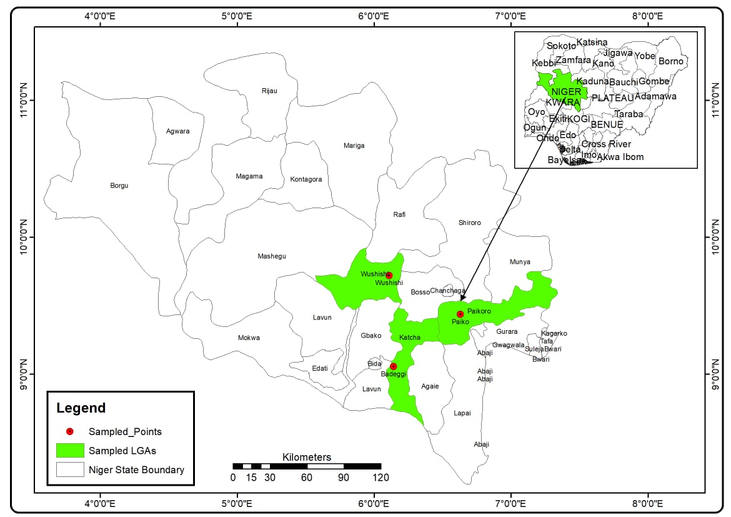

Figure 1: Map of Niger State showing the study area (Geography Department, Federal University of Technology Minna, Niger State)

Firstly, one Local Government Area (LGA) was selected from each zone purposefully based on the predominance of maize and rice production and concentration of smallholder farmers in the area. The selected LGAs are Katcha, Paikoro and Wushishi. Purposive sampling technique was used to select Badeggi from Katcha LGA in Zone A, Paiko were selected in Paikoro LGA in Zone B and Wushishi from Wushishi LGA in Zone C. Secondary data on temperature, rainfall, maize and rice yields of Badeggi, Paiko and Wushishi LGA in Niger State were obtained from Nigerian Meteorological Agency (NiMet) and Niger State Ministry of Agriculture for a period of 30years were analysed using Mann-Kendall and presented in tables and trend graph for research question one and derived data were analysed using multiple regression analysis and graphically using multiple line graph for research question two.

- RESULTS AND DISCUSSION

The data collected from NiMet and Niger State Ministry of Agriculture were analysed and presented thus:

- Analysis of Temperature, Rainfall, Maize and Rice Yields Trends from 1995 to 2024 in the Study Area
Mann-Kendall analysis of temperature, rainfall, maize and rice yields trends from 1995 to 2024 in the study area is presented in Table 1.

Table 1: Mann-Kendall Analysis of Temperature, Rainfall, Maize and Rice Yields Trends from 1995 to 2024 in the Study Area
Parameters | Mann-Kendall stat (S) | Mann-Kendall stat (Z) | Kendall’s tau | P-value (two tailed) | Alpha level | Trend
Temperature (1995-2024) | 167 | 2.9714 | 0.391 | 0.003 | 0.05 | Increasing
Annual Rainfall (1995-2024) | 19 | 0.3213 | 0.044 | 0.735 | 0.05 | No significant
Maize Yield (1995-2024) | -50 | -0.875 | -0.115 | 0.382 | 0.05 | No significant
Rice Yield (1995-2024) | -106 | -1.874 | -0.244 | 0.061 | 0.05 | No significant
(NiMet and Niger State Ministry of Agriculture, 2025)

Table 1 shows Mann-Kendall analysis of temperature, rainfall, maize and rice yields trends from 1995 to 2024 in the study area. From the table, temperature Mann-Kendall positive value indicated an upwardly and increasing trend over time which is in accordance to the result of Ajiere and Weli (2018) whose results showed that there had been a steady but gradual increase in the mean temperatures over the study period of thirty years. Also, Ogbaji et al. (2023) revealed an upward trend of temperature. In the same vein, Baffour-Ata et al. (2023) result revealed a significant temperature rise. The table also shows that the p-value (0.003) is less than the significant level (0.05) alpha level, this implies that there is a significant variability in the average temperature trend in the study area. The result of the table also shows a significant increase in the average temperature trend in the study area.
The Mann-Kendall result from table 1, shows a positive insignificant trend of average annual rainfall in the study area. The table also shows that rainfall Mann-Kendall positive value indicated an upwardly and increasing trend over time. In agreement, Didiso and Hunegnaw (2022) showed that long-term data records show that, rainfall increased annually over the past 33 years. However, Ajiere and Weli (2018) results showed that rainfall is decreasing in their study. The table shows that p-value (0.735) is greater than the significant level (0.05) alpha level, this implies that there is no significant variability in the average annual rainfall trend in the study area. Baffour-Ata et al. (2023) result revealed an increasing insignificant rainfall pattern. Also, Ogbaji et al. (2023) revealed an upward trend of rainfall across the study area. Hence, there is an increasing insignificant trend of average annual rainfall in the study area.
Furthermore, the table shows that maize yield Mann-Kendall negative value indicated a decreasing trend over time. The table shows that p-value (0.382) is greater than the significant level (0.05) alpha level, this implies that there is no significant variability in the average annual maize yield trend in the study area. Hence, there is a decreasing insignificant trend of average annual maize yield in the study area. Also, the table shows that rice yield Mann-Kendall negative value indicated a decreasing trend over time. The table shows that p-value (0.061) is greater than the significant level (0.05) alpha level, this implies that there is no significant variability in the average annual rice yield trend in the study area. Hence, there is a decreasing insignificant trend of average annual rice yield in the study area.

- Analysis of Temperature Trends from 1995 to 2024 in the Study Area
The chart trend of temperature from 1995 to 2024 in the study area is presented in Figure 2. The chart trend of temperature showed a fluctuating trend mean temperature in the study area. In accordance to the result, Oladitan and Emiola (2024) trend analysis indicated a fluctuations in temperature. From the trend chart, it could be observed that the year 1995 had an average temperature of 30.50⁰C. Compared to 1995, there was a slight temperature decline to 30.12⁰C in the year 1996. In comparison to the previous year, the years 1997 and 1998, recorded a slight temperature increase to 31.40⁰C and 32.99⁰C respectively. However, the year 1999 experienced a slight temperature decline to 31.50⁰C. A steady temperature increase was recorded to 31.89⁰C, 33.10⁰C and 33.30⁰C for the year 2000, 2001 and 2022. An average temperature decline to 31.39⁰C was observed in the year 2003 which increased to 33.30C in the year 2004. Compared to the 2004, in 2005, a decline to 31.39 was observed which rose to an average of 32.90⁰C in the year 2006. The average temperature also increased to 33.30⁰C in the year 2007 but declined to 32.89⁰C in the year 2008 but increased to 33.70⁰C in the year 2009. In the year 2010, the average temperature decreased to 30.79⁰C.

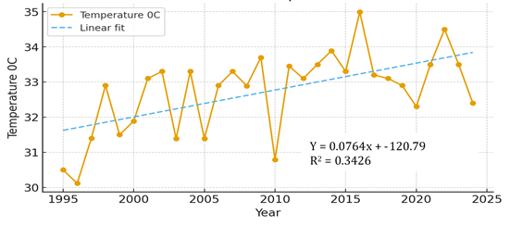
Figure 2: Chart Trend of Temperature from 1995 to 2024 in the Study Area (NiMet, 2025)

From the trend chart, an increased average temperature to 33.45⁰C was observed in the year 2011 but slightly decreased in the year 2012 to 33.10⁰C. An increased was observed in the year 2013 and 2014 to 33.50⁰C and 33.89⁰C respectively, but slightly declined in the year 2015 to 33.30⁰C but increased in the year 2016 to 34.99⁰C and decreased in the 2017 to 33.20⁰C. The trend graph also showed a decreased temperature from the year 2018 to 2020 at 33.10⁰C, 32.90⁰C, 32.30⁰C respectively. There was a slight increase in the year 2021 to 33.50⁰C which also increased in the year 2022 to 34.50⁰C but declined to 33.50⁰C and 32.40⁰C in the year 2023 and 2024 respectively. The highest annual temperature in the study area was 34.99⁰C recorded in the year 2016. The value of r² in the trend equation indicates a 34.26 percent increase trend of average annual temperature.

- Analysis of Rainfall Trends from 1995 to 2024 in the Study Area
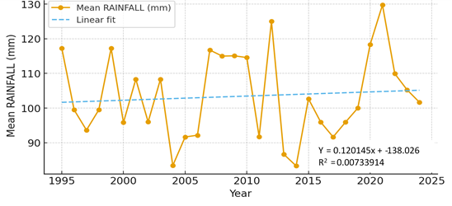
The chart trend of rainfall from 1995 to 2024 in the study area is presented in Figure 3.
Figure 3: Chart Trend of Rainfall from 1995 to 2024 in the Study Area (NiMet, 2025)

The chart trend plot in figure 3 showed a fluctuating trend mean rainfall in the study area. In line with this finding, Audu et al. (2018) result revealed alternate upward and downward trends as well as a general upward trend in recent years. Similarly, Oladitan and Emiola (2024) trend analysis indicated a fluctuations in rainfall. From the trend chart, it could be observed that from the period of 1995 to 1998 recorded a decreasing trend in average rainfall at 117.26mm for the year 1999, 99.48mm for the year 1996, 93.65mm for the year 1997 and 99.49mm for the year 1998. The year 1998 experienced a slight increase in the average annual rainfall in the study area, recorded at 117.26mm. In 2000, a decline was observed at 95.83mm which rose to an average of 108.33mm in the year 2001. The average rainfall also decline to 96.00mm in the year 2002 but increased to 108.33mm in the year 2003. From 2004 to 2006, a decrease in the average annual rainfall was experienced at 83.42mm, 91.67mm and 92.17mm respectively. From the trend chart, it could be observed that a significant increase in average annual rainfall in the year 2007 to 2010 coursed an upward shift in the trend plot, as the average annual rainfall for these years were recorded at 116.75mm, 115mm, 115.08mm and 114.58mm respectively. This increase was however temporary as a decline in average annual rainfall was experienced in the year 2011. During this year, average annual rainfall was recorded at 91.75mm.
From the table, a significant increase in average annual rainfall was recorded in the year 2012 with an upward shift in the trend plot, as the average annual rainfall was recorded at 125mm. However, this increase was temporary as a decline in average annual rainfall was experienced in the year 2013 and 2014 with an average rainfall recorded at 86.67 and 83.33 respectively which increased to 102.67 in 2015. In the year 2016 and 2017, a decrease in the average annual rainfall was experienced with average annual rainfall was recorded at 95.92mm and 91.67mm respectively. From year 2018 to 2021, increased average annual rainfall were recorded at 95.92mm, 100.00mm, 118.33mm and 129.75mm respectively. However, a steady average annual rainfall decreased were experienced from 2022 to 2024. Within these three years, average annual rainfall were recorded at 109.92mm, 105.25mm and 101.67mm respectively. The highest average annual rainfall in the study area was 129.75mm recorded in the year 2021. The value of r² in the trend equation indicates a variation in trend of average annual rainfall at 1 percent. In accordance to this result, Angye et al. (2024) revealed that, there was an almost uniform but increasing trend in average annual rainfall.

- Analysis of Maize Yield Trends from 1995 to 2024 in the Study Area
The chart trend of maize yields is presented in Figure 4.
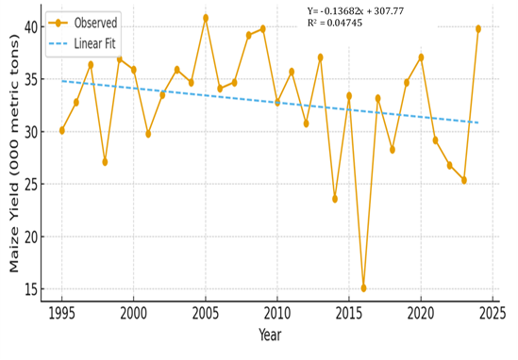
Figure 4: Chart Trend of Maize Yields from 1995 to 2024 in the Study Area (Niger State Ministry of Agriculture, 2025)

The trend of maize yield in the study area shows a steady rise in the yield of maize from 30.13 thousand tonnes in 1995 to a 36.4 thousand tonnes in 1997 which declined tremendously to 27.1 thousand tonnes in 1998 and a sharp increase occurred during the year 1999 and 2000 to 36.93 and 35.9 thousand tonnes respectively. There was a sharp decrease in 2001 to 29.8 thousand tonnes, a steady increase in 2002 to 33.5 thousand tonnes and in 2003 to 35.9 thousand tonnes. After which a slight decrease was recorded in the year 2004 to 34.7 thousand tonnes with a drastic increase in the year 2005 to 40.84 thousand tonnes. In the year 2006, there was a decline to 34.1 thousand tonnes which increased steadily to 39.8 thousand tonnes in 2009. From the year 2006 to 2019 there was an undulating maize yield with rise and fall output. A slight increase was recorded in the year 2020 with a steady decline from the year 2021 to 2023 with an increase in the year 2024. From the trend chart, the value of r² in the trend equation indicates a decrease in trend of average annual maize yield at 4.74 percent. However, this result disagree with that of Angye et al. (2024) whose study revealed that, maize yield showed an increasing trend. Hence, there is an insignificant decrease in the trend of average annual maize yield in the study area.

- Analysis of Rice Yields Trends from 1995 to 2024 in the Study Area
The chart trend of rice yields from 1995 to 2024 in the study area is presented in Figure 5.
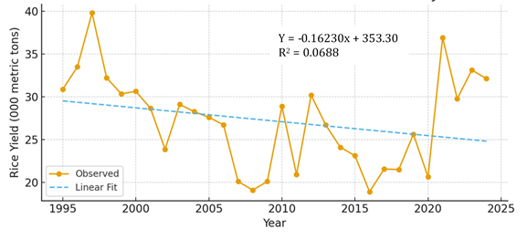
Figure 5: Chart Trend of Rice Yields from 1995 to 2024 in the Study Area (Niger State Ministry of Agriculture, 2025)

The trend of rice yield in the study area shows a steady rise in output from 30.89 thousand tonnes in 1995 to a high peak of 39.8 thousand tonnes in 1997 which declined to 32.22 thousand tonnes in 1998 and a slight decline in the year 1999 to 30.34 thousand tonnes and 30.63 thousand tonnes in the year 2000 with a decrease to 28.67 in 2001. There was a decline in 2002 to 23.87 thousand tonnes, an increase was observed in the year 2003 to 29.10 thousand tonnes. A steady decrease was observed from the year 2004 to 2008 with a slight increase to 20.1 thousand tonnes in the year 2009. A rise was observed in the rice yields in the year 2010 to 28.9 thousand tonnes which decline to 20.9 thousand tonnes in the year 2011 after which a sharp increase was recorded in the year 2012 which declined steadily from the year 2013 to the year 2016. From the year 2017 to 2020, there was an undulating rice yield with minimal rise and fall. A drastic increase was recorded from the year 2021 with a slight decrease in 2022 which slightly increase in 2023 but declined in the year 2024. From the trend chart, the value of r² in the trend equation indicates a variation in trend of average annual rice yield at 6.88 percent. Hence, there is an insignificant decrease in the trend of average annual rice yield in the study area.

- Examining the Relationship between Temperature and Rainfall and Cereals (Maize and Rice) Yields in Niger State
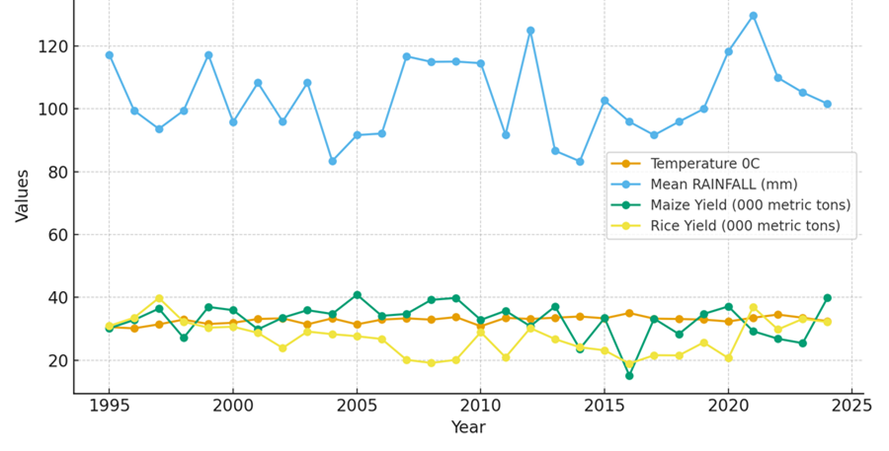
The relationship between temperature and rainfall and cereals (maize and rice) yields in the study area is presented in Figure 6.
Figure 6: Rrelationship between Temperature and Rainfall and Cereals (maize and rice) yields in the Study Area (NiMet and Niger State Ministry of Agriculture, 2025)

Figure 5 shows the relationship that exists between temperature, rainfall and yearly maize and rice yields between 1995 and 2024. The study area witnessed various degrees of fluctuations in rainfall. The rainfall was highest in 2021 and highest average annual temperature was in the year 2016. The significant fluctuations in rainfall have different impacts on the crop yields of the study area. For example, rainfall decline recorded from 1995 to 1997 with decreased temperature led to increased maize and rice yields. In 2016 and 2017, decreased increase in rainfall and increased temperature were recorded with decreased maize and rice yields were recorded. The past four years recorded a decreased annual rainfall, increased temperature with decreased maize and rice yields. This change of annual rainfall and temperature pattern affects the yields of maize and rice.

- Examining the Effect of Temperature and Rainfall on Maize yields in Niger State
The relationship between temperature and rainfall and maize yields in the study area was analysed using multiple regression as shown in Table 2.

Table 2: Model Summary
Model | R | R Square | Adjusted R Square | Std. Error of the Estimate
1 | .451 | .203 | .144 | 5.11590
a. Predictors: (Constant), Mean Temperature 0C, Mean Rainfall (mm)
(Authors, Fieldwork 2025)
Table 2 shows the model summary on the effect of rainfall and temperature on the maize yields in the study area. The table shows that the predictors (rainfall and temperature) together produced an r² coefficient of 0.203 revealing that there is a weak correlation between rainfall, temperature, and maize yield. Also, the combine effects of both rainfall and temperature on maize yields produced an r of 0.451. This signifies that rainfall and temperature can only explain 45.1% of maize yields in the study area, leaving the other 54.9% to other climatic elements, soil types, farming techniques applied, and maize species used which are not considered in this study. Also, Musa et al. (2021) result shows weaker relationships between maize yield and climatic variable. Ajiere and Weli (2018) results also showed that multiple regression model showed r2 values of 0.28 for maize by rainfall and temperature in the state. The analysis of variance (ANOVA) on the effect of annual temperature and rainfall on maize yield is presented in Table 3.

Table 3: Regression ANOVA Testing of Overall Model Fitness
Model |  | Sum of Squares |  | df |  | Mean Square |  | F |  | Sig.
1 | Regression | 180.021 | 2 |  | 90.011 |  | 3.439 |  | .047^{b}
1 | Residual | 706.655 | 27 |  | 26.172
1 | Total | 886.676 | 29
(Authors, Fieldwork 2025)

Table 3 shows that the model is significant at F (3.439) = p (0.47) < (0.05). This shows that maize yield in the study area significantly depends on rainfall and temperature. The regression coefficient of maize yields in the study area is presented in Table 4.

Model |  | Unstandardized Coefficients |  | Standardized Coefficients | t | Sig.
 |  | B | Std. Error | Beta | t | Sig.
1 | (Constant) | 104.706 | 29.686 |  | 3.527 | .002
1 | Mean Rainfall (mm) | -.006 | .078 | -.013 | -.077 | .940
1 | Mean Temperature 0C | -2.177 | .836 | -.452 | -2.603 | .015
Table 4: Regression Coefficient of Maize Yields in the Study Area
(Authors, Fieldwork 2025)

Table 4 reveals that the effect of temperature and rainfall on maize yields in the study area over the period of 30 years (B = -0.013, t = -.0.77, p (.940)>0.05) indicating no significant rainfall effect and (B = -0.452, t = -.2603, p (0.015)<0.05) indicating a significant temperature effect. The negative standardise t coefficients revealed a negative negligible effect of rainfall on maize yields in the study area and significant negative effect of temperature on maize yields in the study area. The table also revealed that an increased in temperature will cause a decrease of 45.2 unit of maize yield. In agreement, Coster and Adeoti (2015) result showed that climate variability have negative impact on maize net revenue in the future. Also, Angye et al. (2024) revealed a non-significant weak negative relationship between rainfall variability and maize yield. Similarly, Oladitan and Emiola (2024) correlation analysis revealed a non-significant negative relationship between maize yield and rainfall. Although, Zhang et al. (2022) result show that temperature and precipitation have a positive impact on maize output. Also, Eze et al. (2022) result revealed that changes in climatic events such as temperature and rainfall significantly affect the yield of crops. Baffour-Ata et al. (2023) reported increasing annual rainfall and temperature patterns significantly affect maize yield positively. Similarly, Angye et al. (2024) revealed a significant moderate positive relationship between average temperature and maize yield. Hence, this study revealed a negative negligible effect of rainfall on maize yields and significant negative effect of temperature on maize yields in the study area.

- Examining the Effect of Temperature and Rainfall on Rice yields in Niger State
The relationship between temperature and rainfall and rice yields in the study area was analysed using multiple regression as shown in Table 5.

Table 5: Model Summary
Model | R | R Square | Adjusted R Square | Std. Error of the Estimate
1 | .458ª | .209 | .151 | 5.01902
a. Predictors: (Constant), Mean Temperature ⁰C, Mean Rainfall (mm)
(Authors, Fieldwork 2025)

Table 5 shows the regression analysis on the effect of rainfall and temperature on the rice yields in the study area. The table shows that the predictors (rainfall and temperature) together produced an r² coefficient of 0.151 revealing that there is weak correlation between rainfall, temperature, and rice yields. Also, the combine effects of both rainfall and temperature on rice yields produced an r of 0.458 which signifies that rainfall and temperature can account for 45.8% of rice yields in the study area, leaving the other 54.2% to other conditions and attributes which are not considered in this study. The regression ANOVA testing of overall model fitness is presented in Table 6.

Table 6: Regression ANOVA Testing of Overall Model Fitness
Model |  | Sum of Squares | df | Mean Square |  | F |  | Sig.
1 | Regression | 180.206 | 2 | 90.103 | 3.577 |  | .042^{b}
1 | Residual | 680.145 | 27 | 25.191
1 | Total | 860.351 | 29
(Authors, Fieldwork 2025)

Table 6 shows that the model is a significant at F (3.577) = p (0.042) < (0.05). This shows that rice yield in the study area significantly depends on rainfall and temperature. In addition, Olumide (2024) finding revealed that climate variability in Nigeria has caused declining cereals yield. Also, Yahaya et al. (2025) study revealed that change in mean temperature has significant impact on maize yield. The regression coefficient of rice yields in the study area in the study area is shown in Table 7.

Table 7: Regression Coefficient of Rice Yields in the Study Area
Model |  | Unstandardized Coefficients |  | Standardized Coefficients | t | Sig.
 |  | B | Std. Error | Beta | t | Sig.
1 | (Constant) | 94.059 | 29.124 |  | 3.230 | .003
1 | Mean Rainfall (mm) | .023 | .076 | .053 | .306 | .762
1 | Mean Temperature 0C | -2.117 | .820 | -.447 | -2.581 | .016
(Authors, Fieldwork 2025)

Table 7 reveals that the effect of rainfall is not significant on rice yields over a period of 30 years (B = 0.053, t = .0306, p (.762)>0.05) and the effect of temperature is significant on rice yields over a period of 30 years (B = -0.447, t = -2.581, p (.016)<0.05. The table revealed that an increased in temperature will cause a decrease of 44.7 unit of rice yield. In correlation, Ologeh and Adesina (2022) study revealed that in the past yearly rainfall value has no influence on annual crop yield. The study concluded that the effect of rainfall is negligible on rice yields over a period of 30 years and the effect of temperature is significant on rice yields over a period of 30 years, an increased in temperature will cause a decrease of 44.7 unit of rice yield.

- Summary of Findings
Table 1 shows an upwardly and increasing temperature rend over time, a significant increase in the average temperature trend in the study area. The table also shows a positive insignificant trend of average annual rainfall in the study area. The table also shows an upwardly and increasing rainfall trend over time. The result from the table shows a positive insignificant trend of average annual rainfall in the study area. Furthermore, the table shows a negative insignificant trend of average annual maize yield in the study area. Also, the table shows a negative insignificant trend of average annual rice yield in the study area. The chart trend of temperature in Figure 1 showed a fluctuating trend mean temperature in the study area. It also showed that the highest annual temperature in the study area was 34.99⁰C recorded in the year 2021. The value of r² in the trend equation indicates a variation in trend of average temperature at 34.26 percent. Also, the chart trend plot in Figure 2 showed a fluctuating trend mean rainfall in the study area. The value of r² in the trend equation indicates a variation in trend of average annual rainfall at 1 percent.
The trend chart of maize yields in Figure 3 indicates a decrease in trend of average annual maize yield at 4.74 percent. The trend of rice yield in the study area shows a steady rise which indicates a variation in trend of average annual rice yield at 4.84 percent. Hence, there is an insignificant decrease in the trend of average annual maize yield in the study area. Table 2 shows that the predictors (rainfall and temperature) together produced an r coefficient of 0.451 and the combine effects of both rainfall and temperature on maize yields produced an r² of 0.203. This signifies that rainfall and temperature can only explain 20.3% of maize yields in the study area. The negative standardized t coefficients in table 4 revealed a negative negligible effect of rainfall on maize yields in the study area and significant negative effect of temperature on maize yields in the study area.

- CONCLUSION
The effect of annual temperature and rainfall variability on climate variability on cereals yields in Niger State was investigated. The study also examined the statistical relationships between annual temperature and rainfall and cereals crop yields. The study concluded that the study area has become progressively warmer over the past three decades. In contrast, rainfall exhibited an upward but statistically insignificant trend. Maize and rice yields displayed negative but insignificant long-term trends, suggesting that although yields fluctuated considerably, these changes were not statistically strong enough to indicate a long-term decline. The study revealed that the effect of rainfall is negligible on maize and rice yields and the effect of temperature is significant on maize and rice yields over a period of 30 years in the study area. Based on the findings of the study, the following were recommended; with the fluctuating rainfall pattern government and non-governmental organisations (NGOs) should invest in small-scale and community-based irrigation schemes by digging tube wells and boreholes for cereal farmers. Agricultural agencies should ensure farmers have access to improved and climate-resilient seed varieties, drought-tolerant, early-maturing, and pest-resistant maize and rice varieties. This study provides three decades of updated empirical evidence on temperature and rainfall trends in Niger State, revealing a statistically significant increase in temperature and an insignificant but upward rainfall pattern. The findings reinforce climate change projections for Northern Nigeria and highlight the urgent need for temperature-targeted adaptation interventions. The novel insight into the weak statistical link between climate variability and cereals yield shows that rainfall and temperature account for only 45.1% of maize yield variation and 45.8% of rice yield variation. This challenges common assumptions that climate variables alone are primary yield determinants in Niger State. It underscores the importance of non-climatic factors such as soil fertility, input use, seed quality, and farm management in productivity. Policymakers must therefore design integrated interventions that combine climate strategies with agronomic improvements.

- REFERENCES
Adeagbo, O. A., Ojo, T. O., & Adetoro, A. A. (2021). Understanding the determinants of climate variability adaptation strategies among smallholder maize farmers in South-west, Nigeria. Heliyon, 7(e06231), 1-10. https://doi.org/10.1016/j.heliyon.2021.e06231
Ajiere, S. I., & Weli, V. E. (2018). Assessing the impact of climate variability on maize (zea mays) and cassava (manihot esculenta) yields in Rivers State, Nigeria. Atmospheric and Climate Sciences, 8, 274-285. https://doi.org/10.4236/acs.2018.82018
Akintonde, J. O., Tiamiyu, A. O., Akintaro, O. S., Gbadamosi, S. A., & Agunloye, T. O. (2019). Adoption of climate variability adaptation strategies among maize farmers in Ogbomosho agricultural zone of Oyo state, Nigeria. Climate variability, 5(17), 29-33.
Angye, G. F., Ezekiel, B., Bwasi, A. Y., Oruonye, E. D., Magaji, M. M., & Albert, R. K. (2024). Effects of climate variability on maize yield in Wukari Local Government Area of Taraba State, Nigeria. African Journal of Agriculture and Food Science, 7(4), 288-307. https://doi.org/10.52589/AJAFS-QUR886VL
Asa, P. S., Madaki, K., & Jibo, A. (2024). Analysis of rainfall Trends and changes for Sustainable Agricultural Planning in Southern Taraba, Northeast Nigeria. Eastern Journal of Agricultural and Biological Sciences, 4(1), 92-105.
Audu, E. B., Abubakar, A. S., Ojoye, S., Muhammed, M., & Mohammed, S.Y. (2018). Characteristics of annual rainfall over guinea savanna zone, Nigeria. Journal of Information, Education, Science and Technology, 5(1), 87-94.
Baffour-Ata, F., Tabi, J. S., Sangber-Dery, A., Etu-Mantey, E. E., & Asamoah, D. K. (2023). Effect of rainfall and temperature variability on maize yield in the Asante Akim North District, Ghana. Current Research in Environmental Sustainability, 5(100222), 1-12. https://doi.org/10.1016/j.crsust.2023.100222
Bamiro, O. M., Adeyonu, G. A., Babatunde, A., Solaja, S. O., Sanni, S. A., Faronbi, O. A., & Awe, T. E. (2020). Effects of climate variability on grain productivity in Nigeria (1970-2014). IOP Conference Series: Earth and Environmental Science, 445(012058), 1-9. doi:10.1088/1755-1315/445/1/012058
Barnett, J. (2020). Climate variability and food security in the pacific islands. Food security in small island states. Springer, Singapore, 25–38.
Coster, A. S., & Adeoti, A. I. (2015). Economic effects of climate variability on maize production and farmers’ adaptation strategies in Nigeria: A Ricardian Approach. Journal of Agricultural Science, 7(5), 67-84. http://dx.doi.org/10.5539/jas.v7n5p67
Didiso, T. M., & Hunegnaw, D. K. (2022). Impact of climate change and variability on maize (zea mays l) production and factor affecting farmers adaptation strategies in Hawassa Zuria District, Southern Ethiopia. Global Scientific Journals, 10(8), 604-625
Eze, J. N., Salihu, B. Z., Isong, A., Musa, M., Aliyu, U., Ibrahim, P. A., Gbanguba, A. U., Ayanniyi, N. N., Alfa, M., Aremu, P. A., Ekaette, J. E., Olaniyan, B. O., & Okachi, M. O. (2022). Climate change impact on agriculture and water resources - a review. Badeggi Journal of Agricultural Research and Environment, 04(02), 72 – 85. https://doi.org/10.35849/BJARE202202012
Komolafe, J. O., Onyemekonwu, C. R., Ositanwosu, C. O., & Adejoh, S. O. (2023). Smallholder maize farmers’ perception of weather variability and its influence on sustainable adaptation strategies in Anambra state, Nigeria. International Journal of Agriculture, Food and Biodiversity, 2(2), 47-54.
NiMet, (2025). Nigerian Meteorological Agency, Niger State.
Muia V. K., Opere A. O., Ndunda E., Amwata D. A. (2024). Rainfall and temperature trend analysis using mann-kendall and sen’s slope estimator test in Makueni County, Kenya, Journal of Materials and Environmental Science, 15(3), 349-367.
Musa, M., Bello, A. S., Usman, A. A., & Yisa, M. K. (2021). Strength of association between climatic variables and cereal crops in parts of North central states, Nigeria. International Journal of Agricultural Research and Biotechnology, 5(1), 1-14.
Niger State Ministry of Agriculture (2025). Reports of maize and rice yields from Badeggi, Paiko and Wushishi.
Ogbaji, P. O., Weli V.E., & Nwagbara, M. O. (2023). Impact of recent temperature and rainfall trends on farming activities in selected states in the Niger-Delta Region, Nigeria. International Journal of Advances in Engineering and Management, 5(1), 344-356. DOI: 10.35629/5252-0501344356
Ogunjobi, K. O., Abiodun, B. J., Salami, A. T., & Ajayi, V. O. (2020). Recent climate trends and impacts on rainfed agricultural production in Nigeria. Climatic Change, 162(4), 2285-2304. DOI: 10.1007/s10584-020-02815-5
Oladitan, T. O., & Emiola, A. (2024). Impact of rainfall and temperature trend on the yield of maize production in Ondo state. Proceedings of the 14th Nigeria Association of Hydrological Sciences Conference (Okitipupa 2024) held at Olusegun Agagu University of Science and Technology, Okitipupa, Ondo State, Nigeria, 519-526.
Ologeh, A., & Adesina, F. (2022). Evaluation of climate variability as a major determinant of crop yield improvement in Nigeria. IOP Conference Series: Earth and Environmental Science, 1077, 012002, 1-12. doi:10.1088/1755-1315/1077/1/012002
Olumide, A. (2024). Effect of climate variability on crop yield in Nigeria. International Journal of Agriculture, 9(2), 24 – 34. https://doi.org/10.47604/ija.2662
Oparinde, L. O., & Okogbue, E. C. (2018). Analysis of climate-related risk and maize production in southwest, Nigeria. Scientific Papers Series Management, Economic Engineering in Agriculture and Rural Development, 18(1), 287-297.
Rathoure, A. K., & Patel, U. R. (2020). Climate conditions and biodiversity decline: impact assessment. Current state and future impacts of climate variability on biodiversity. IGI Global, 79–94.
Riccetto, S., Davis, A. S., Guan, K., Pittelkow, C. M. (2020). Integrated assessment of crop production and resource use efficiency indicators for the US Corn Belt. Global Food Security, 24, 100339.
Samuel, I., & Ikpe, E. (2024). Assessing climate variability adaptation strategies and challenges in maize farming: A study of Giwa LGA, Kaduna State, Nigeria. International Journal of Scientific Research in Multidisciplinary Studies, 10(12), 32-37.
Sylvester, O. (2020). Achieving food security in the face of inequity, climate variability, and conflict. The difficult task of peace. Palgrave Macmillan, Cham, 277–295.
Yahaya, M. O., Omonigho, E. O., Agele, S. O., Ajayi, V. O., & Oyem, A. O. (2025). Sensitivity analysis of climate variability impacts on maize yield in some climate regions of Nigeria using DSSAT Version 4.8.2. Financial Engineering, 3(1), 78-100. DOI: 10.37394/232032.2025.3.9
Zadawa, A. N., & Omran, A. (2020). Rural development in africa: challenges and opportunities. In sustaining our environment for better future. Springer, Singapore, 33–42.
Zhang, Z., Wei, J., Li, J., Jia, Y., Wang, W., Li, J., Lei, Z., & Gao, M. (2022). The impact of climate variability on maize production: Empirical findings and implications for sustainable agricultural development. Frontiers in Environmental Science, 10(954940), 1-10. doi: 10.3389/fenvs.2022.954940

