Towards Enhancing Load-Scheduling and Balancing in Heterogeneous Cloud Environments
^{1*}Adeyinka B. Omirinlewo, ²John E. Efiong, ³Adeoye Paul Omosebi, ⁴Emmanuel A. Olajubu
^{1*,3} Department of Computer Science and Information Science, Trinity University, Lagos
^{2,4} CyberSCADA/Cybersecurity LAB, Department of Computer Science & Engineering, Obafemi Awolowo University, Ile-Ife
Corresponding Author: yinka.omirinlewo@trinityuniversity.edu.ng

ABSTRACT: Load scheduling in heterogeneous cloud computing environments has been a challenge with regard to the waiting times and throughputs. This paper presents a framework that utilizes five agents to bring improvement to the process. The proposed model was simulated using Java Agent Development Environment (JADE) and evaluated using average waiting times and throughput. The dataset was sourced from the Food Concept cloud data center. The simulation varied server scalability from 10 to 50 servers, each with 158 jobs. Lower waiting times of 4.9147s to 5.0692s were achieved demonstrating an improvement over existing techniques in load scheduling. Furthermore, a slight increase in the throughput was realized, showing higher performance of the proposed model. From the results, this study demonstrates that the designed multi-agent load scheduling framework could effectively operate in heterogeneous cloud computing environments, which suggests its potential to decrease task completion times and improve throughput for cloud providers.

KEYWORDS: Cloud Services, JADE, Load Balancing, Load Scheduling, Throughput, Waiting Time
- INTRODUCTION
Load balancing is crucial for enhancing performance and reducing response times by distributing loads evenly across nodes. In cloud computing, jobs arrive unpredictably with varying CPU utilization, resulting in overloaded resources and underutilized ones. Load-balancing techniques aim to optimize network and resource performance while minimizing response times. This is particularly important for web applications to improve user experience by reducing network latency. Various load-balancing algorithms exist, each with its advantages[1]. The Round Robin algorithm randomly selects servers for load distribution, resulting in uneven loads among servers[2],[3]. Conversely, the Equally Spread Current Execution Algorithm prioritizes processes by distributing loads to virtual machines with the least load or the capability to handle tasks efficiently[4]. Centralized Load-balancing Techniques rely on a single node for resource allocation, which reduces the time needed to analyze cloud resources but poses risks of network failure and recovery challenges in case of a centralized node breakdown. Despite the variety of existing load-balancing techniques, significant gaps remain when applied to heterogeneous cloud environments. For instance, the Round Robin algorithm selects servers randomly or sequentially, resulting in uneven load distribution because it fails to account for the varying response times or current load status of the servers [2, 3]. Similarly, centralized load-balancing techniques, while easier to analyze, rely on a single node for resource allocation. This creates a bottleneck that limits scalability and poses a risk of total system failure if the central node breaks down [16].
Furthermore, traditional Batch Mode Heuristic Algorithms (BMHA) like FCFS and Min-Min pool jobs for scheduling after a set time, which causes delays and fails to adapt to the unpredictable job arrival patterns inherent in cloud computing [7]. In heterogeneous environments where servers possess diverse capabilities regarding CPU, RAM, and bandwidth these static and centralized approaches lead to resource underutilization. Consequently, a new approach utilizing Lightweight Agents (LWAs) is required. Unlike traditional methods, these agents offer autonomy and mobility, allowing for decentralized, real-time load estimation and distribution that can adapt to the complex, dispersed nature of cloud components [4].
Developing a load-balancing algorithm involves load estimation, comparison, system stability, performance assessment, node interactions, and workload analysis[9]. Node selection is critical, considering factors like memory and CPU load. Load-balancing is exemplified by web applications, preventing issues like delays and slow responses[10]. Load-balancing is the redistribution of the overall load among system nodes to enhance network and resource efficiency[2]. This can happen in cloud environment[1],[11], virtual machines[5],[6], IoT networks[9],[12] software-defined networks[13], cyber-physical systems, etc. When developing a load-balancing algorithm or model, factors like load estimation, comparison, system stability, throughput, response time, performance, scalability, node interaction, power saving, resource utilization factor, workload, node selection, etc must be considered[10],[14],[15]. Agents are categorized based on mobility and behaviour as static or mobile and deliberate or reactive. Deliberative agents have internal models and plans, while reactive agents respond to their environment without symbolic models. Reactive agents challenge the need for explicit symbolic representations. Agents should possess autonomy, learning, and cooperation. Autonomy enables independent operation, including proactive actions. Collaboration requires agents to communicate and work together. Learning enhances intelligence and performance over time. Various agent types exist, such as collaborative, interface, mobile, information, reactive, hybrid, and smart agents. Mobile agents, in particular, are autonomous and cooperative, enabling data exchange without revealing all their information. Mobile Agents (MAs) are self-contained software components capable of executing tasks and moving across a distributed system, offering flexibility, adaptability, and autonomous service provision[4]. They excel in scenarios with low bandwidth, high latency, and unstable networks. Middleware platforms like Grasshopper, Aglets, and JADE support MAs in LAN and WAN networks. Mobile agents have applications in various industries and time-sensitive scenarios.
MA characteristics include mobility, proxy capabilities, proactivity, intelligence, coordination, learning, cooperation, and resilience. The combination of these traits depends on the specific task and context. Mobile agents offer advantages in information and network management, remote software administration, mobile computing, and online services. They enable local processing of data, respond to real-time systems, and adapt to heterogeneous environments. MA requirements include mobile agent code, execution environments (platforms), and interfaces. Java is commonly used for coding MAs due to its platform independence. Operations in the MA lifecycle include creation, cloning, migration, retraction, activation, deactivation, and disposal. In summary, agents come in various types, with mobile agents being autonomous and cooperative, offering advantages in distributed systems. They require specific coding and operational capabilities, making them valuable in diverse applications and industries. Efficient load scheduling in cloud-based computing systems is challenging due to the impracticality of maintaining idle services to meet demands and the complexity of the cloud's dispersed components. Lightweight agents (LWAs) are small, low-domain intelligence agents capable of communicating, interacting, and displaying collective intelligence. LWAs require minimal coding, making them adaptable and efficient for distributed computing systems across various operating systems. In this study, LWAs are employed to achieve equitable load distribution in cloud computing. These ant-like mobile agents exhibit collective intelligence through communication and interaction with their surroundings, allowing them to detect their environment and perform simple calculations. Current load-balancing techniques are inadequate for cloud computing, as they fail to consider the diverse range of cloud resources. Effective load balancing is crucial for optimizing resource usage in shared cloud environments. The specific contributions of this paper include:
- design and simulate a lightweight agent-based load scheduling framework for cloud computing and
- evaluate the performance of the scheduler based on metrics such as throughput, CPU time unit, and average waiting time.

- RELATED WORKS
Recent literature has explored various load-balancing strategies to optimize cloud performance. Centralized approaches, such as the mobile agent model proposed by [16], improved dynamic load balancing but introduced single-point bottlenecks that limit scalability in large infrastructures. Similarly, while modified Round Robin algorithms [3] have attempted to incorporate skewness measurements, they often fail to account for server response times, leading to increased latency. In terms of scheduling, [18] and [19] proposed heuristic algorithms for heterogeneous environments, focusing on rank calculation and energy awareness, respectively. However, these studies did not fully address throughput optimization in cloud scenarios. Other frameworks, such as SenSchedule [20] and LATOC (Mori et al., 2022), addressed resource constraints in sensor networks but lacked applicability to general heterogeneous cloud data centers. Bio-inspired algorithms have also gained traction. Studies utilizing Binary Particle Swarm Optimization (BPSO) [11, 23] and other meta-heuristics [24, 25, 27] have shown promise in optimizing task scheduling. Notably, [28] utilized Hawks and Pigeon-inspired optimization to achieve efficient load distribution. However, our review indicates that while these methods improve energy efficiency or make-span, there is a gap in effectively balancing throughput and waiting times simultaneously using Lightweight Agents (LWAs) in a fully heterogeneous environment.

- METHODOLOGY
This section presents the methods adopted for the study and the experimental setup.

- Simulation Environment and Parameters
To ensure the replicability of this study, the proposed multi-agent load scheduling framework was simulated using the Java Agent Development Framework (JADE). The experiments were conducted on a host machine with the specifications and configuration parameters detailed in Table 1.

Table 1: Simulation Parameters and System Configuration
Parameter | Specification / Value
Simulation Platform | JADE (Java Agent Development Framework)
Development IDE | NetBeans Swing Framework 8.2
Programming Language | Java (JDK 1.8)
Database | SQLite (In-process database)
Host Hardware | Intel Core i3 Processor, 8GB RAM, Windows OS
Cloud Nodes (Scalability) | Scaled from 10 to 50 Servers
Workload Source | Food Concept Cloud Data Center Logs
Total Jobs Simulated | 158 Jobs per iteration
Task Characteristics | Heterogeneous (Varying CPU time, Thread count, and Priority)
Metrics Evaluated | Average Waiting Time (AWT), Throughput
Agent Configuration | 5 Agent Types (JO, JR, UT, JD, JP) interacting via ACL Messages

Clarification on Heterogeneity: The simulation modeled a heterogeneous environment by assigning varying processing capabilities (MIPS) and RAM specifications to the server nodes. The Utility Agent was configured to update the Master Lookup Table (MLT) periodically to reflect the real-time Available Computational Power (ACP) and Percent Utilization (PUT) of these diverse nodes.

- Model Description
The proposed framework is composed of five interacting entities designed to facilitate autonomous load scheduling:
- Client (Job Owner): The entity submitting service requests (tasks) to the cloud provider.
- Cloud Data Center: The primary resource pool containing the management unit and servers.
- Tasks: Cloud-based services characterized by attributes such as CPU utilization, process ID, thread count, and base priority.
- Virtual Machines (VMs): The execution environments hosting the allocated tasks.
- Lightweight Agents (LWAs): The core of this model. Unlike standard agents, these LWAs are designed for minimal code size and high mobility. They autonomously migrate across the heterogeneous network to collect state data and execute load-balancing decisions without incurring significant bandwidth overhead.

- Agent Roles in Load Scheduling
The model delegates the workload distribution to five specialized agents:
- Job Owner Agent (JO): Initiates service requests and carries job specifications (priority, computation requirements) to the Job Receiver.
- Job Receiver Agent (JR): Acts as the intake gateway, queuing incoming jobs and notifying the system of new arrivals.
- Utility Agent (UT): A mobile monitor that periodically traverses the network to update the Master Lookup Table (MLT) with real-time server metrics (computational power and current utilization).
- Job Distributor Agent (JD): Resident on the server, this agent utilizes data from the UT to map jobs to the most suitable server based on capacity.
- Job Processor Agent (JP): Executes the assigned tasks on the selected server.

This multi-agent collaboration allows the system to dynamically adapt to varying server capacities (heterogeneity) by separating the monitoring (UT) and decision-making (JD) processes.
The agents in this paper are lightweight, mobile, autonomous, proactive, miniature in size, and upgradable. The mobile agents could autonomously migrate across nodes in a heterogeneous network, carrying their state and data with them; while the autonomous agents had the freedom to pursue their objectives and goals independently. The proactive agents on the other hand could anticipate and take action to address issues before they arise, based on their interactions with the environment. The miniature agents had compact code size, making them easy to transport and store in the cloud network; and the upgradable agents had the characteristic of being downloadable and deleted and could require intelligence for specific tasks, enhancing flexibility.

- Model Design
The architecture of the model shown in Figure 1 shows clients connecting to a cloud service provider. The provider consists of a management unit, multiple servers, and virtual machines. Servers collectively form a common resource pool. Agents perform two cycles on this server pool:
- Cycle_1: agents leave the initiation server, collect data from all servers, and make load-balancing decisions.
- Cycle_2: balance server loads based on the average cloud load.
This model aimed to facilitate cloud resource allocation and task processing, emphasizing the importance of load-balancing in cloud computing.

- Model Development
The model was developed on the Java Agent Development Framework (JADE). JADE simplifies the creation of multi-agent systems, offering tools and middleware compliant with FIPA specifications. JADE in Java supports remote method invocation (RMI) and object serialization for agent communication.
- JADE Architecture for the Model Development
JADE comprises runtime environments that provide essential services. Each runtime instance is called a “Container” and can host multiple agents. The collection of all containers is referred to as the “Platform.” JADE includes special agents such as RMA, Directory Facilitator, and Agent Management System (AMS) within the main container. Agents are given unique names and can communicate via services like Yellow Pages provided by the Directory Facilitator.
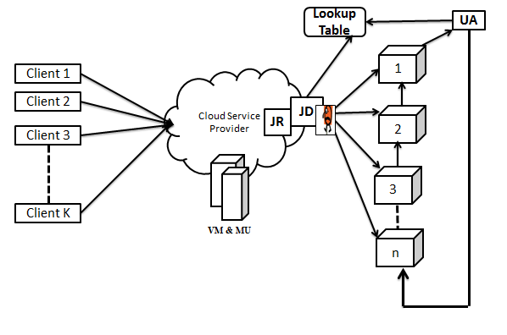
Figure 1: The Model Architecture

- Load Scheduling and Resource Allocation
The model utilized mobile agents to distribute work across a cluster of heterogeneous devices in the cloud. Five agents were involved in the development of the model:
- Job Owner Agent (JO): Requests services from the cloud service provider, carrying job descriptions, computational requirements, and priorities. JO interacts with JR.
- Job Receiver Agent (JR): Receives jobs from JO and communicates with JD to inform about new job arrivals, along with job information.
- Utility Agent (UT): Periodically gathers information about server computational power, current load, and utilization in the network. Updates a Lookup table with this data.
- Job Distributor Agent (JD): A functional agent residing on a server, responsible for distributing new jobs among servers based on capacity and utilization.
- Job Processor Agent (JP): Receives distributed jobs from JD and assigns them to servers for actual computations.
Agents in the model dynamically collected performance data from cloud nodes to calculate and execute tasks. They adapt to the varying computational abilities of servers.

Model Implementation
The developed model was implemented by utilizing multiple agents, (as depicted in Figure 2) including JO, JR, JD, UT, and JP, throughout the process as follows. According to Figure 3:
- The mobile agents were made to move among servers, enhancing efficiency. The architecture involves customers, cloud servers, and a cloud service provider;
- The utility agent periodically moved between servers in the server pool, updating the Master Lookup Table (MLT) with server information. It also updated the Detail Lookup Table with job details, priority, and required computational power. Additionally, it calculated Available Computational Power (ACP) and Percent Utilization (PUT) for each server, assisting in load distribution, and
- The clients (Job Owners) handled the job distribution process by submitting jobs with priorities to the Job Receiver (JR). The JR, Job Distributor (JD), and Lookup table resided on a single server. The process ensured that jobs with higher priorities were executed efficiently. Job distribution uses a round-robin algorithm to retrieve jobs from JR queues and assigns them to servers with sufficient computational power.

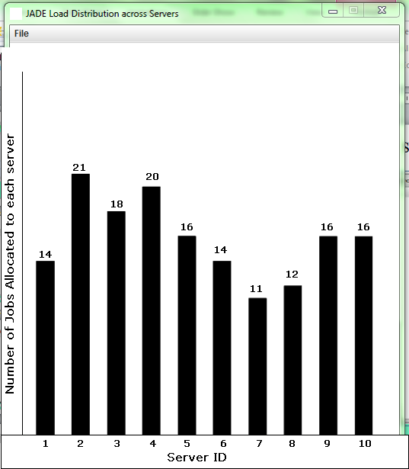
Figure 2: Load Distribution among Servers (Multi-agent-based)

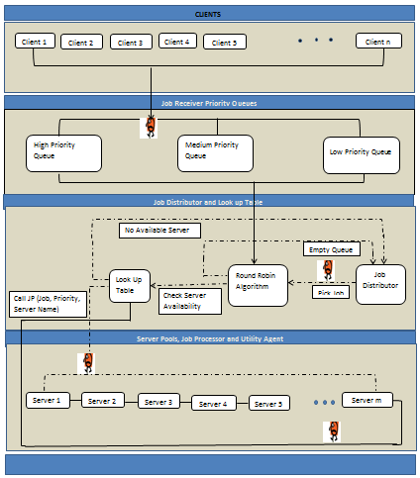
Figure 3: Illustration of the Proposed Model

- RESULTS AND DISCUSSION
This section presents and discusses the results of the system implementation of the designed load scheduling model.

- Model Simulation Result
The simulation involved a comparison analysis, evaluating two distinct. The Traditional Server-Based Load-balancing Scheme was examined alongside a JADE Multi-Agent-Based Load-balancing Scheme. The Graphical User Interface (GUI) was crafted using NetBeans Swing Framework 8.2. Figure 4 illustrates the UI, employing group and border layouts to create a user-friendly frontend. This UI facilitated interaction with database records, load balancer modules, and the simulation environment. JTextArea The GUI Builder Interface streamlined the process, employing Swing Components like JButton, JTextField, JLabel, JScrollPane, JMenu, JMenuBar, and JMenuItem. These components were adjusted in terms of size, alignment, and anchoring to ensure an optimal layout. The GUI Builder Interface spared developers from manual coding for component properties, significantly expediting application development. The simulation environment comprised a file menu with items like LookUp Table data, Average Waiting Time, and Throughput. These metrics facilitate a comparative evaluation of the Traditional Server-Based Load-balancing Scheme and the JADE Multi-Agent-Based Load-balancing Scheme. Client data specifications, including client identification numbers, IP addresses, CPU types, RAM sizes, hard disk sizes, operating systems, and submitted tasks, can be found in the file menu. Similarly, server data specifications, such as server identification numbers, IP addresses, CPU types, RAM sizes, hard disk sizes, operating systems, and location details, are available.
The environment provided a JTextField output viewer for displaying service patterns after load scheduling. It also featured a JTextArea output viewer in the right pane to detail the number of registered clients connected to the cloud server service. For load-balancing, two buttons were provided. One initiated typical load-balancing among registered servers using a centralized server method. This button displayed bar charts illustrating load distribution across servers, along with the IP addresses of clients and servers executing jobs. It also provided throughput and average waiting time details. The second button enabled multi-agent load balancing, offering similar frames for load distribution as the typical load scheduler but with a multi-agent approach. The simulation incorporated a random-server-queue variable and used counter-controlled for-loops to manage servers and determine those with the minimum load based on the number of connected clients. The average load is calculated differently depending on whether the typical load-balancing module or the multi-agent load-balancing module is in use. In the typical load-balancing module, the centralized server analyzes server specifications to determine the average load and reassigns servers accordingly. In the multi-agent load-balancing module, the Utility Agent collects server specifications from all registered servers and collaborates with various agents and a Lookup Table to determine the most suitable load for each server.
In our design, Java interfaces with SQLite, an in-process database designed for embedded was used within applications, eliminating the need for separate database server programs. SQLite offers speed, rigorous testing, and flexibility, making it suitable for prototyping, simulation, and production deployment. The size of network components, affecting communication speed, becomes a crucial factor in choosing between the traditional server-based load-balancing scheme and the JADE multi-agent-based load-balancing scheme. Smaller and faster algorithms are necessary for efficient cloud server service load-balancing. Additionally, database size is considered, and SQLite's portability and structured data retrieval make it a suitable choice. SQLite's portability across operating systems and architectures aligns well with our study's focus on heterogeneous servers. SQLite served as the foundation for the LookUp Table design, showcasing job/task execution details within the load scheduler. This table included attributes like process identification numbers, client IP addresses, job descriptions, task sizes, CPU time, task statuses, session IDs, platforms, and base priorities. The Utility Agent continually updated this LookUp Table by collecting information from servers.
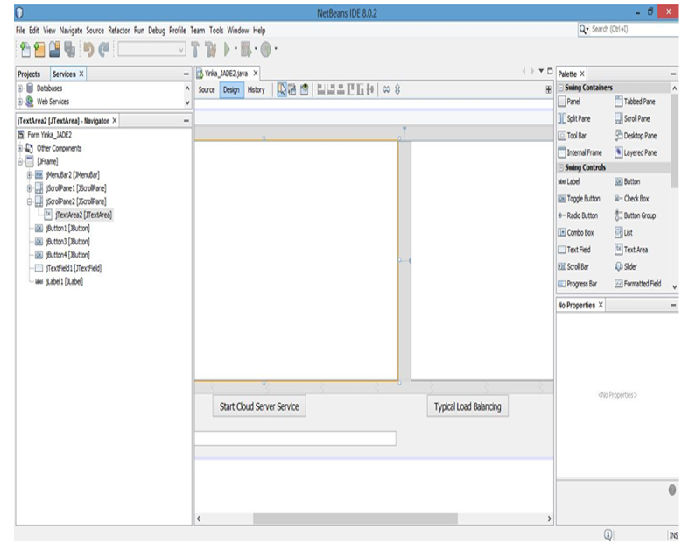
Figure 4: User Interface (UI) Design

- Benchmarking: Centralized vs. Decentralized Approaches
To validate the proposed model, we utilized a Traditional Server-Based Load-balancing Scheme as the control benchmark. This scheme represents standard centralized algorithms (akin to Round Robin and Randomized selection) where a single central server assesses requests and distributes loads based on a "Selection Rule" (random allocation) and "Location Rule" (broadcast status). This baseline was chosen to demonstrate the specific advantages of overcoming the single-point bottleneck inherent in non-agent-based centralized architectures.
Benchmarking Traditional Server-Based and JADE Multi-Agent-Based Load-balancing Scheme
The Traditional Load-balancing Scheme adopts a centralized server approach, where a central server assesses each cloud server's capacity to execute requests, ensuring balanced load distribution to maximize system performance. This method employs three key rules: location, distribution, and selection. The selection rule randomly allocates load to servers pre-emptively. The location rule gathers server status information using a broadcast method, considering server specifications like IP address, CPU type, RAM, and disk size. Servers report as busy, ready, or idle. The distribution rule utilizes a global domain to balance load by exchanging task load data globally, ensuring efficient load balancing. While this system efficiently handles large volumes of data, it incurs higher overhead costs due to outdated information. This leads to our exploration of the JADE multi-agent-based load-balancing scheme, using a LookUp Table for more efficient load-balancing. In the JADE Multi-Agent-Based Load-balancing Scheme, each agent operates autonomously, enabling decentralized and efficient load-balancing. Agents include the Utility Agent, Job-Receiver Agent, Job-Owner Agent, Job-Processor Agent, and Job-Distributor Agent. The Utility Agent collects information from all servers, tracks their statuses, and ensures they remain balanced. The Job-Receiver Agent, Job-Owner Agent, and Job-Processor Agent collaborate to balance server loads based on the cloud's average load. Agents maintain continuous inter-agent communication throughout the load-balancing operation.

Evaluation of System Units
To test the system, two crucial aspects were evaluated - the Cloud Server Service Management Unit and the LookUp Table. In the first scenario, the researchers deliberately interrupted the system after specifying the number of servers and clients. Upon clicking the start button again, the system generated a warning message and shut down. These interruptions, both user-controlled and aberrant, are essential for alerting users, gathering information, and managing errors without compromising system functionality. On the other hand, the LookUp Table was tested by sending an excessive number of jobs, exceeding the system's handling capacity. The LookUp Table issued an error message and shut down the system to prevent overloading. This scenario is called overloading and can degrade server performance.

Performance Evaluation
System performance hinges on inter-component communication and individual component performance. The researchers employed an execution-based performance simulation approach, using program executables as input to derive metrics like response time, throughput, and resource utilization. The study focused on throughput and average waiting time for both the traditional server-based and JADE multi-agent-based load-balancing schemes, considering scalability with varying numbers of servers and jobs.

- Average Waiting Time: This metric represents the total time to assign all clients to servers divided by the number of jobs or requests sent to the cloud server service. It showcases the efficiency of load balancing.
- Throughput: It signifies the percentage of jobs allocated or requests attended to per second compared to the total number of jobs/requests sent per second. Higher throughput implies better system performance.
Scalability tests for 10, 20, 30, 40, and 50 servers with 158 jobs each reveal the advantages of the JADE multi-agent-based load-balancing scheme were conducted and the performances were evaluated. Figures 5 and 6 illustrate that this scheme outperforms the traditional server-based load-balancing in terms of average waiting time and throughput. The saved CPU time could be allocated to other tasks, further boosting throughput and reducing average waiting times.

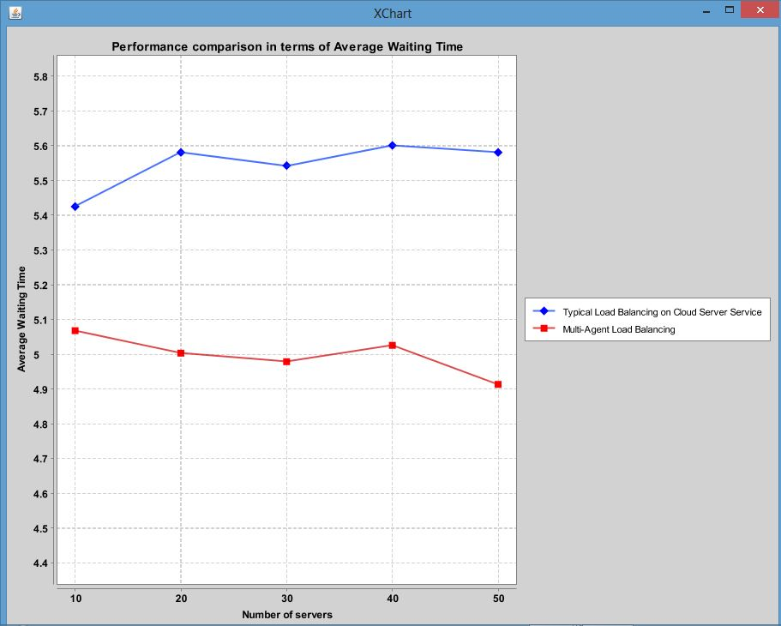

Figure 5: Performance Comparison of Load-Balancing in Terms of Average Waiting Time

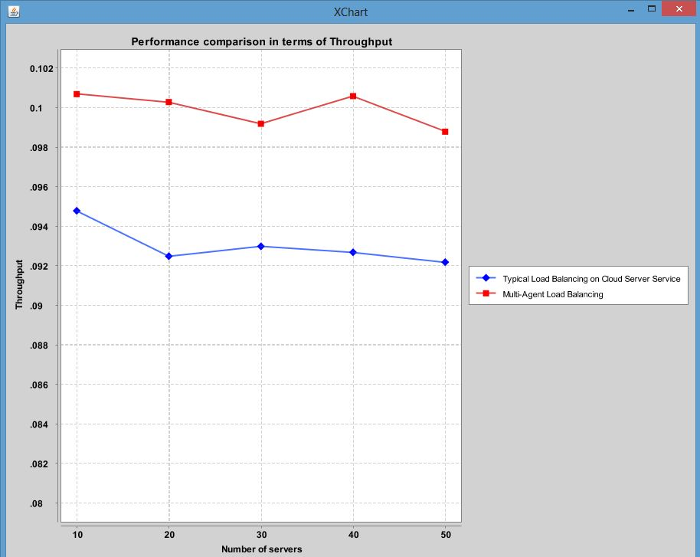
Figure 6: Performance Comparison of Load-Balancing in Terms of Throughput

The evaluation of the Cloud Server Service Management Unit demonstrates its robustness, as the system does not hang or shut down unexpectedly when subjected to user-controlled interrupts. This user-friendly feature issues appropriate warning messages and gracefully shuts down the system. The LookUp Table Unit evaluation confirms its ability to handle overloading gracefully. It ensures that users adhere to the prescribed limits for servers and clients in the cloud server service. In cases of non-compliance, the system issues relevant warning messages. The system performance evaluation, focusing on Average Waiting Time, reveals that the JADE multi-agent-based load-balancing consumes significantly less time than the typical server-based load-balancing. This result emphasizes the superiority of agent-based dynamic load-balancing in terms of cloud response time. The evaluation of system performance based on Throughput demonstrates that the JADE multi-agent-based load-balancing achieves notably higher throughput than the typical server-based load-balancing. This highlights the benefits of agent-based dynamic load-balancing in reducing CPU communication cost and response time, ultimately improving throughput.
The key findings from the results are as follows:
- The JADE multi-agent-based load-balancing scheme significantly reduces average waiting time compared to the typical server-based load-balancing.
- The JADE multi-agent-based load-balancing scheme achieves notably higher throughput than the typical server-based load-balancing. This improvement in throughput is attributed to the efficiency of agent-based load-balancing, reducing CPU communication cost and response time as agents spend minimal time moving between servers.
These results underscore the advantages of agent-based dynamic load-balancing in cloud computing, emphasizing its potential to enhance system performance and efficiency.

- CONCLUSION
This research focused on designing and simulating a lightweight agent-based load scheduling framework in cloud computing, aiming to enhance cloud service delivery via heterogeneous devices. In this cloud-based system, the distribution of jobs and the demand for efficient load-balancing led to the development of a lightweight agent-based scheduler. Traditional load-balancing algorithms proved inefficient for the dynamic and heterogeneous cloud environment. To address these challenges, this study leveraged lightweight agents to create a load scheduler, optimizing time and bandwidth utilization in cloud computing. Through the literature review and simulation using a custom Java-based JADE integrated simulator, this study compared two schemes: the Traditional Server-Based Load-balancing Scheme and the JADE Multi-Agent-Based Load-balancing Scheme. The findings highlight the superiority of agent-based dynamic load-balancing, significantly reducing average waiting time and enhancing throughput. This approach minimizes server communication costs, expedites load-balancing, and improves cloud response time and throughput. Consequently, the JADE Multi-Agent scheme demonstrated superior throughput and reduced waiting times compared to the traditional centralized baseline. While this study focused on the architectural advantages over standard centralized schemes, future work will extend this evaluation to compare the proposed Lightweight Agent framework against specific meta-heuristic algorithms, such as Min-Min and Particle Swarm Optimization (PSO), to further validate its efficiency in high-complexity heterogeneous environments.

REFERENCES
[1] S. K. Mishra, B. Sahoo, and P. P. Parida, “Load balancing in cloud computing: A big picture,” Journal of King Saud University - Computer and Information Sciences, vol. 32, no. 2, pp. 149–158, Feb. 2020, doi: 10.1016/j.jksuci.2018.01.003.
[2] M. M. Kaur and S. Singh, “A Comparative Study of Load Balancing Algorithms With Various Performance Metrics For Cloud Computing.” [Online]. Available: http://www.webology.org
[3] B. Bhaskar and E. M. Reddy, “A Novel Load Balancing Model Using RR Algorithm for the Cloud Computing.” [Online]. Available: http://haproxy.1wt.eu/.
[4] J. Zhou et al., “Comparative analysis of metaheuristic load balancing algorithms for efficient load balancing in cloud computing,” Journal of Cloud Computing, vol. 12, no. 1, p. 85, Jun. 2023, doi: 10.1186/s13677-023-00453-3.
[5] S. Gul, B. A. Malik, and M. T. Banday, “Intelligent Load Balancing Algorithms for Internet of Things - A Review,” International Journal of Sensors, Wireless Communications and Control, vol. 12, no. 6, pp. 415–439, Jul. 2022, doi: 10.2174/2210327912666220726150049.
[6] J. Zhou et al., “Comparative analysis of metaheuristic load balancing algorithms for efficient load balancing in cloud computing,” Journal of Cloud Computing, vol. 12, no. 1, p. 85, Jun. 2023, doi: 10.1186/s13677-023-00453-3.
[7] M. Dwivedi and R. Pandit, “Rakesh Pandit et al/ Resources Load Sharing using RR, FCFS, SJF, MSJF,GP Algorithms in Cloud Computing”, doi: 10.14704/NQ.2022.20.11.NQ66780.
[8] R. Kaur and N. S. Ghumman, “Task-Based Load Balancing Algorithm by Efficient Utilization of VMs in Cloud Computing,” 2018, pp. 55–61. doi: 10.1007/978-981-10-6620-7_7.
[9] D. Kanellopoulos and V. Sharma, “Dynamic Load Balancing Techniques in the IoT: A Review,” Symmetry (Basel), vol. 14, no. 12, p. 2554, Dec. 2022, doi: 10.3390/sym14122554.
[10] S. Roy, Dr. Md. A. Hossain, S. Kumar Sen, N. Hossain, and Md. R. Al Asif, “Measuring the Performance on Load Balancing Algorithms,” Global Journal of Computer Science and Technology, pp. 41–49, May 2019, doi: 10.34257/GJCSTBVOL19IS1PG41.
[11] M. I. Alghamdi, “Optimization of Load Balancing and Task Scheduling in Cloud Computing Environments Using Artificial Neural Networks-Based Binary Particle Swarm Optimization (BPSO),” Sustainability, vol. 14, no. 19, p. 11982, Sep. 2022, doi: 10.3390/su141911982.
[12] S. Gul, B. A. Malik, and M. T. Banday, “Intelligent Load Balancing Algorithms for Internet of Things - A Review,” International Journal of Sensors, Wireless Communications and Control, vol. 12, no. 6, pp. 415–439, Jul. 2022, doi: 10.2174/2210327912666220726150049.
[13] M. Hamdan et al., “A comprehensive survey of load balancing techniques in software-defined network,” Journal of Network and Computer Applications, vol. 174, p. 102856, Jan. 2021, doi: 10.1016/j.jnca.2020.102856.
[14] R. Kaur and N. S. Ghumman, “Task-Based Load Balancing Algorithm by Efficient Utilization of VMs in Cloud Computing,” 2018, pp. 55–61. doi: 10.1007/978-981-10-6620-7_7.
[15] S. Afzal and G. Kavitha, “A Taxonomic Classification of Load Balancing Metrics: A Systematic Review.”
[16] J. G. Anjali, M. Singh, C. Singh, and H. Sethi, “A New Approach for Dynamic Load Balancing in cloud computing,” in National Conference on Advances in Engineering. Technology & Management (AETM) 2015), IOSR-JCE. https://api.semanticscholar.org/CorpusID:15336575, 2015.
[17] H. Suleiman and O. Basir, “SLA-driven Load Scheduling in Multi-tier Cloud Computing: Financial Impact Considerations,” International Journal on Cloud Computing: Services and Architecture, vol. 10, no. 2, pp. 1–24, Apr. 2020, doi: 10.5121/ijccsa.2020.10201.
[18] A. Mazrekaj, A. Sheholli, D. Minarolli, and B. Freisleben, “The Experiential Heterogeneous Earliest Finish Time Algorithm for Task Scheduling in Clouds,” in Proceedings of the 9th International Conference on Cloud Computing and Services Science, SCITEPRESS - Science and Technology Publications, 2019, pp. 371–379. doi: 10.5220/0007722203710379.
[19] G. Rattihalli et al., “Fine-Grained Heterogeneous Execution Framework with Energy Aware Scheduling,” in 2023 IEEE 16th International Conference on Cloud Computing (CLOUD), IEEE, Jul. 2023, pp. 35–44. doi: 10.1109/CLOUD60044.2023.00014.
[20] Bose, S., & Mukherjee, N. (2020), “SenSchedule: Scheduling Heterogeneous Resources in Sensor-Cloud Infrastructure,” IEEE Trans Serv Comput, vol. 15, no. 4, pp. 1825–1840, Jul. 2022, doi: 10.1109/TSC.2020.3022679.
[21] L. Kong, J. P. B. Mapetu, and Z. Chen, “Heuristic Load Balancing Based Zero Imbalance Mechanism in Cloud Computing,” J Grid Comput, vol. 18, no. 1, pp. 123–148, Mar. 2020, doi: 10.1007/s10723-019-09486-y.
[22] K. D. Patel and T. M. Bhalodia, “An Efficient Dynamic Load Balancing Algorithm for Virtual Machine in Cloud Computing,” in 2019 International Conference on Intelligent Computing and Control Systems (ICCS), IEEE, May 2019, pp. 145–150. doi: 10.1109/ICCS45141.2019.9065292.
[23] R. M. Alguliyev, Y. N. Imamverdiyev, and F. J. Abdullayeva, “PSO-based Load Balancing Method in Cloud Computing,” Automatic Control and Computer Sciences, vol. 53, no. 1, pp. 45–55, Jan. 2019, doi: 10.3103/S0146411619010024.
[24] M. Gamal, R. Rizk, H. Mahdi, and B. E. Elnaghi, “Osmotic Bio-Inspired Load Balancing Algorithm in Cloud Computing,” IEEE Access, vol. 7, pp. 42735–42744, 2019, doi: 10.1109/ACCESS.2019.2907615.
[25] D. Chaudhary and B. Kumar, “Cost optimized Hybrid Genetic-Gravitational Search Algorithm for load scheduling in Cloud Computing,” Appl Soft Comput, vol. 83, p. 105627, Oct. 2019, doi: 10.1016/j.asoc.2019.105627.
[26] B. Mondal, “BIO-INSPIRED LOAD BALANCING STRATEGIES IN CLOUD COMPUTING-A COMPREHENSIVE STUDY.”
[27] J. R. Adaikalaraj and T. Vengattaraman, “Load Balancing In Cloud Computing Environment Using Quasi Oppositional Dragonfly Algorithm,” 2021.
[28] G. Annie Poornima Princess and A. S. Radhamani, “A Hybrid Meta-Heuristic for Optimal Load Balancing in Cloud Computing,” J Grid Comput, vol. 19, no. 2, p. 21, Jun. 2021, doi: 10.1007/s10723-021-09560-4.
[29] G. Annie Poornima Princess and A. S. Radhamani, “A Hybrid Meta-Heuristic for Optimal Load Balancing in Cloud Computing,” J Grid Comput, vol. 19, no. 2, p. 21, Jun. 2021, doi: 10.1007/s10723-021-09560-4.
[30] A. K. Kulkarni and B. Annappa, “Context Aware VM Placement Optimization Technique for Heterogeneous IaaS Cloud,” IEEE Access, vol. 7, pp. 89702–89713, 2019, doi: 10.1109/ACCESS.2019.2926291.

